On approval of the Traffic rules, the Basic regulations for the admission of vehicles for operation, the list of operational and special services, with the transport subject to be equipped with special light and sound signals and painting according to special colour and graphic schemes
Invalidated
Unofficial translation
Resolution of the Government of the Republic of Kazakhstan dated November 13, 2014 №1196. Abolished by the Decree of the Government of the Republic of Kazakhstan dated 09/01/2023 No. 758
Unofficial translation
Footnote. Abolished by the Decree of the Government of the Republic of Kazakhstan dated 09/01/2023 No. 758 (effective ten calendar days after the date of its first official publication).
In accordance with Article 9, subparagraph 7) of the Law of the Republic of Kazakhstan "On road traffic," the Government of the Republic of Kazakhstan hereby RESOLVED as follows:
Footnote. The preamble - in the wording of the resolution of the Government of the Republic of Kazakhstan dated 26.10.2022 No. 850 (shall enter into force upon expiry of ten calendar days after the day of its first official publication).
1. To approve the attached:
1) Traffic rules;
2) Basic regulations for the admission of vehicles to operation;
3) the list of operational and special services, with the transport subject to be equipped with special light and sound signals and painting according to special colour schemes.
2. To recognize as invalid some decisions of the Government of the Republic of Kazakhstan in accordance with the Annex.
3. This Resolution shall come into effect ten calendar days after the day of its first official publication.
Prime Minister

of the Republic of Kazakhstan
Approved
by Resolution of the Government of the
Republic of Kazakhstan
dated November 13, 2014 No. 1196
Traffic Laws
1. General Provisions
1. These Traffic rules (hereinafter referred to as the Rules) shall establish a single procedure for road traffic throughout the territory of the Republic of Kazakhstan.
2. The following basic concepts shall be used in the Rules:
1) highway - a road specially built or reconstructed in accordance with the project for the movement of vehicles, which does not serve roadside properties. Access to it shall be possible only from other roads through interchanges at different levels. This road shall:
have separate carriageways for traffic in different directions, separated from each other by a traffic line not intended for traffic;
not have intersections at the same level with other roads, railway and tram tracks and footpaths;
be specially marked as a motorway, when entering the motorway with sign 5.1 and exiting with sign 5.2 (hereinafter, the numbering of road signs is given in accordance with Annex 1 to these Rules);
2) bus - a car designed for the transportation of passengers and luggage, with more than eight seats, not including the driver's seat;
3) motor vehicle - a power-driven vehicle intended for driving on roads and transporting people, cargo or equipment installed on it or towing on roads vehicles intended for transporting people, cargo or equipment installed on it, including trolleybuses, except for agricultural tractors or motor vehicles for which the transport of people and cargo is an auxiliary function. This concept shall not apply to tractors and self-propelled machines;
4) road train - a mechanical vehicle coupled to a trailer (trailers);
5) advantage (priority) - the priority of movement in the intended direction concerning other participants in the movement;
6) heavy vehicle - a vehicle with or without cargo, the total mass or load distribution along with the axles of which exceeds the maximum permissible loads for this category of roads and structures on them;
7) stop - a deliberate cessation of the movement of the vehicle for up to five minutes or for a longer time, if necessary for embarking or disembarking passengers, loading or unloading the vehicle (the need to stop the movement of the vehicle due to the organization of traffic shall not be considered a stop (parking).);
8) luggage - the property of a passenger, packed and transported in the luggage compartment of a bus, minibus or luggage car accompanying the bus, or minibus, within the limits established by the Rules transportation of passengers and luggage by road, as well as in a taxi based on an additional agreement with the carrier;
9) main road - a road marked with signs 2.1, 2.3.1-2.3.3 or 5.1 concerning a crossed (adjacent) road, or a paved road (asphalt and cement concrete, stone materials, etc.) concerning a dirt road. The presence of a paved section on a secondary road immediately before the intersection shall not make it equal in value to the crossed one;
10) overtaking - vehicle passing one or more vehicles moving in front, associated with the departure from the occupied lane and subsequent return to the previously occupied lane;
11) traffic line - a structurally separated element of the road that separates adjacent carriageways of the road and is not intended for the movement or stopping of trackless vehicles and pedestrians, except for the forced stop of pedestrians when crossing the road outside the settlement;
12) bicycle - a vehicle having two wheels or more (except for wheelchair seats for individuals with disabilities) and driven by the muscular force of people on it;
12-1) cyclist - a person who drives a bicycle;
12-2) cycle path - a separate road or part of the road intended for the movement of bicycles and marked with a corresponding sign. The cycle path shall be structurally separated from other roads or other elements of the same road;
12-3) cycle lane - a carriageway lane intended for the movement of bicycles. The cycle lane shall be separated from the rest of the carriageway with longitudinal road markings and special signs;
13) lawn - a piece of land with an artificial grass cover, which is the background for planting plants and park structures;
14) flower bed - a piece of land in the form of a geometric figure, on which plants form a pattern or pattern;
15) built-up area - a built-up area, the entrances to which and the exits from which are marked with signs 5.22 - 5.25;
16) a pedestrian – in individual who is outside the vehicle on the road and does not work on it. Pedestrians shall be equated with individuals moving in wheelchair seats for individuals with disabilities, driving a bicycle, motorcycle, carrying sledges, trolley, pram;
17) pedestrian crossing - a section of the carriageway, marked with signs 5.16.1, 5.16.2 and (or) markings 1.14.1 - 1.14.3 and allocated for pedestrian traffic across the road. In the absence of markings, the width of the pedestrian crossing shall be determined by the distance between signs 5.16.1 and 5.16.2 along the axis of the road (hereinafter, the numbering of road markings is given in accordance with Annex 2 to these Rules);
18) insufficient visibility - the visibility of the road is less than 300 m in conditions of fog, rain, dust, snowfall and the like, as well as at dusk;
19) passenger - a person who is on (in) a vehicle and does not control it;
20) non-regular road transportation of passengers and luggage - transportation that is not classified as regular, carried out using buses, minibuses by carriers that have licenses issued in the prescribed manner;
21) road - the entire land allotment strip or the surface of an artificial structure, equipped or adapted and used for the movement of vehicles and pedestrians in the manner established by the Law of the Republic of Kazakhstan "On the Road Traffic" and these Rules. The road includes one or more carriageways of the road, as well as tram tracks, sidewalks, roadsides and dividing lanes if any;
22) give way (not to create hindrance) - means that a road user shall not start, resume or continue to move, shall not perform any manoeuvre, if this may force other road users who have an advantage over him to change direction movement or speed;
23) roadside - a road element adjacent directly to the carriageway and designed to ensure the stability of the subgrade, improve road safety, organize the movement of pedestrians and cyclists, as well as use in emergencies;
24) road traffic - a set of social relations arising in the process of moving people and cargo using vehicles or without them within roads;
25) carriageway - a part of the road used for the movement of vehicles;
26) road user - a person directly involved in the process of road traffic as a pedestrian, passenger or driver;
27) road safety - the state of road traffic, reflecting the degree of protection of its participants from traffic accidents and their consequences, as well as the negative impacts of road traffic on the environmental situation, and public health;
28) organization of traffic - a complex of organizational and legal, regulatory and methodological, design and survey, organizational and technical, control and supervision, administrative and other measures for traffic management;
29) traffic accident - an event that occurred during the movement of a vehicle on the road and with its participation, resulting in harm to health, death of a person, damage to vehicles, structures, cargo or other material damage;
29-1) simplified registration of a traffic accident - execution of documents on a traffic accident without the participation of employees of the internal affairs bodies of the Republic of Kazakhstan in cases established by the Law of the Republic of Kazakhstan "On compulsory insurance of civil liability of vehicle owners;
30) intersection - a place of intersection, junction or branching of roads at the same level, limited by imaginary lines connecting respectively opposite, the beginnings of the bend of the carriageways of the roads, which are the most distant from the centre of the intersection. Exits from adjacent territories, as well as places of intersection (adjacency) with the field, forest, exits from residential areas and other minor roads, in front of which priority signs are not installed, shall not be considered intersections;
31) driver - a person driving a vehicle, a driver, leading cattle, herd, pack, draft or riding animals along the road;
32) mass without load - the mass of a vehicle without a crew, passengers and cargo, but with a full supply of fuel and the necessary set of tools;
33) weight with load - the actual weight of the loaded vehicle, crew and passengers;
34) edge of the carriageway – shall be determined by the marking line, and in its absence by a conditional line passing along the edge of the road surface, as well as at the junction of the carriageway to the tram tracks at the edge of the road. If it is impossible to determine the edge of the road surface, including according to road conditions, the edge of the carriageway shall be determined by the road user him/herself along the edge of the rolled lane;
35) traffic lane - any of the longitudinal lanes of the carriageway, marked or not marked with longitudinal markings and having a width sufficient for the movement of cars in one row;
36) traffic obstruction - an immovable object on a traffic lane that does not allow to continue driving along this lane. A traffic jam or a vehicle that has stopped on this lane in accordance with the requirements of the Rules shall not be an obstacle;
37) danger to traffic - a situation that has arisen in the course of traffic, in which the continuation of traffic in the same direction and at the same speed creates a risk of a traffic accident;
38) lane-change - changing the lane occupied by a vehicle while maintaining the original direction of movement;
39) dangerous cargo - cargo, which, due to its inherent properties and characteristics during transportation, loading and unloading operations and storage, can cause an explosion, fire or damage to technical means, devices, buildings, structures and facilities, as well as death, injury or diseases of people, animals, damage to the environment;
39-1) public transport - public transport, carrying out regular and irregular road transport of passengers and luggage, as well as taxis;
40) vehicle - a device designed to transport people, cargo or equipment installed on it by road;
41) daytime running lights - external lighting devices designed to improve the visibility of a moving vehicle in front during daylight hours;
42) manoeuvring - the beginning of movement from a stop (parking), standing, turning (U-turning), lane-change, braking and moving the vehicle in reverse;
43) route vehicle - a vehicle of general use (bus, trolley bus, tram) intended for the transportation of passengers on roads and moving along an established route with designated stopping points (stops);
44) forced stop - stopping the movement of a vehicle due to its technical malfunction or danger created by the transported cargo, the condition of the driver (passenger) or the appearance of an obstacle on the road;
45) power-driven vehicle - a self-propelled road vehicle driven by an engine, except for mopeds and rail vehicles. The concept shall also apply to tractors and self-propelled vehicles with their participation in road traffic;
46) moped - a two- or three-wheeled vehicle equipped with an internal combustion engine with a cylinder capacity not exceeding fifty cubic centimetres, or an electric engine and having a maximum design speed of not more than fifty kilometres per hour. Bicycles with outboard motors, mokicks, scooters and other vehicles with similar characteristics shall be equated to mopeds;
47) motorcycle - a two-wheeled mechanical vehicle with or without a side trailer, having an engine. Three- and four-wheeled vehicles, the unladen weight of which does not exceed four hundred kilograms, scooters with a cylinder capacity exceeding fifty cubic centimetres, and other vehicles with similar characteristics, shall be equated to motorcycles;
47-1) vehicle passing - the movement of a vehicle at a speed greater than the speed of a vehicle moving in an adjacent lane, in one direction;
48) permitted maximum mass - the mass of an equipped vehicle with cargo, driver and passengers, established by the manufacturer as the maximum allowable. For the permitted maximum mass of the composition of vehicles, that is, coupled and moving as a whole, the sum of the permitted maximum masses of the vehicles included in the composition is taken;
49) traffic warden - a recognizable and visible at any time of the day an employee of the internal affairs bodies, military police or a serviceman of the road commandant unit, an employee of the transport control bodies of the Ministry for Investment and Development of the Republic of Kazakhstan (hereinafter referred to as the Transport control bodies), an employee of the road maintenance service, an officer on duty at a level crossing, a ferry crossing, having an appropriate certificate and equipment (uniform or a distinctive sign - an armband, a baton, a disk with a red signal or a retro reflector, a red lantern or flag), authorized to carry out regulatory actions to control traffic on the roads;
49-1) taxi - a car designed for the transportation of passengers and luggage by road, equipped in accordance with the Rules for the transportation of passengers and luggage by road;
50) dark time of the day - a period from the end of evening twilight to the beginning of morning twilight;
51) level crossing - the intersection of a road with railway tracks on the same level. The boundary of the crossing is a section of the road bounded by an imaginary line at a distance of 10 m from the nearest rail;
52) parking - a deliberate stoppage of the movement of a vehicle for more than five minutes for reasons not related to the embarking or disembarkation of passengers or the loading or unloading of a vehicle;
53) sidewalk - a part of the road intended for the movement of pedestrians, adjacent to the carriageway of the road or separated from it by a lawn;
54) residential area - a plot, built-up area or massif, marked with the sign 5.38;
55) trailer - a vehicle that is not equipped with an engine and is intended to be driven in combination with a power-driven vehicle. The concept shall also apply to semi-trailers and trailers-dissolutions;
56) organized pedestrian column - a group of pedestrians moving along the road, organized and marked in accordance with the requirements of paragraph 2 of section 3 of these Rules;
57) organized transport column - a group of three or more motor vehicles following directly one after another along the same traffic lane with constantly on headlights, accompanied by a lead vehicle with a blue flashing beacon or blue and red beacons;
57-1) limited visibility - visibility by the driver of the road less than 100 meters in the direction of movement, limited by the terrain, the geometric parameters of the road, vegetation, buildings, structures or other objects, including vehicles;
57-2) adjacent territory - the territory directly adjacent to the road and not intended for through traffic of vehicles. Movement on the adjacent territory shall be carried out in accordance with these Rules;
58) large vehicle - a vehicle with or without cargo, which exceeds the overall dimensions established by regulatory legal acts.
Footnote. Paragraph 2 as amended by Resolutions of the Government of the Republic of Kazakhstan dated 02.08.2017 No. 463 (shall come into effect ten calendar days after the day of its first official publication); dated 21.10.2017 No. 667 (shall come into effect ten calendar days after the day of its first official publication); dated 26.10.2022 No. 850 (shall enter into force upon expiry of ten calendar days after the day of its first official publication); dated 17.12.2022 No. 1021 (shall enter into force from 01.01.2024).
3. Right-hand movement of vehicles is established in the territory of the Republic of Kazakhstan.
4. Necessary changes and restrictions in the organization of traffic are introduced in the prescribed manner only with the help of road signs, road markings, traffic lights and traffic wardens, as well as orders of persons authorized to regulate traffic.
When there is a change in the organization of traffic on the roads or individual sections of roads, road users shall be notified through the media.
5. The realization of the rights of some road users must not violate the rights of other road users.
Road users shall be required:
1) to know and comply with the Rules, and requirements of the Law of the Republic of Kazakhstan "On the Road Traffic";
2) to comply with the requirements of the signals of the traffic warden and traffic lights, road signs, road markings, which are used to regulate traffic, sound and light signals used in road works, special light and sound signals of vehicles of operational and special services;
3) to create safe conditions for road traffic, by their actions or inaction not cause harm to other road users, their vehicles and other property;
4) not to damage or pollute the road surface, not to remove road signs, not obscure or damage them, and not arbitrarily install road signs, traffic lights and other technical means of organizing traffic;
5) not to obstruct traffic or endanger its safety by throwing, unloading or leaving on the road objects or materials that interfere with traffic, refrain from any actions that may interfere with traffic, endanger people or cause damage to property;
6) to take measures in case of detection or creation of an obstacle to traffic on the road to remove this obstacle, and if this is not possible - to mark this obstacle in accordance with the requirements of the Law of the Republic of Kazakhstan "On the Road Traffic" or in another way that ensures road safety, and report the obstacle to the authorized body for ensuring road safety or road owners;
7) to act conscientiously, correctly, be attentive and mutually polite, and not create obstacles and dangers for traffic;
8) to prevent road pollution, including not throwing garbage, objects that create a danger to traffic, and other objects outside specially designated places;
9) to perform other duties in the field of traffic, established by the laws Republic of Kazakhstan.
6. Persons who violate the Rules shall be liable in accordance with the laws Republic of Kazakhstan.
7. In the event of a stop of the vehicle, persons who have the right to check the documents of the driver of the vehicle or use the vehicle shall immediately approach the vehicle, explain the reasons for the stop of the vehicle and present, at the request of the driver, for familiarization and identification of the name and position, an official certificate without his transfer to the driver, if the violation by the driver of the vehicle of the requirements of the Law of the Republic of Kazakhstan "On the Road Traffic" and (or) these Rules is recorded by certified special technical means and devices, present the relevant materials to the driver for review.
Footnote. Paragraph 7 as amended by Resolution of the Government of the Republic of Kazakhstan dated 10.21.2017 No. 667 (shall come into effect ten calendar days after the day of its first official publication).
8. In the event of a traffic accident, if there are no victims, with the mutual consent of drivers in assessing the circumstances of the incident, having previously drawn up an accident scheme and marked it, they shall arrive at the nearest division of the internal affairs bodies for the registration of the incident, with the exception of a simplified registration of a traffic accident.
Footnote. Paragraph 8 – in the wording of the resolution of the Government of the Republic of Kazakhstan dated 17.12.2022 No. 1021 (shall into force from 01.01.2024).
2. General obligations of drivers
1. The driver of a power-driven vehicle must:
1) have with him/her and at the request of authorized officials of the internal affairs bodies, transport control bodies to transfer to them for verification:
driving licence for the vehicle or a temporary license issued instead of a driving licence, except for those issued in the Republic of Kazakhstan, if there is a document proving the identity of the driver;
certificate of state registration of the vehicle, except for the one issued in the Republic of Kazakhstan, or a document certifying ownership of the vehicle;
waybill, a document for the transported cargo (delivery note) and other documents for a vehicle established by the legislation of the Republic of Kazakhstan;
2) stop the vehicle at the request of an employee of the internal affairs bodies, transport control in uniform to stop the vehicle by giving a signal using a loudspeaker, a hand gesture or a baton directed at the vehicle, with a simultaneous whistle signal, which must be understandable to the driver and filed on time so that their execution does not create an emergency;
3) not leave the vehicle without taking measures to prevent the spontaneous movement of the vehicle, as well as in the event it is stopped by an employee of the internal affairs bodies without his permission;
4) pass, at the request of an employee of the internal affairs bodies, an examination for the state of intoxication;
5) when driving in a vehicle equipped with seat belts, be fastened and not carry passengers who are not fastened with seat belts;
6) pass a test of knowledge of these Rules in cases established by the Code of the Republic of Kazakhstan on Administrative Offenses;
7) provide a vehicle to:
medical workers travelling in a passing direction to provide medical care, as well as, regardless of the direction of movement, medical workers, employees of internal affairs bodies and national security bodies for transporting citizens in need of urgent medical care to medical institutions, as well as during anti-terrorist cost recovery operations;
employees of the internal affairs bodies for the transportation of vehicles damaged in traffic accidents travel to the place of natural disaster, as well as employees of the internal affairs bodies, the State Security Service of the Republic of Kazakhstan and national security bodies in other cases provided for by the legislation of the Republic of Kazakhstan;
Notes:
the requirement to provide a vehicle shall not apply to vehicles of representative offices of foreign states and international organizations with diplomatic immunity;
persons using the vehicle must, at the request of the driver, issue a certificate or make an entry in the waybill (indicating the duration of the trip, the distance travelled, their surname, position, service certificate number, and name of their organization);
the costs associated with the provision of a vehicle to the above employees of state organizations, at the request of the owner of the vehicle, shall be reimbursed by these organizations in accordance with the established order.
8) in case of a traffic accident, the driver involved in it must:
immediately stop (not move) the vehicle, turn on the emergency light alarm and set the emergency stop sign (flashing red light) in accordance with the requirements of paragraph 2 of section 7 of the Rules, not to move objects related to the incident;
take all possible measures to provide first aid to the victims, call an ambulance, and in emergency cases, send the victims on a passing, and if this is not possible, deliver them to the nearest medical institution in his/her vehicle, provide his/her last name, state registration license plate of the vehicle (with the presentation of an identity document or a driving licence and registration document for the vehicle) and return to the scene of the accident;
immediately report the incident to the nearest internal affairs body, write down the names and addresses of eyewitnesses and wait for the arrival of employees of the internal affairs bodies, except for cases provided for in paragraph 8 of section 1 of the Rules;
free the carriageway if the movement of other vehicles is impossible;
if it is necessary to clear the carriageway, first fix in the presence of witnesses the position of the vehicle, traces and objects related to the incident, take all possible measures to preserve them and ensure a bypass of the scene.
When driving a motorcycle, drivers shall wear a fastened motorcycle helmet and not carry passengers without a fastened motorcycle helmet.
Footnote. Paragraph 1 as amended by Resolutions of the Government of the Republic of Kazakhstan dated June 23, 2015 No. 472 (shall come into effect ten calendar days after the day of its first official publication); dated 21.10.2017 No. 667 (shall come into effect upon the expiration of ten calendar days after the day of its first official publication); dated November 16, 2018 No. 749 (shall come into effect from January 1, 2019); dated 28.04.2021 No. 275 (shall come into effect upon the expiration of ten calendar days from the date of its first official publication).
2. Vehicles in international traffic shall be permitted to participate in road traffic on the territory of the Republic of Kazakhstan in the presence of international treaties issued in accordance with the requirements ratified by the Republic of Kazakhstan:
1) certificate of registration of the vehicle, and trailer;
2) vehicle registration number;
3) the distinctive sign of the state;
4) vehicle identification mark
5) a document confirming the fact of passing the technical inspection of the vehicle;
3. If other malfunctions and conditions occur along the way, with which the operation of vehicles is prohibited by the Basic Provisions for the admission of Vehicles for Operation (hereinafter referred to as the Basic Provisions) and which the driver can detect, he shall eliminate them, and if this is not possible, then he shall go to parking or repair site with the necessary precautions.
4. The driver shall be prohibited from:
1) driving a vehicle without a driving licence for a vehicle or a temporary license issued instead of a driving licence, except for those issued in the Republic of Kazakhstan, if he/she has a document proving the identity of the driver;
2) driving a vehicle while intoxicated (alcoholic, narcotic and (or) toxicogenic); under the influence of drugs that impair reaction and attention; in a sick or tired condition that endangers road safety;
3) driving a vehicle that is out of order, a vehicle that has not passed a mandatory technical inspection, except for vehicles of categories M1, the age of which shall not exceed seven years, including the year of manufacture, that is not used in business activities in the field of road transport;
4) driving a vehicle, the owner of which, in accordance with the legislation of the Republic of Kazakhstan has not agreed on compulsory liability insurance of vehicle owners and (or) an agreement on compulsory liability insurance of the carrier to passengers;
5) driving a vehicle in the absence of state registration license plates or their non-compliance with registration documents;
6) excluded by Resolution of the Government of the Republic of Kazakhstan dated June 23, 2015 No. 472 (shall come into effect ten calendar days after the day of its first official publication);
7) transferring control of the vehicle to persons in a state of intoxication, under the influence of drugs that impair reaction and attention, in a sick or tired state, as well as to persons, except for those who are learning to drive, who do not have a driving licence or a temporary license issued instead of a driving licence; certificates for the right to drive a vehicle of this category, except for those issued in the Republic of Kazakhstan, he/she has a document proving the identity of the driver, or not specified in the waybill (itinerary) sheet, or to persons who do not have the right to drive or are deprived of the right to drive a transport means;
8) crossing organized (including foot) columns and taking a place in them;
9) when driving a vehicle, using a telephone or a radio station, except for their use through the use of headphones or a speakerphone;
10) driving a vehicle with an inoperative service brake system or steering, a defective coupling device (as part of a train), and at night on roads without artificial lighting or in conditions of poor visibility - with off (absent) headlights and (or) tail lights, during rain or snowfall - with defective windshield wipers;
Note. A service brake or steering system that does not allow the vehicle to stop or manoeuvre when moving at minimum speed is considered inoperative.
11) using alcoholic beverages, narcotic or psychotropic substances after a traffic accident in which he/she is involved, or after the vehicle was stopped at the request of an employee of the internal affairs bodies until an authorized official examines to establish a state of intoxication or until the adoption by an authorized official of a decision on exemption from such an examination.
In paragraphs 12 and 13 of section 8, paragraphs 2 and 3 of section 9, paragraph 5 of section 10, paragraphs 4 and 5 of section 11, paragraphs 4, 5 and 7 of section 12, and paragraphs 2 and 3 of section 13, paragraph 4 of section 14, paragraph 3 of section 15, paragraph 1 of section 16, paragraph 2 of section 17, paragraphs 4 and 5 of section 20, paragraphs 6 and 7 of section 22 of these Rules provide for other prohibitions for drivers.
Footnote. Paragraph 4 as amended by Resolutions of the Government of the Republic of Kazakhstan dated June 23, 2015 No. 472 (shall come into effect ten calendar days after the day of its first official publication); dated 21.10.2017 No. 667 (shall come into effect upon the expiration of ten calendar days after the day of its first official publication); dated 28.04.2021 No. 275 (shall come into effect upon the expiration of ten calendar days from the date of its first official publication).
3. Obligations of pedestrians
1. Pedestrians shall move on sidewalks or footpaths, and in their absence - on shoulders, as well as in accordance with the requirements of paragraphs 1 and 4 of Section 17 of the Rules.
Pedestrians carrying or carrying bulky objects, as well as individuals moving in wheelchairs without an engine, move along the edge of the roadway (on roads with a dividing strip - along the outer edge of the roadway) if their movement on sidewalks or shoulders interferes with other pedestrians.
In the absence of sidewalks, footpaths or shoulders, as well as if it is impossible to move along them, pedestrians move along the bicycle path or go in one row along the edge of the roadway (on roads with a dividing strip - along the outer edge of the roadway).
Outside settlements, when driving along the roadway, pedestrians go towards the movement of vehicles.
Individuals moving in wheelchairs without an engine, driving a motorcycle, moped, bicycle along the edge of the roadway follow the right side of the road as vehicles move.
Footnote. Paragraph 1 – in the wording of the resolution of the Government of the Republic of Kazakhstan dated 26.10.2022 No. 850 (shall enter into force upon expiry of ten calendar days after the day of its first official publication).
2. The movement of organized pedestrian columns along the carriageway shall be carried out in the direction of the movement of vehicles on the right side of no more than four people in a row. In front and behind the column on the left side there shall be escorts with red flags, and in the dark and conditions of insufficient visibility - with lights on: in front – of white colour, behind - of red colour.
3. Pedestrians shall cross the carriageway at pedestrian crossings, including underground and elevated ones, and if they are absent within sight, at intersections along the line of sidewalks or roadsides.
If there is no crossing or intersection in the visibility zone, it shall be permitted to cross the road at a right angle to the edge of the carriageway where it is visible in both directions. It shall be prohibited to cross the carriageway outside the pedestrian crossing if there is a traffic line in the settlement, as well as in places where pedestrian or road barriers are installed.
4. In places where traffic is regulated, pedestrians shall be guided by the signals of a traffic warden or a pedestrian traffic light, and in their absence, a transport traffic light.
5. At unregulated pedestrian crossings, pedestrians shall enter the carriageway after they estimate the distance to approaching vehicles, and their speed and make sure that the crossing will be safe for them. When crossing the carriageway outside the pedestrian crossing, pedestrians shall not interfere with the movement of vehicles and shall not leave because of a standing vehicle or another obstacle that limits visibility without making sure that there are no approaching vehicles.
Note. The concepts of regulated and unregulated pedestrian crossings shall be similar to the concepts of regulated and unregulated intersections established in paragraph 4 of section 13 of the Rules.
6. Having entered the carriageway, pedestrians shall not linger and do not stop, if this is not related to ensuring traffic safety. Pedestrians who did not have time to complete the transition shall stop on the line separating the traffic flows of opposite directions. It shall be permitted to continue the transition only after making sure that the further movement is safe and taking into account the traffic lights (traffic warden).
7. When approaching vehicles with a blue flashing beacon and a special sound signal turned on, pedestrians shall not cross the carriageway, but those on it shall give way to these vehicles and clear the carriageway.
8. Waiting for a route vehicle and a taxi shall be carried out on landing sites raised concerning the carriageway, and in their absence - on the sidewalk or roadside. At stopping points that are not equipped with elevated landing areas, it shall be permitted to enter the carriageway of the road to board the vehicle only after it has stopped. After disembarking, pedestrians shall leave the carriageway without stopping.
When moving across the carriageway to the stopping point or from it, pedestrians shall be guided by the requirements of paragraphs 4-7 of this section.
4. Obligations of passengers
1. Passengers shall be obliged to:
1) excluded by Resolution of the Government of the Republic of Kazakhstan dated 21.10.2017 No. 667 (shall come into effect ten calendar days after the day of its first official publication);
2) when riding a vehicle equipped with seat belts, be fastened with them (taking into account subparagraph 2) of paragraph 1 of section 2 of the Rules), and when riding a motorcycle - be in a fastened motorcycle helmet;
3) get on and off from the sidewalk or roadside and only after the vehicle has come to a complete stop.
If embarking and disembarking is not possible from the sidewalk or roadside, it shall be carried out from the side of the carriageway, provided that it will be safe and will not interfere with other traffic participants.
Footnote. Paragraph 1 as amended by Resolution of the Government of the Republic of Kazakhstan dated 10.21.2017 No. 667 (shall come into effect ten calendar days after the day of its first official publication).
2. Passengers shall be prohibited from:
1) distract the driver from driving the vehicle while it is moving;
2) when driving a truck with an onboard platform, stand, sit on the sides or a load higher than the sides;
3) open doors, as well as protrude into window openings and hatches of the vehicle during its movement.
5. Traffic light and traffic warden signals
Note. Images of traffic lights and traffic wardens are shown in Fig. 1.
Traffic light signals
1. To regulate traffic, traffic lights with a vertical or horizontal arrangement shall be used.
Light signals of green, yellow, red and white-lunar colour shall be used in traffic lights.
In traffic lights with a vertical arrangement of signals, the red signal shall be placed at the top, and the green one shall be at the bottom; with a horizontal arrangement of signals - red shall be placed on the left, green - on the right.
Depending on the purpose, traffic light signals may be round, in the form of an arrow (arrows), a silhouette of a pedestrian or a bicycle, "X" and "+"-shaped.
Traffic lights with round signals may have one or two additional sections with signals in the form of a green arrow (arrows), which shall be located at the level of the green round signal.
Footnote. Paragraph 1 as amended by Resolution of the Government of the Republic of Kazakhstan dated 10.21.2017 No. 667 (shall come into effect ten calendar days after the day of its first official publication).
2. Round traffic lights shall have the following meanings:
1) green signal allows movement;
2) green flashing signal allows movement and informs that its time expires and a prohibition signal will soon be turned on (digital displays shall be used to inform drivers and pedestrians about the time in seconds left before the green signal turns off);
3) yellow signal prohibits movement, except for the cases provided for in paragraph 14 of this section, and warns of the upcoming change of signals;
4) yellow flashing signal informs about the presence of an intersection or a pedestrian crossing that is not regulated by a traffic light and warns of danger;
5) red signal, including flashing, prohibits movement. The combination of red and yellow signals prohibits movement and informs about the upcoming green signal.
Fig.1 Traffic light and traffic warden signals Transport traffic lights
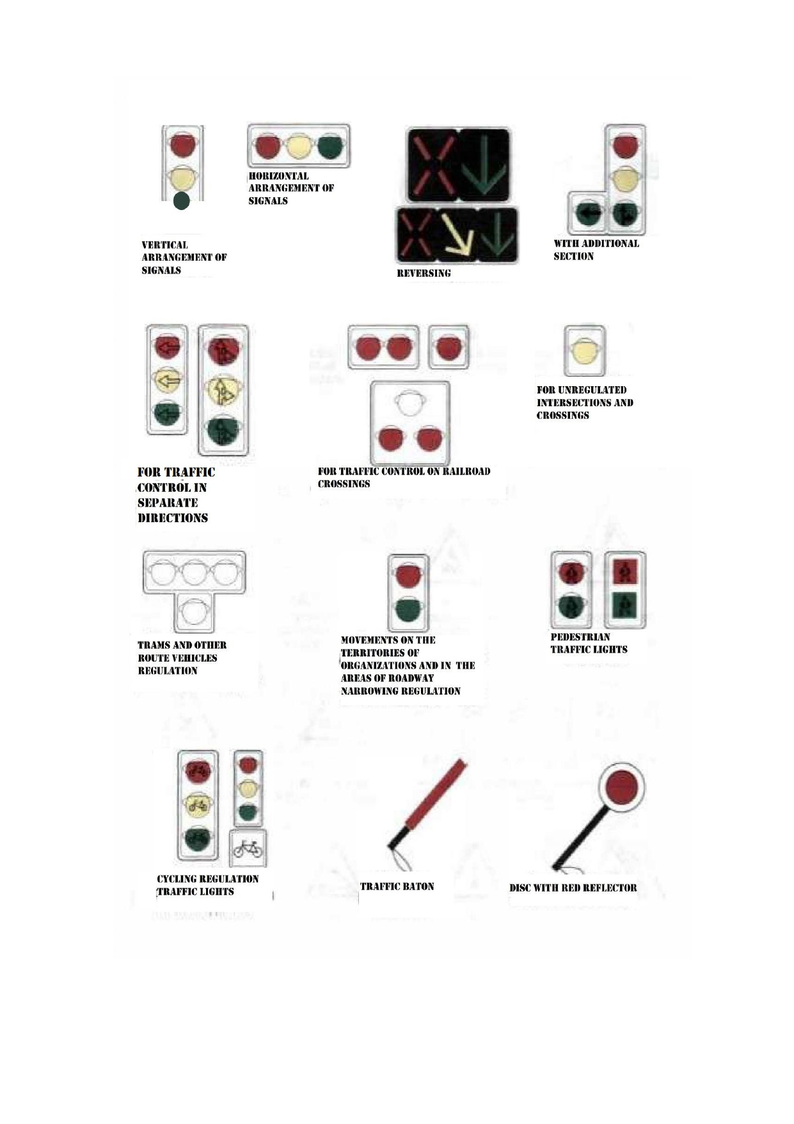

The main signals of the traffic warden

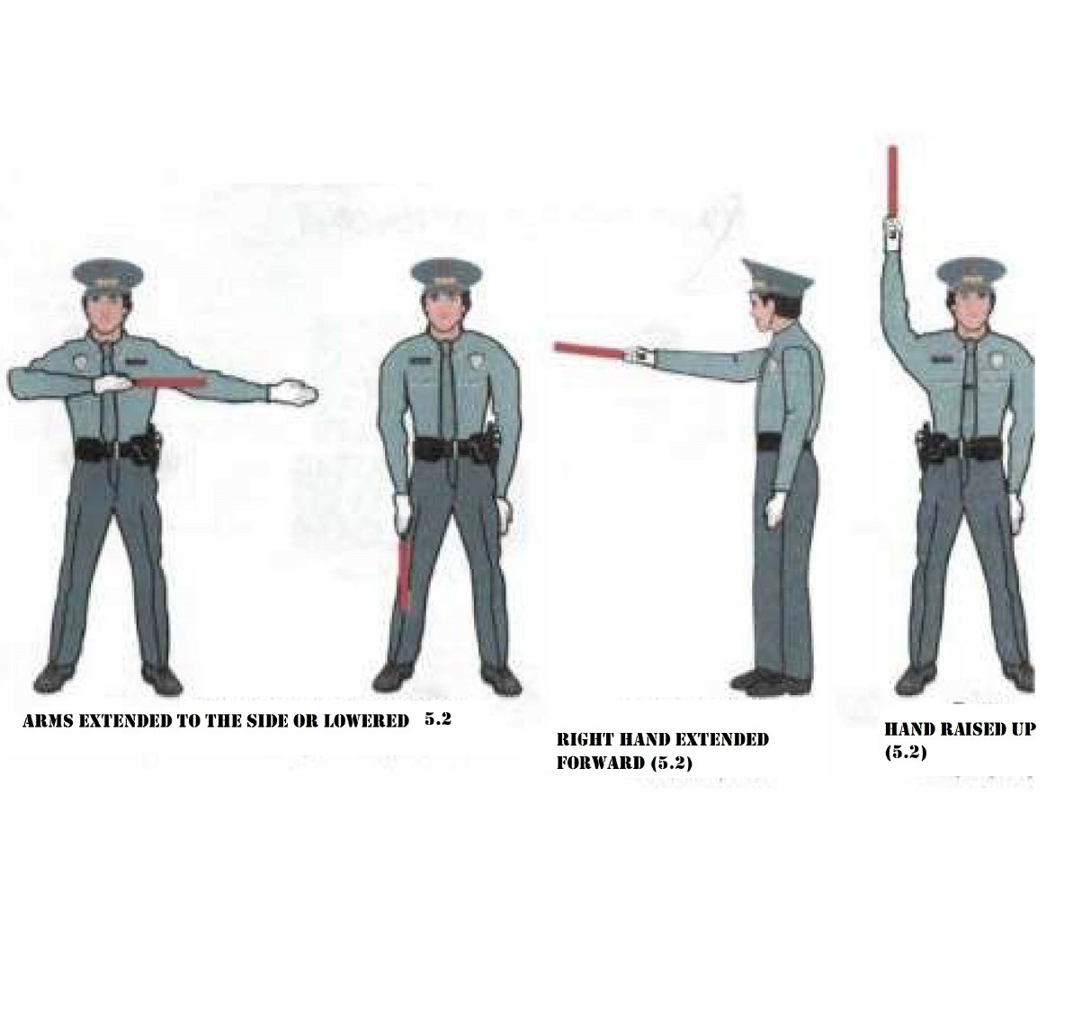

3. Traffic light signals made in the form of red, yellow and green arrows shall have the same meaning as round signals of the corresponding colour, but their effect shall extend only to the direction (directions) indicated by the arrows. In this case, the arrow that allows a left turn shall also allow a U-turn unless this is prohibited by the corresponding road sign.
Footnote. Instead of red and yellow arrows with the same meaning, round red and yellow signals with black contour arrows printed on them may be used.
The green arrow in the additional section shall have the same meaning. The switched-off signal of the additional section shall mean the prohibition of movement in the direction regulated by this section.
4. If a black contour arrow (arrows) is applied to the main green signal of the traffic light, then it shall inform drivers about the presence of an additional section of the traffic light and indicate other permitted directions of movement than the signal of the additional section.
5. If the traffic light signal is made in the form of a silhouette of a pedestrian (bicycle), then its effect shall apply only to pedestrians (cyclists). In this case, the green signal allows, and the red one prohibits the movement of pedestrians (cyclists).
To regulate the movement of cyclists, a traffic light with round signals of reduced size shall also be used, supplemented by a white rectangular plate 300x200 mm in size with the image of a black bicycle.
6. To inform pedestrians with complete loss of vision about the possibility of crossing the roadway, traffic lights can be supplemented with a sound markal.
Footnote. Paragraph 6 – in the wording of the resolution of the Government of the Republic of Kazakhstan dated 26.10.2022 No. 850 (shall enter into force upon expiry of ten calendar days after the day of its first official publication).
7. To regulate the movement of vehicles on the lanes of the carriageway, in particular on those where the direction of movement may be reversed, reverse traffic lights with a red X-shaped signal and a green signal in the form of an arrow pointing down shall be used. These signals shall respectively prohibit or permit movement in the lane above which they are located.
The main signals of a reversing traffic light may be supplemented by a yellow signal in the form of an arrow, tilted diagonally down to the right or left, the inclusion of which informs about the upcoming signal change and the need to change lanes to which the arrow points.
When the signals of the reversing traffic light, which is located above the lane marked on both sides with markings 1.9, are turned off, entry to this lane shall be prohibited.
8. To regulate the movement of trams, as well as public transport, moving along the lane allocated for them, single-colour signalling traffic lights with four round white-lunar signals arranged in the form of the letter "T" shall be used. Movement shall only be permitted when the lower signal and one or more upper ones are turned on, of which the left one shall allow movement to the left, the middle one - straight ahead, the right one - to the right.
Footnote. Paragraph 8 as amended by Resolution of the Government of the Republic of Kazakhstan dated 02.08.2017 No. 463 (shall come into effect ten calendar days after the day of its first official publication).
9. Round white-lunar flashing signal, located at the level crossing, shall allow the movement of vehicles through the crossing. When the flashing white-lunar and red signals are turned off, the movement shall be permitted if there is no train (locomotive, railcar) approaching the crossing within sight.
9-1. The red "+"-shaped signal shall inform that for the vehicles in the opposite direction, the prohibiting red traffic light is turned on.
The turned-off red "+"-shaped signal shall inform that the permissive green traffic light is on for vehicles in the opposite direction.
Footnote. Section 5 is supplemented by paragraph 9-1 in accordance with the Resolution of the Government of the Republic of Kazakhstan dated 10.21.2017 No. 667 (shall come into effect ten calendar days after the day of its first official publication).
Traffic warden signals
10. The signals of the traffic warden shall be the position of his body and gestures with his hands, including with a baton, which has the following meanings:
1) arms extended to the sides or lowered:
from the left and right side - the tram shall be permitted to move straight, trackless vehicles and to the right, pedestrians are permitted to cross the carriageway;
from the side of the chest and back - the movement of all vehicles and pedestrians shall be prohibited.
2) the right hand is extended forward:
from the left side - the tram shall be permitted to move to the left, with trackless vehicles in all directions;
from the side of the chest - all vehicles are permitted to move only to the right;
from the right side and back - the movement of all vehicles shall be prohibited;
Pedestrians shall be permitted to cross the carriageway behind the back of the traffic warden.
3) hand raised:
the movement of all vehicles and pedestrians shall be prohibited in all directions, except as provided in paragraph 14 of this section.
The traffic warden may give hand gestures and other signals understandable to drivers and pedestrians.
For better visibility of the signals, the traffic warden may use a baton or disk with a red signal (reflector).
11. The request to stop the vehicle shall be submitted with the help of a loudspeaker, a hand gesture or a baton directed at the vehicle with a simultaneous whistle signal, which must be understandable to the driver and given on time so that their execution shall not create an emergency.
12. An additional whistle signal shall be given to attract the attention of traffic participants.
13. With a prohibitory signal of a traffic light (except for a reversing one) or a traffic warden, drivers shall stop in front of the stop line (sign 5.33), and in its absence:
1) at the intersections - in front of the crossed carriageway or shall be guided by the requirements of paragraph 8 of section 13 of the Rules, without interfering with pedestrians;
2) before a level crossing - in accordance with paragraph 4 of section 15 of the Rules;
3) in other places - in front of a traffic light or a traffic warden, without interfering with vehicles and pedestrians whose movement shall be permitted.
14. Drivers who, when the traffic warden raises his hand or turns on the yellow signal in cases where the mode of operation of the traffic signal does not ensure the flashing of the green signal immediately before it turns off, cannot stop without resorting to emergency braking in the places specified in paragraph 13 of this section, shall keep moving forward.
Pedestrians who, when the traffic warden raised his hand or turned on the yellow signal, were on the carriageway of the road, clear it, and if this is not possible, shall stop on the line dividing the traffic flows of opposite directions.
15. Drivers and pedestrians shall comply with the requirements of the signals and orders of the traffic warden, even if they contradict traffic signals, traffic signs or markings.
16. At level crossings, simultaneously with a red flashing traffic light, an audible signal may be given, additionally informing traffic participants about the prohibition of movement through the crossing.
6. The use of special signals
1. Drivers of vehicles of operational and special services with a flashing beacon of blue and (or) red on, performing an urgent official task, may deviate from the requirements of sections 5 (except for the signals of the traffic warden), 8-18 of these Rules, Annexes 1 and 2 to these Rules subject to ensuring traffic safety.
To gain an advantage over other road users, drivers of such vehicles shall turn on a blue and (or) red flashing beacon and a special sound signal. They shall take advantage only after making sure that they give way.
The same right shall be enjoyed by drivers of vehicles accompanied by vehicles of operational and special services in the cases established by this paragraph of the Rules.
2. When approaching vehicles with a blue and (or) red flashing beacon and a special sound signal, drivers shall give way to ensure the unimpeded passage of these and other vehicles accompanied by them.
3. When approaching a stationary vehicle with a blue and/or red flashing light on, the driver shall slow down to be able to stop immediately if necessary.
4. Drivers of vehicles with an orange or yellow flashing beacon on when performing construction, repair or cleaning work, mobile emergency response teams of private security organizations, mobile checkpoints of transport control authorities on the road, specialized vehicles of cash collection services accompanying organized groups cyclists carrying out activities to suppress offences in the field of flora and fauna protection may deviate from the requirements of road signs (except signs 2.2, 2.4 - 2.6, 3.11 - 3.14, 3.17.2, 3.20) and markings, as well as paragraphs 4 - 8 of section 9 and paragraph 1 of section 16 of the Rules, subject to ensuring traffic safety. Drivers of other vehicles shall not interfere with their work.
Footnote. Paragraph 4 as amended by Resolution of the Government of the Republic of Kazakhstan dated 28.04.2021 No. 275 (shall come into effect upon the expiration of ten calendar days from the date of its first official publication).
7. The use of hazard lights and warning triangle
1. The hazard lights shall be turned on:
1) in case of a traffic accident;
2) in case of a forced stop in places where stopping is prohibited;
3) when reversing;
4) when the driver is blinded by headlights;
5) when towing (on a towed power-driven vehicle);
6) when standing and parking on unlit sections of roads or in conditions of insufficient visibility with defective marker lights;
7) outside the settlement when standing at the side of the road in the case when its width is insufficient for a complete exit from the carriageway or it is not possible to determine the width of the side of the road in these road conditions.
Hazard lights shall also be switched on in other cases to warn road users of the danger that the vehicle may create.
2. After turning on the hazard lights, as well as in case of its malfunction or absence, immediately puts up an emergency stop sign (or a flashing red light) on the carriageway from the side of the greatest danger when:
1) traffic accident;
2) a forced stop in places where it is prohibited, or places where the visibility of the road is less than one hundred meters in at least one direction.
An emergency stop sign (or a flashing red light) is installed at a distance that provides, in a specific situation, a timely warning to other drivers about the danger at a distance of at least fifteen meters from the vehicle in built-up areas and thirty meters outside built-up areas.
3. In the absence or malfunction of an emergency light signalling, an emergency stop sign shall be attached to the rear of the towed power-driven vehicle.
8. Manoeuvring
1. Before starting the manoeuvre, the driver shall give signals with light indicators for the appropriate purpose, and if they are absent or defective, with his hand. In this case, the manoeuvre shall be carried out safely and not interfere with other road users.
2. The signal for manoeuvre to the left shall be the left turn light indicator turned on or the left arm extended to the side or the right arm extended to the side and bent at the elbow at a right angle upwards. The signal for manoeuvre to the right shall be the right turn light indicator turned on, or the right arm extended to the side or the left arm extended to the side and bent at the elbow at a right angle upwards. The brake signal shall be given by a brake light or a raised hand. The signal for reversing shall be given by turning on the reversing lights and the alarm.
Signalling by direction indicators or a hand signal shall be carried out without misleading other road users, well in advance of the start of the manoeuvre and stop immediately after its completion (hand signalling may be completed immediately before the manoeuvre is performed).
Giving a signal shall not give the driver an advantage and shall not relieve him from taking precautionary measures.
3. When entering a road from a secondary road, the driver shall give way to vehicles and pedestrians moving along it, and when leaving the road, to pedestrians and cyclists whose path he/she crosses.
4. When approaching a stop or parking place, the driver shall give way to pedestrians, drivers of bicycles, mopeds, horse-drawn carriages, drivers of riding and pack animals moving along the edge of the carriageway or the roadside.
5. When changing lanes, the driver shall give way to vehicles moving along the way without changing the direction of movement. With the simultaneous lane-change of vehicles moving along the way, the driver shall give way to the vehicle on the right.
Lane-change, as a result of which a dangerous distance is created between moving vehicles, shall be prohibited.
6. Before turning right, left or making a U-turn, the driver shall take the appropriate outer position on the carriageway and on the lane intended for movement in this direction in advance, except when making a turn at the entrance to an intersection where a roundabout is organized.
If signs 5.8.1 or 5.8.2 are installed on the road, then these manoeuvres shall be permitted along the corresponding traffic lanes; in this case, it shall be prohibited to occupy non-outer lanes with free outer lanes.
If there are tram tracks on the left of the following direction, located on the same level as the carriageway of the road, a left turn and a U-turn must be carried out from them, unless signs 5.8.1 or 5.8.2 prescribe the direction of movement along the lanes of the carriageway. In this case, the driver shall give way to the tram.
7. The turn shall be carried out in such a way that when leaving the intersection of the carriageways, the vehicle does not end up on the side of oncoming traffic.
8. If the vehicle, due to its dimensions or for other reasons, cannot make a turn at the intersection and outside it or a U-turn at the intersection in compliance with the requirements of paragraph 6 of this section, it shall be permitted to shift partially, and if necessary, completely, to the adjacent lane, provided ensure traffic safety and if it does not interfere with other vehicles.
9. When turning left or making a U-turn outside the intersection, the driver of a trackless vehicle shall give way to oncoming vehicles.
If, when turning outside the intersection, the width of the carriageway is insufficient to manoeuvre for the outer left position, it shall be permitted to perform it only from the right edge of the carriageway (from the right roadside). In this case, the driver shall give way to passing and oncoming vehicles.
10. In cases where the trajectories of the movement of vehicles intersect, and the order of passage is not defined by these Rules, the driver, to whom the vehicle is approaching from the right, shall give way.
11. If there is a deceleration lane, a driver intending to turn must change lanes to this lane on time and slow down only on it.
If there is an acceleration lane at the entrance to the road, the driver shall move along it and change lanes to the adjacent lane, giving way to vehicles moving along this road.
12. U-turn shall be prohibited:
1) at pedestrian crossings and intersections along the line of sidewalks or roadsides;
2) in tunnels;
3) on bridges, viaducts, overpasses and under them;
4) at level crossings;
5) in places where the visibility of the road is less than one hundred meters;
6) at the locations of stopping points.
13. The movement of the vehicle in reverse shall be permitted provided that the manoeuvre is safe and does not interfere with other traffic participants. Reversing shall be prohibited at intersections and in places where a U-turn is prohibited in accordance with paragraph 12 of this section.
Footnote. Paragraph 13 as amended by Resolution of the Government of the Republic of Kazakhstan dated 10.21.2017 No. 667 (shall come into effect ten calendar days after the day of its first official publication).
9. Position of vehicles on the carriageway
1. The number of lanes for trackless vehicles shall be determined by markings or signs 5.8.1, 5.8.2, 5.8.7, 5.8.8, and if there are none, then by the drivers themselves, taking into account the width of the carriageway, the dimensions of the vehicles and the necessary intervals between them. In this case, the side intended for oncoming traffic shall be considered to be half the width of the carriageway of the road (or the roadbed if it is impossible to determine the edge of the carriageway of the road), located on the left, unless a different traffic order is determined by the traffic organization. When determining the conditional line separating the side intended for oncoming traffic, the local widening of the carriageway (roadway) shall not be taken into account.
2. On roads with two-way traffic, having four lanes or more, it shall be prohibited to drive to the side of the road intended for oncoming traffic. On such roads, left turns or U-turns may be performed at intersections and other places where it is not prohibited by the Rules, signs and (or) markings.
Footnote. Paragraph 2 as amended by Resolution of the Government of the Republic of Kazakhstan dated 10.21.2017 No. 667 (shall come into effect ten calendar days after the day of its first official publication).
3. On two-way roads with three lanes, it shall be prohibited to drive to the leftmost lane intended for oncoming traffic.
4. Outside built-up areas, as well as in built-up areas on roads marked with signs 5.1 and 5.3, or where traffic at a speed of more than 80 km/h shall be permitted, drivers of vehicles drive them closer to the right edge of the carriageway, while not occupying the left traffic lanes at free right ones.
In settlements, taking into account the requirements of this paragraph and paragraph 5 of this section, paragraph 1 of section 16 and paragraph 2 of section 24 of the Rules, traffic shall be carried out in any lane, however, drivers of vehicles moving along the left lanes at a speed less than the permitted one, shall clear the lane they occupy with lane-change to the right to vehicles approaching from behind in the same lane at a higher speed and giving warning signals in accordance with paragraph 13 of section 19 of the Rules.
On any roads that have three or more lanes for traffic in this direction, it shall be permitted to occupy the leftmost lane only in heavy traffic when other lanes are occupied, as well as for overtaking, turning left or turning around, and trucks with a maximum permissible weight of more than three thousand five hundred kilograms - only for a left turn or a U-turn. Departure to the left side of the road with one-way traffic for standing and parking shall be carried out in accordance with paragraph 1 of section 12 of the Rules.
The movement of vehicles in one lane at a speed greater than in the adjacent lane shall not be considered overtaking.
5. Vehicles whose speed does not exceed 40 km/h or which, for technical reasons, do not develop such a speed, shall move along the outer right lane intended for the movement of this vehicle in the direction it needs, except for cases of the bypass, overtaking, lane-change before turning to the left, turning around or standing (parking) in permitted cases on the left side of the road.
6. It shall be permitted to drive on tram tracks of a passing direction, located on the left at the same level as the carriageway of the road, when all lanes of this direction are occupied, as well as when passing, overtaking, turning left or making a U-turn, taking into account paragraph 6 of section 8 of the Rules. This should not interfere with the tram. It shall be prohibited to enter the tram tracks of the opposite direction, as well as the movement through the intersection on the tram tracks if signs 5.8.1 or 5.8.2 are installed on the road.
7. If the carriageway of the road is divided into lanes by marking lines, the movement of vehicles must be carried out strictly along the marked lanes. It shall be permitted to run into broken marking lines only when changing lanes.
8. When turning onto a road with reverse traffic, the driver shall drive the vehicle in such a way that when leaving the intersection of the carriageways, the vehicle takes the rightmost lane. Lane change shall be permitted only after the driver is convinced that movement in this direction is also permitted in other lanes.
9. Vehicles shall be prohibited to move along roadsides, sidewalks and footpaths (except for cases provided for in paragraph 1 of section 12 and paragraph 2 of section 24 of the Rules), and in populated areas - in addition, outside the carriageway. The movement of vehicles for road maintenance and public utilities shall be permitted, as well as the entrance along the shortest path of vehicles transporting cargo to objects located directly at the roadsides, sidewalks or footpaths, in the absence of other access possibilities. In this case, traffic safety must be ensured.
10. The driver, depending on the speed of movement, maintains such a distance from the vehicle moving in front, which will allow avoiding a collision, as well as the necessary lateral interval, ensuring traffic safety.
11. Outside built-up areas on two-way roads with two lanes, drivers of vehicles for which a speed limit is set, as well as vehicles (composition of vehicles) with a length of more than seven meters, shall maintain such a distance between their own and the vehicle moving in front so that vehicles overtaking them could change lanes to the previously occupied lane without interference. This requirement shall not apply if the driver is preparing to overtake, as well as in heavy traffic and when driving in an organized transport convoy.
12. On roads with two-way traffic, in the absence of a dividing lane, safety islands, bollards and elements of road structures (supports of bridges, overpasses, etc.) located in the middle of the carriageway, the driver shall drive around on the right, unless signs and markings prescribe otherwise.
10. Movement speed
1. The driver shall drive the vehicle at a speed not exceeding the established limit, taking into account the intensity of traffic, the features and condition of the vehicle and cargo, road and meteorological conditions, in particular, visibility in the direction of travel. The speed shall provide the driver with the possibility of constant control over the movement of the vehicle to comply with the requirements of the Rules.
In the event of an obstacle and (or) a danger to traffic that the driver can detect, he/she takes measures to reduce speed until the vehicle stops or avoids the obstacle safely for other road users.
2. In settlements, the movement of vehicles shall be permitted at a speed of no more than 60 km/h, except for special traffic modes established by the relevant road signs, but not more than 90 km/h, and in residential areas and yard areas - no more than 20 km/h h.
3. Outside settlements, the movement shall be permitted:
1) for cars and motorcycles on highways - at a speed not exceeding that set by the relevant road sign 3.24, but not more than 140 km/h, on roads with a traffic line - no more than 110 km/h, on other roads - no more than 100 km/h;
2) trucks with a maximum authorized mass of not more than three thousand five hundred kilograms, intercity buses, minibuses on highways - no more than 110 km/h, on roads with a traffic line - no more than 100 km/h, on other roads - no more than 90 km/h;
3) other buses, including those carrying out organized transportation of groups of children, cars when towing a trailer, trucks with a maximum permitted weight of more than three thousand five hundred kilograms on motorways - no more than 90 km/h, on roads with a traffic line - not more than 80 km/h, on other roads - no more than 70 km/h.
4. The speed of vehicles must not exceed:
1) 60 km/h - when transporting passengers in the back of a truck;
2) 50 km/h - when towing mechanical vehicles;
3) the prescribed value - upon agreement on the conditions of transportation of dangerous, heavy and bulky cargo.
5. The driver shall be prohibited from:
1) exceed the maximum speed determined in accordance with the established procedure;
2) exceed the maximum speed determined by the technical characteristics of the vehicle;
3) exceed the speed indicated on the identification sign "Speed Limit" installed on the vehicle (hereinafter, the identification signs are indicated in accordance with the Basic Provisions);
4) interfere with other vehicles;
5) to brake sharply if it is not required to prevent a traffic accident.
11. Overtaking, oncoming traffic
1. Before overtaking, the driver must make sure that:
1) the lane to which he/she intends to enter is free at a distance sufficient for overtaking and by this manoeuvre he/she will not interfere with oncoming vehicles and vehicles moving behind in this lane, including those giving warning signals in accordance with paragraphs 12 and 13 of section 19 Rules;
2) a vehicle following behind in the same lane has not started overtaking;
3) the driver of a vehicle moving ahead in the same lane has not given a signal to manoeuvre to the left;
4) upon completion of overtaking with exit to the lane (side) of oncoming traffic, he/she will be able, without interfering with the overtaken vehicle, to return to the previously occupied lane.
2. It shall be permitted to overtake a trackless vehicle on the left side. Overtaking a vehicle, the driver of which has signalled a turn to the left and proceeded to manoeuvre shall be carried out on the right side.
3. Upon completion of overtaking with exit to the lane (side) of oncoming traffic, the driver shall return to the previously occupied lane.
4. The driver of the vehicle being overtaken shall be prohibited from preventing overtaking by increasing the speed of movement or by other actions.
5. Overtaking shall be prohibited:
1) at regulated intersections with exit to the lane of oncoming traffic;
2) at unregulated intersections when driving on the main road that changes direction (except for permitted overtaking on the right) and on a road that is not the main one (except for overtaking at roundabouts, overtaking two-wheeled vehicles without a side trailer and permitted overtaking on the right);
3) at pedestrian crossings if there are pedestrians on them;
4) at level crossings and closer than a hundred meters in front of them;
5) a vehicle that overtakes or bypasses;
6) at the end of the ascent and on other sections of roads with limited visibility with exit to the oncoming traffic lane and (or) marked with signs 3.20 and 3.22.
6. The driver of a low-speed or large-sized vehicle outside built-up areas, in cases where overtaking this vehicle, is difficult, shall take as much to the right as possible, and if necessary, stop to let the vehicles that have accumulated behind him pass.
7. If the oncoming passing is difficult and the priority of the passing is not determined by signs 2.6 and 2.7, then the driver on whose side there is an obstacle shall give way. On slopes marked with signs 1.13 and 1.14, in the presence of an obstacle, the driver of a vehicle moving downhill shall give way.
12. Standing and parking
1. Standing and parking of vehicles shall be permitted on the right side of the road on the side of the road, and in its absence - on the carriageway of the road at its edge.
On the left side of the road, standing and parking shall be permitted in built-up areas on roads with one lane for each direction without tram tracks in the middle and one-way roads stop for loading or unloading).
2. It shall be permitted to park a vehicle on the carriageway in one row parallel to the edge of the carriageway, except for those places whose configuration (local widening of the carriageway) allows for a different arrangement of vehicles. Two-wheeled vehicles without a side trailer may be parked in two rows.
Parking on the edge of the sidewalk bordering the carriageway, with full or partial driving on it, shall be permitted only for cars, motorcycles, mopeds and bicycles, provided that this does not interfere with the movement of pedestrians.
3. Parking for long-term rest, overnight stay, and the like outside a built-up area shall be permitted only on the sites provided for this or outside the road.
4. Standing shall be prohibited:
1) near the tram tracks, if this interferes with the movement of trams;
2) at level crossings, in tunnels;
3) on flyovers, bridges, overpasses (if there are less than three lanes for traffic in this direction) and under them (regardless of the number of lanes);
4) in places where the distance between a stopped vehicle and a solid marking line (except for the one marking the edge of the carriageway) or the opposite edge of the carriageway, or a vehicle standing at the opposite edge of the carriageway is less than three meters, if this interferes with the movement of vehicles funds;
5) at pedestrian crossings and closer than five meters in front of them;
6) on the carriageway of the road near sharp bends and convex fractures of the longitudinal profile of the road when the visibility of the road is less than one hundred meters in at least one direction;
7) at the intersection of carriageways and closer than thirty meters from the edge of the carriageway to be crossed, except for the side opposite the side passage of three-way intersections (crossroads) having a continuous marking line or a traffic line; at standing areas and closer than fifteen meters to them, and in their absence - closer than fifteen meters from the pointer to the stop of route vehicles or taxis;
8) in places where the vehicle will block other drivers from traffic lights, road signs or make it impossible for other vehicles to move (entry or exit), or interfere with the movement of other vehicles (congestion) and pedestrians;
9) in flowerbeds, lawns, children's and sports grounds.
5. Parking shall be prohibited:
1) in places where standing is prohibited;
2) excluded by Resolution of the Government of the Republic of Kazakhstan dated June 23, 2015 No. 472 (shall come into effect ten calendar days after the day of its first official publication);
3) on flyovers, bridges, and overpasses;
4) outside settlements on the carriageway of roads marked with sign 2.1;
5) closer than fifty meters from level crossings;
6) motor vehicles with a running engine in populated areas, if this causes inconvenience to residents;
7) in flowerbeds, lawns, children's and sports grounds.
Footnote. Paragraph 5 as amended by Resolution of the Government of the Republic of Kazakhstan dated 23.06.2015 No. 472 (shall come into effect ten calendar days after the day of its first official publication).
6. In the event of a forced stop in places where standing is prohibited, the driver shall take all necessary measures to withdraw the vehicle from these places.
7. It shall be prohibited to open the doors of the vehicle, leave them open or go out onto the carriageway without making sure that this will not create a hindrance or danger to other road users.
13. Passage of intersections
1. When turning to the right or the left, the driver shall give way to pedestrians crossing the carriageway in his/her direction of movement to which he/she is turning, cyclists crossing it along the cycle path, fixed-route vehicles and other public transport moving along the lane marked with the sign 5.9 (subject to paragraph 2 of section 18 of the Rules).
Footnote. Paragraph 1 as amended by Resolution of the Government of the Republic of Kazakhstan dated 02.08.2017 No. 463 (shall come into effect ten calendar days after the day of its first official publication).
2. It shall be prohibited to drive to an intersection or to cross carriageways if a traffic jam has formed that will force the driver to stop, creating an obstacle to the movement of vehicles in the transverse direction.
3. It shall be prohibited to pass ahead of vehicles moving in the same direction, limiting the driver's view.
If a vehicle has stopped at the intersection or in front of it, the drivers of other vehicles moving in adjacent lanes continue to move, making sure that it will be safe.
4. An intersection, where the order of movement is determined by the signals of a traffic light or a traffic warden, is considered to be regulated.
With a yellow flashing signal, traffic lights not working or there is no traffic warden, the intersection is considered unregulated and drivers shall be guided by the rules for driving through unregulated intersections and priority signs installed at the intersection.
5. When turning left or making a U-turn at the permissive signal of a traffic light, the driver of a trackless vehicle shall give way to vehicles moving from the opposite direction straight or to the right, including those entering the intersection in accordance with paragraph 14 of section 5 of the Rules. Tram drivers shall be guided by the same rule.
6. When driving in the direction of the arrow switched on in the additional section in this case as the yellow or red traffic light, the driver shall give way to vehicles moving from other directions.
7. If the signals of a traffic light or a traffic warden allow the movement of a tram and trackless vehicles in this case, then the tram has an advantage regardless of the direction of its movement. However, when moving in the direction of the arrow switched on in the additional section simultaneously with a red or yellow traffic light, the tram shall give way to vehicles moving from other directions.
8. A driver who enters an intersection with an enabling traffic signal shall drive in the intended direction, regardless of the traffic signals at the exit from the intersection. If there are stop lines and (or) sign 5.33 at the intersection in front of the traffic lights located on the driver's route, the driver shall be guided by the signals of each traffic light.
9. When the permissive signal of the traffic light is turned on, the driver shall give way to vehicles completing the movement through the intersection, and pedestrians who have not completed the crossing of the carriageway of the road in this direction.
10. At an intersection where traffic is regulated by a traffic light with an additional section, the driver, who is on the lane from which the turn is made, shall continue to move in the direction indicated by the turned-on arrow, if his/her stop will interfere with the vehicle (vehicles) following after them in the same lane.
Footnote. Paragraph 10 as amended by Resolution of the Government of the Republic of Kazakhstan dated 10.21.2017 No. 667 (shall come into effect ten calendar days after the day of its first official publication).
11. At the intersection of unequal roads, the driver of a vehicle moving along a secondary road shall give way to vehicles approaching along the main road, regardless of the direction of their further movement, including those making a U-turn. A driver moving on the main road with a median, before completing a U-turn at an intersection, shall make sure that vehicles approaching the intersection on a secondary road give way to him/her.
12. In the case when the main road changes direction at an intersection, drivers moving along the main road shall be guided by the rules for passing the intersections of equivalent roads. The same rules shall apply to drivers moving on secondary roads.
13. At the intersection of equivalent roads, the driver of a trackless vehicle shall give way to vehicles approaching from the right. Tram drivers shall be guided by the same rule.
At such intersections, the tram has an advantage over trackless vehicles, regardless of the direction of its movement.
14. When turning left or making a U-turn, the driver of a trackless vehicle shall give way to vehicles moving straight or to the right on the same road from the opposite direction. Tram drivers shall be guided by the same rule.
15. If it is impossible to determine the presence of coverage on the road (dark hours, mud, snow, etc.) and the absence of priority signs, the driver shall be guided by the principle that he/she is on a secondary road.
14. Pedestrian crossings and stops of route vehicles
1. The driver of a vehicle shall give way to pedestrians crossing the carriageway of the road in his direction of travel at an unregulated pedestrian crossing.
2. If a vehicle has stopped or slowed down in front of an unregulated pedestrian crossing, drivers of other vehicles moving in adjacent lanes may continue driving only after making sure that there are no pedestrians in front of the stopped or slowed down vehicle.
3. At regulated pedestrian crossings, when the permissive signal of the traffic light is turned on, the driver shall give way to pedestrians who complete the crossing of the carriageway of the road in his direction of movement.
4. It shall be prohibited to enter a pedestrian crossing if a traffic jam has formed behind it, which will force the driver to stop at the pedestrian crossing.
5. In all cases, including outside pedestrian crossings, the driver will allow pedestrians with complete vision loss to markal with a white cane
Footnote. Paragraph 5 - in the wording of the resolution of the Government of the Republic of Kazakhstan dated 26.10.2022 No. 850 (shall enter into force upon expiry of ten calendar days after the day of its first official publication).
6. The driver shall give way to pedestrians walking towards or away from a shuttle vehicle standing at a stop (from the side of the doors) if embarking and disembarking are carried out from the carriageway or a landing site located on it.
7. Approaching a stopped vehicle with the sign "Children", the driver shall slow down, if necessary, stop and let a group of children pass.
15. Driving through railway tracks
1. Drivers of vehicles shall cross railway tracks at level crossings, giving way to a train (locomotive, trolley).
2. When approaching a level crossing, the driver shall be guided by the requirements of road signs, traffic lights, markings, the position of the barrier and the instructions of the person on duty at the crossing, and, in addition, makes sure that there is no approaching train (locomotive, trolley).
3. It shall be prohibited to go to the level crossing:
1) when the barrier is closed or starting to close (regardless of the traffic light signal);
2) at a prohibiting traffic light signal (regardless of the position and presence of the barrier);
3) at the forbidding signal of the officer on duty at the crossing (the officer on duty is facing the driver with his chest or back, in his raised hand - a rod, a red lantern or a flag, or with his arms extended to the sides);
4) if a traffic jam has formed behind the level crossing, which will force the driver to stop at the level crossing;
5) if a train (locomotive, trolley) is approaching the crossing within sight.
Also, it shall be prohibited:
1) to cross railway tracks outside of level crossings;
2) drive around with an exit to the lane of oncoming traffic vehicles standing in front of the crossing;
3) arbitrarily open a barrier at a level crossing;
4) move agricultural, road, construction and other machines and mechanisms through the level crossing in a non-transport position without the permission of the head of the distance of the railway track, the movement of low-speed vehicles, the speed of which is less than 8 km/h, as well as tractor drag sledges.
4. In cases where movement through the crossing is prohibited, the driver shall stop at the stop line, sign 2.5 or traffic lights, and if there are none, at the border of the level crossing.
5. In the event of a forced stop at a level crossing, the driver shall immediately disembark passengers and take measures to free the level crossing. In this case, the driver shall perform the following actions:
1) if possible, send two people along the tracks in both directions from the crossing for one thousand meters (if one, then in the direction of the worst visibility of the track), explaining to them the rules for giving a stop signal to the driver of the approaching train (locomotive, trolley);
2) stay near the vehicle and give general alarm signals;
3) when a train appears, run towards it, giving a stop signal.
Note. The stop signal is a circular movement of the hand (during the day with a patch of bright matter or some visible object, at night - with a torch or lantern). The general alarm signal is a series of one long and three short beeps.
16. Driving on motorways
1. On motorways it shall be prohibited:
1) the presence of pedestrians, as well as domestic animals outside the vehicle, drive bicycles, mopeds, tractors and self-propelled vehicles, as well as other vehicles, the speed of which, according to the technical characteristics or their condition, is less than 40 km/h;
2) drive trucks with a maximum authorized mass of more than three thousand five hundred kilograms beyond the second lane;
3) stop outside special parking areas, marked with signs 5.15 or 6.11;
4) U-turn and entry into the technological gaps of the traffic line;
5) reversing;
6) training ride.
2. In case of a forced stop on the carriageway, the driver shall mark the vehicle in accordance with the requirements of section 7 of the Rules and take measures to bring it to the designated lane (to the right of the line marking the edge of the carriageway).
3. The requirements of this section shall also apply to roads marked with sign 5.3.
17. Driving in residential areas
1. In a residential area, pedestrians shall move both on sidewalks and the carriageway. In a residential area, pedestrians shall have an advantage, but their movement should not create unreasonable obstacles to the movement of vehicles.
2. In the residential area it shall be prohibited:
1) through the traffic of vehicles;
2) movement of vehicles outside the carriageway;
3) training ride;
4) parking with a running engine;
5) parking of trucks with a maximum permitted weight of more than three thousand five hundred kilograms, buses outside specially allocated and marked with signs and (or) markings;
6) give a sound signal, turn on loud music;
7) parking on sidewalks, lawns, children's and sports grounds.
Footnote. Paragraph 2 as amended by Resolution of the Government of the Republic of Kazakhstan dated 10.21.2017 No. 667 (shall come into effect ten calendar days after the day of its first official publication).
3. When leaving a residential area, drivers shall give way to other road users.
4. The requirements of this section shall also apply to yard areas.
18. Priority of route vehicles
1. Outside intersections where tram tracks cross the carriageway, the tram has priority over trackless vehicles, except when leaving the depot.
2. On roads with a lane for route vehicles, marked with signs 5.9, 5.10.1 - 5.10.3, no other vehicles are moving or standing on this lane, except for public transport (except for the cases provided for in paragraphs 2 and 4 of section 24 of the Rules).
If the lane marked with the sign 5.9 is separated from the rest of the carriageway by a broken marking line, then when turning, vehicles change lanes to it. It shall also be permitted in such places to drive into this lane when entering the road and for embarking and disembarking passengers at the right edge of the carriageway, provided that this does not interfere with route vehicles and other public transport.
Footnote. Paragraph 2 as amended by Resolution of the Government of the Republic of Kazakhstan dated 02.08.2017 No. 463 (shall come into effect ten calendar days after the day of its first official publication); as amended by Resolution of the Government of the Republic of Kazakhstan dated 21.10.2017 No. 667 (shall come into effect ten calendar days after the day of its first official publication).
3. In populated areas, drivers give way to trolleybus and bus drivers moving along the established route, starting from the designated stop. Drivers of trolleybuses and buses shall start moving from the designated stop only after making sure that they are given way.
19. Use of external lights and sound signals
1. At night and in conditions of insufficient visibility, regardless of road lighting, as well as in tunnels on a moving vehicle, the following lighting devices shall be switched on:
1) on all motor vehicles and mopeds - marker lights and high or low beam headlights, on bicycles - headlights or lanterns, on horse-drawn carriages - lanterns (if any);
2) on trailers and towed motor vehicles - marker lights.
2. High beam switches to low beam:
1) in built-up areas, if the road is lit;
2) when passing oncoming traffic at a distance of not less than one hundred and fifty meters from the vehicle, as well as at a greater distance, if the driver of the oncoming vehicle shows the need for this by periodically switching the headlights;
3) in any other cases to exclude the possibility of blinding drivers of both oncoming and passing vehicles.
When blinded, the driver shall turn on the emergency light alarm and, without changing the lane, stop.
3. When standing and parking at night on unlit sections of roads, as well as in conditions of insufficient visibility, the marker lights shall be switched on on the vehicle. In conditions of insufficient visibility, in addition to the side lights, dipped beam headlights, fog lights and rear fog lights may be turned on.
In the event of a malfunction of the side lights, the vehicle shall be driven off the road, and if this is not possible, the vehicle shall be marked in accordance with the requirements of paragraphs 1 and 2 of section 7 of these Rules.
4. The contours of the side and rear sides of vehicles of categories M2, M3, N2, N3, O2, O3, and O4 in accordance with the technical regulations, except for technological vehicles operated in closed areas and not subject to operation in public roads, as well as vehicles farms used within these farms shall be marked with retroreflective material in accordance with ST RK GOST R 51253 and ST RK GOST R 41.104.
5. Fog lights may be used:
1) in conditions of insufficient visibility, both separately and with low or high beam headlights;
2) at night on unlit sections of roads together with low or high beam headlights;
3) instead of dipped headlights under the conditions provided for in paragraph 7 of this section.
6. Fog lights turn on when the side lights are on, regardless of the high beam and (or) low beam headlights on.
7. In the daytime, on all moving vehicles, to identify them, low headlights or daytime running lights shall be switched on.
8. A searchlight and a searchlight may only be used outside built-up areas in the absence of oncoming vehicles. In populated areas, only drivers of vehicles of operational and special services may use such headlights when performing an official assignment.
9. Rear fog lamps shall be used only in conditions of insufficient visibility. The rear fog lights shall not be connected to the brake lights.
10. Identification sign "Road train" shall turn on when the road train is moving, and in the dark and in conditions of insufficient visibility, in addition, during its stop or parking.
11. An orange or yellow flashing beacon shall be turned on on vehicles when performing construction, repair or maintenance of roads, loading and transporting damaged, out of order and other vehicles; vehicles during the transportation of heavy, oversized cargo; vehicles accompanying the transportation of heavy, bulky and dangerous cargo; buses designed to transport organized groups of children; vehicles of mobile emergency response teams of private security organizations when leaving for unauthorized entry to protected facilities; vehicles of mobile checkpoints of transport control bodies when serving on the roads; specialized vehicles of collection services when leaving the route for collection of valuables; vehicles accompanying organized groups of cyclists; vehicles carrying out activities to suppress offences in the field of protection of flora and fauna.
Footnote. Paragraph 11 as amended by Resolution of the Government of the Republic of Kazakhstan dated 28.04.2021 No. 275 (shall come into effect upon the expiration of ten calendar days from the date of its first official publication).
12. Sound signals shall be used only:
1) to warn other drivers of the intention to overtake outside built-up areas;
2) in cases where it is necessary to prevent a traffic accident.
13. To warn of overtaking, as well as in the cases provided for in paragraph 4 of section 9 of the Rules, a light signal shall be given, which represents during daylight hours a periodic short-term switching on and off of the headlights, and in the dark hours - repeated switching of headlights from near to far light.
20. Towing motor vehicles
1. Towing shall be carried out using a hitch or by hanging the front of the vehicle on a special supporting device of the towing vehicle, or by partially loading it onto the platform of the towing vehicle.
2. Towing on a rigid or flexible hitch shall be carried out only if there is a driver behind the wheel of the towed vehicle, except for cases when the design of the rigid hitch ensures that the towed vehicle follows the trajectory of the towing vehicle during straight motion.
3. When towing on a flexible hitch, the distance between the towing and towed vehicles shall be within four to six meters, and when towing on a rigid hitch, no more than four meters. Connecting links must meet the requirements of paragraphs 12 and 13 of the Basic Provisions, respectively.
4. When towing on a flexible or rigid hitch, it shall be prohibited for passengers to be in the towed bus (trolleybus) and the body of the towed truck, and when towing by hanging or partial loading, it shall be prohibited for passengers to be in the cabin or body of the towed vehicle, as well as the body of the towing vehicle.
5. It shall be prohibited to tow:
1) a vehicle that does not have steering control (towing by hanging or partial loading shall be permitted);
2) two or more vehicles;
3) a vehicle with an inoperative braking system, if its actual mass is more than half of the actual mass of the towing vehicle. With a lower actual weight, towing of such a vehicle shall be permitted only on a rigid hitch or by partial loading;
4) a motorcycle without a side trailer, as well as such a motorcycle;
5) into icy conditions on a flexible hitch.
21. Training driving
1. Initial training in driving vehicles shall be carried out in closed areas or autodromes.
2. Training driving on the roads shall be carried out only with a trainer and if the trainee has initial driving skills, in the absence of passengers in a power-driven vehicle.
3. The instructor shall have an appropriate qualification certificate, a driving licence for a vehicle of the category for which he/she conducts training, and the trainee - an identity document, and a medical certificate confirming that there are no contraindications to driving a vehicle.
Footnote. Paragraph 3 as amended by Resolution of the Government of the Republic of Kazakhstan dated 23.06.2015 No. 472 (shall come into effect ten calendar days after the day of its first official publication).
4. A power-driven vehicle for learning to drive shall be additionally equipped in accordance with the requirements of paragraph 6 of the Basic Provisions.
5. Training in driving a vehicle on public roads shall be carried out only along the routes agreed with the authorized body in the manner established by the Government of the Republic of Kazakhstan.
22. Transportation of passengers
1. Drivers of twenty-five years of age with a certificate for the right to drive vehicles of the "C" category (when transporting more than 8 people, including passengers in the cabin - "C" and "D" categories) and driving experience for more than five years shall be permitted to transport passengers in the back of a truck vehicles of this category.
Note. The admission of military drivers to the transportation of passengers shall be carried out in the manner prescribed by the legislation of the Republic of Kazakhstan.
Persons who have reached the age of twenty-one and have at least three years of experience as a driver, including the experience of driving vehicles of the "C1" category for at least one year, shall be permitted to transport passengers by vehicles intended for passengers transportation, with more than eight, but not more than sixteen seats, in addition to the driver's seat (subcategory "D1").
Persons who have reached the age of twenty-five, who have at least five years of driving experience, including at least three years of driving experience in vehicles belonging to subcategory "D1", shall be permitted to transport passengers by vehicles intended for passengers transportation, with more than eight seats, in addition to the driver's seat (category "D")
Vehicles used to transport passengers and baggage must comply with the requirements of technical regulations.
It shall be prohibited to use for transportation like taxi, the vehicles with special control, including fully manual, as well as right-hand drive.
2. Transportation of passengers in the body of a truck with an onboard platform shall be permitted if it is equipped in accordance with the requirements of paragraph 5 of the Basic Provisions.
3. Before the trip, the truck driver shall instruct passengers on the procedure for embarking, disembarking and placing in the car body; warns that standing in the car body and sitting on the sides while driving is not permitted.
The start of movement shall be permitted only after making sure that the conditions for the safe transportation of passengers are provided.
4. Passage in the body of a truck with an onboard platform, not equipped for the transportation of passengers, shall be permitted only to persons accompanying the cargo or following it, provided that they are equipped with a seat located below the level of the sides.
5. The driver is obliged to carry out embarking and disembarking of passengers in places where the standing of vehicles established by section 12 of these Rules is not prohibited, only after a complete stop of the vehicle, and start driving only with closed doors and not open them to a complete stop.
The driver of the route vehicle shall carry out embarking and disembarking of passengers only at the designated standing point.
Footnote. Paragraph 5 as amended by Resolution of the Government of the Republic of Kazakhstan dated 23.06.2015 No. 472 (shall come into effect ten calendar days after the day of its first official publication).
6. It shall be prohibited to carry passengers:
1) outside the cab of a car (except for the cases of transportation of passengers in the body of a truck with an onboard platform or a box body), a tractor, a self-propelled vehicle, on a cargo trailer, a summer cottage trailer, the body of a cargo motorcycle and outside the seats provided for by the design of the motorcycle;
2) above the amount provided for by the technical characteristics of the vehicle, while the actual mass of the vehicle must not exceed the value of the permitted maximum mass established by the manufacturer;
3) in a state of intoxication on the back seat of a motorcycle;
4) above the number of places equipped for sitting in the back of a truck.
5) excluded by Resolution of the Government of the Republic of Kazakhstan dated 21.10.2017 No. 667 (shall come into effect ten calendar days after the day of its first official publication).
Footnote. Paragraph 6 as amended by Resolution of the Government of the Republic of Kazakhstan dated 10.21.2017 No. 667 (shall come into effect ten calendar days after the day of its first official publication).
7. It shall be prohibited to transport children under 12:
1) in the back seat of a motorcycle;
2) in the absence of special child restraint or other means that allow fastening a child with the help of seat belts provided for by the design of the vehicle, and on the front seat of a power-driven vehicle in the absence of special child restraint.
8. Transportation of organized groups of children shall be carried out by buses with at least two doors, the technical condition of which meets the requirements established by the Rules transportation of passengers and luggage by road, approved by the authorized body in the field of transport and communications.
Buses intended for transportation of organized groups of children shall be equipped with a yellow flashing beacon. On these buses, front and rear identification signs "Transportation of children" shall be installed.
Transportation of organized groups of children shall be permitted for drivers at least twenty-five years of age who have a driving licence of the appropriate category and at least five years of experience as a driver.
The number of children transported on the bus should not exceed the number of seats.
Columns of two or more buses carrying children on country roads shall be compulsory accompanied by special vehicles of the internal affairs bodies.
23. Transportation of cargo
1. Transportation of cargo must be carried out using transport and combinations of vehicles intended for this purpose.
The buses shall be prohibited to carry cargo, including luggage, outside the luggage compartment.
2. The mass of the transported cargo and passengers, and the distribution of the load along the axles must not exceed the values established by the manufacturer for this vehicle.
3. Before starting and during the movement, the driver shall control the placement, fastening, shelter and condition of the load to prevent it from falling and interfering with the movement.
4. Transportation of cargo shall be permitted provided that it:
1) placed and, if necessary, fixed on the vehicle in a way that it does not endanger people and does not cause damage to state, public or personal property;
2) does not restrict the driver's view and visibility;
3) does not impede driving and not impair the stability of the vehicle;
4) does not cover external lighting devices, including a brake light and direction indicators, reflective devices, state registration plates and a distinctive sign of the state of registration, which should be on the vehicle, or did not cover hand signals;
5) does not cause avoidable inconvenience.
If the condition and placement of the cargo do not meet the specified requirements, the driver is obliged to eliminate the violations of the listed transportation rules, and if elimination is impossible, stop further movement.
5. Cargo or parts of the vehicle that protrude beyond the dimensions of the vehicle in front and behind by more than one meter or to the side by more than forty centimetres from the outer edge of the side light are marked with identification signs "Wide Load", and in the dark and in conditions of insufficient visibility, in addition, in front with a flashlight or a white reflector, at the back - with a flashlight or a red reflector.
6. Transportation of heavy, bulky and dangerous cargo shall be carried out in the manner determined by the authorized body in the field of transport and communications.
The vehicle must be marked with identification marks: "Dangerous cargo" - when transporting dangerous cargo; "Long-length vehicle" - in cases provided for in paragraph 9 of the Basic Provisions.
24. Additional requirements for the movement of bicycles, mopeds, and horse-drawn carriages, as well as the passage of animals
Footnote. Section 24 as amended by Resolution of the Government of the Republic of Kazakhstan dated 21.10.2017 No. 667 (shall come into effect ten calendar days after the day of its first official publication).
1. The right to drive a moped shall be granted to persons who have reached the age of sixteen.
2. Cyclists shall move along a cycle path, a cycle lane, and in their absence, along the right edge of the carriageway, including along a lane for route vehicles or along a roadside, sidewalk or footpath, without endangering pedestrian traffic.
It shall be prohibited to drive along the legal edge of the carriageway, the lane of route vehicles, or the roadside of cyclists under the age of fourteen.
On roads with a cycle lane marked with sign 4.5 with sign 7.14, no other vehicles, except for mopeds, are moving or stopping on this lane.
If the lane marked with sign 4.5 with plate 7.14 is separated from the rest of the carriageway by a broken marking line, then when turning, vehicles shall change lanes to it. It shall also be permitted in such places to drive into this lane at the entrance to the road and for embarking and disembarking passengers at the right edge of the carriageway.
3. Cyclists on the road shall move in one row.
4. Mopeds shall move along the cycle path, cycle lane, and in their absence - along the right edge of the carriageway, including the lane for route vehicles, in one row.
5. Horse-drawn carriages (sledges), pack, draft or riding animals shall move along the rightmost lane in one row or the roadside if this does not interfere with pedestrians.
6. Columns of cyclists, horse-drawn carriages (sledges), pack, draft or riding animals, when moving along the carriageway, must be divided into groups of ten cyclists, riding and pack animals and five carriages (sledges). To facilitate overtaking, the distance between groups should be eighty to one hundred meters.
7. Bicycle and moped drivers shall be prohibited from:
1) driving without holding the steering wheel with at least one hand;
2) carrying passengers;
3) transportation cargo that protrudes more than fifty centimetres in length or width beyond the dimensions, or cargo that interferes with control;
4) moving along the road if there is a bicycle path nearby;
5) turning left or around on roads with tram traffic and roads with more than one lane for traffic in this direction.
6) towing bicycles and mopeds, as well as by bicycles and mopeds, except for towing a trailer intended for use with a bicycle or moped;
7) riding at a pedestrian crossing.
8. At an unregulated intersection of a cycle path with a road, located outside the intersection, drivers of bicycles and mopeds must give way to vehicles moving along this road.
The driver of a horse-drawn carriage (sleigh), when entering the road from a secondary road in places with limited visibility, shall lead the animal by the bridle.
9. Animals on the road should be driven, as a rule, during daylight hours. The drivers guide the animals closer to the right side of the road.
10. When driving a group of animals along the road or through it at night and in conditions of insufficient visibility, the drovers shall give signals to warn drivers about the presence of animals on the road.
Note. The signal is a circular movement of a hand with a torch or a lantern, while the giving signal is at a distance of ten to fifteen meters from the group of animals towards the approaching vehicle.
11. When driving animals across the railway tracks, the herd must be divided into groups of such a size that, taking into account the number of drivers, the safe passage of each group shall be ensured.
12. Drivers of horse-drawn carriages (sledges), drivers and owners of the pack, draught, saddle animals, and livestock shall be prohibited to:
1) leave animals unattended in cases that do not exclude their appearance on paved roads;
2) drive animals across railway tracks and roads outside specially designated areas, as well as at night and in conditions of insufficient visibility (except for cattle passes at different levels);
3) lead animals along the road with asphalt and cement concrete pavement if there are other ways.
25. Transportation of people with the musculoskeletal system disorders
1. Organization of movement of people with disorders of the musculoskeletal system and parking of vehicles serving them:
1) vehicles driven by drivers with disorders of the musculoskeletal system or drivers of vehicles serving people with disorders of the musculoskeletal system or complete loss of vision shall not be covered by the marks 3.28, 3.29, 3.30;
2) vehicles driven by drivers with a violation of the musculoskeletal system or drivers of vehicles serving people with disorders of the musculoskeletal system should be equipped with appropriate mechanisms for control and (or) devices;
3) if a mark 7.17 is installed with a mark 5.15, the effect of the road mark 5.15 applies only to motorcycle wheels and cars on which the identification marks "An individual with disabilities" shall be installed;
4) if the mark 7.18 is installed with prohibiting or prescribing marks, then the effect of these road marks does not apply to motor wheels and cars on which the identification marks "An individual with disabilities" shall be installed.
Footnote. Paragraph 1 - in the wording of the resolution of the Government of the Republic of Kazakhstan dated 26.10.2022 No. 850 (shall enter into force upon expiry of ten calendar days after the day of its first official publication).
2. Drivers with a violation of the musculoskeletal system, driving vehicles with the identification marks " An individual with a disability," shall have the right to:
1) stop and park a vehicle in populated areas within the coverage area of road signs prohibiting standing or parking, provided that the vehicle is completely located on the sidewalk in such a way that a free lane with a width of at least one and a half meters remains for pedestrians. This rule shall not apply on sections of the road marked with road markings prohibiting standing;
2) park the vehicle within the coverage area of signs prohibiting parking, in parking places with limited time beyond the stipulated period and on roads in the yard outside the parking places, provided that this does not interfere with pedestrians and does not deprive other vehicles of the possibility of movement.
Footnote. Paragraph 2 as amended by the resolution of the Government of the Republic of Kazakhstan dated 26.10.2022 No. 850 (shall enter into force upon expiry of ten calendar days after the day of its first official publication).
3. Drivers of vehicles with identification marks "An individual with disability," serving people with disorders of the musculoskeletal system or complete loss of vision, stop the vehicle in settlements in the area of action of road marks prohibiting stopping, for boarding or disembarking people with disorders of the musculoskeletal system or complete loss of vision.
Footnote. Paragraph 3 - in the wording of the resolution of the Government of the Republic of Kazakhstan dated 26.10.2022 No. 850 (shall enter into force upon expiry of ten calendar days after the day of its first official publication).
4. The driver of a vehicle with the identification marks "An individual with disability," serving a person with disabilities of the musculoskeletal system or complete loss of vision, who leads by the hand of a person with disabilities of the musculoskeletal system or complete loss of vision to the destination and back, shall stop the vehicle in settlements on the conditions specified in subparagraph 1) of paragraph 2 of this section.
Footnote. Paragraph 4 - in the wording of the resolution of the Government of the Republic of Kazakhstan dated 26.10.2022 No. 850 (shall enter into force upon expiry of ten calendar days after the day of its first official publication).
Annex 1
to the Traffic rules
Road signs (according to ST RK 1125 and ST RK 1412)
Footnote. Annex 1 as amended by Resolutions of the Government of the Republic of Kazakhstan dated 02.08.2017 No. 463 (shall come into effect ten calendar days after the day of its first official publication); dated 21.10.2017 No. 667 (shall come into effect ten calendar days after the day of its first official publication); dated 26.10.2022 No. 850 (shall enter into force upon expiry of ten calendar days after the day of its first official publication).
Note. Marking of road signs shall be carried out in accordance with the legislation on technical regulation of the Republic of Kazakhstan.
1. Warning signs
Warning signs shall inform drivers that they are approaching a dangerous section of the road, where the movement requires the adoption of measures appropriate to the situation.
1.1 "Level crossing with a barrier".
Note. The numbering of road signs shall correspond to ST RK 1125. The names and images of road signs are shown in Fig. 2. Images of road signs 4.1.2 and 4.1.3 have been changed in accordance with ST RK 1125, the previous images of these road signs shall be valid until they are replaced.
1.2 "Level crossing without barrier".
1.3.1 "Single-track railway".
1.3.2 "Multi-track railway". Designation of a level crossing not equipped with a barrier: 1.3.1 - with one track, 1.3.2 - with two or more tracks.
1.4.1 - 1.4.6 "Level crossing ahead". Additional warning about approaching a level crossing outside built-up areas.
1.5 "Intersection with the tram line".
1.6 "Crossing equivalent roads".
1.7 "Intersection with roundabout".
1.8 "Traffic regulation". An intersection, a pedestrian crossing, or a stretch of road where traffic is controlled by a traffic light.
1.9 "Swing bridge ahead". Swing bridge or ferry crossing.
1.10 "Quayside or river bank". Departure to the quayside or river bank.
1.11.1, 1.11.2 "Bend ahead". Rounding of the road of a small radius or with limited visibility: 1.11.1 - to the right, 1.11.2 - to the left.
1.12.1, 1.12.2 "Sharp bends ahead". Road section with sharp bends: 1.12.1 - with the first turn to the right, 1.12.2 - with the first turn to the left.
1.13 "Steep hill downwards".
1.14 "Steep hill upwards".
1.15 "Slippery road". A section of the road with the increased slipperiness of the carriageway.
1.16 "Uneven road". A section of the road that has irregularities in the carriageway (undulations, potholes, uneven junctions with bridges, etc.).
1.16.1 "Artificial unevenness".
1.17 "Loose chippings". A section of the road where gravel, crushed stone and the like may be thrown out from under the wheels of vehicles.
1.18.1 - 1.18.3 "Road narrows on both sides". Narrowing on both sides - 1.18.1, on the right - 1.18.2, on the left - 1.18.3.
1.19 "Two-way traffic straight ahead". The beginning of a road section (carriageway) with oncoming traffic.
1.20 "Pedestrian crossing". Pedestrian crossing marked with signs 5.16.1, 5.16.2 and (or) markings 1.14.1 - 1.14.3.
1.21 "Children". A section of the road near a children's institution (school, health camp, etc.), on the carriageway of which children may appear.
1.22 "Cycle route ahead".
1.23 "Road works".
1.24 "Cattle".
1.25 "Wild animals".
1.26 "Falling or fallen rocks". A section of the road where collapses, landslides, and falling stones are possible.
1.27 "Side winds".
1.28 "Low-flying aircraft".
1.29 "Tunnel ahead". A tunnel without artificial lighting, or a tunnel with limited visibility of the entrance portal.
1.30 "Other danger". A section of the road where there are dangers that are not covered by other warning signs.
1.31.1, 1.31.2 "Direction of turn". The direction of movement on the rounding of the road of a small radius with limited visibility. Bypass direction of the repaired section of the road.
1.31.3 "Direction of turn". Traffic directions at a T-junction or road fork. Bypass directions of the repaired section of the road.
1.31.4, 1.31.5 "Direction of turn".
1.32.1, 1.32.2 and 1.32.3 "Obstacle passing".
1.33 "Soft verges".
1.34 "Traffic queues likely ahead".
Warning signs 1.1, 1.2, 1.5-1.30 outside settlements shall be installed at a distance of 150 - 300 m, and in settlements and residential areas - at a distance of 50 - 100 m before the beginning of the dangerous section. If necessary, signs may be installed at a different distance, which in this case is indicated on plate 7.1.1.
Signs 1.13 and 1.14 may be installed without plate 7.1.1 immediately before the start of the descent or ascent if the descents and ascents follow one another.
Sign 1.23 during short-term work on the roadway may be installed (without plate 7.1.1) at a distance of 10 - 15 m to the place of work.
Outside settlements, signs 1.1, 1.2, 1.9, 1.10, 1.21 and 1.23 shall be repeated. The second sign shall be installed at a distance of at least 50 m before the beginning of the dangerous section.
Signs 1.4.1 - 1.4.3 shall be installed on the right side of the road, and signs 1.4.4 - 1.4.6 - on the left. Signs 1.4.1 and 1.4.4 - under the first sign 1.1 or 1.2 in the direction of travel, sign 1.4.3 and 1.4.6 - under the second sign 1.1 or 1.2, and signs 1.4.2 and 1.4.5 - independently, at an equal distance between the first and second characters 1.1 or 1.2.
Signs 1.3.1 and 1.3.2 shall be installed directly before the level crossing.
2. Signs of priority
Priority signs shall prioritize intersections, carriageway crossings, or narrow sections of the road.
2.1 "Main road". The road on which the right of way of passage of unregulated intersections is granted.
2.2 "End of main road".
2.3.1 "Crossroads".
2.3.2, 2.3.3 "Junction of a minor road". Junction on the right - 2.3.2, on the left - 2.3.3.
2.4 "Give way". The driver shall give way to vehicles moving on the intersecting road, and if there is a plate 7.13 - on the main one.
2.5 "Stop". It shall be prohibited to move without stopping in front of the stop line, and if there is none, in front of the edge of the crossed carriageway. The driver shall give way to vehicles moving on the intersecting road, and if there is a plate 7.13 - on the main one.
Sign 2.5 may be installed in front of a level crossing or a quarantine post. In these cases, the driver shall stop in front of the stop line, and in its absence - in front of the sign.
2.6 "Give priority to vehicles from opposite direction". It shall be prohibited to enter a narrow section of the road if it may impede oncoming traffic. The driver shall give way to oncoming vehicles located in a narrow area or the opposite entrance to it.
2.7 "Traffic has priority over oncoming vehicles". A narrow stretch of road where the driver shall have priority over oncoming vehicles.
3. Prohibition signs
Prohibition signs shall introduce or cancel certain traffic restrictions.
3.1 "No entry". It shall be prohibited to enter all vehicles in this direction.
3.2 "No vehicles". All vehicles are prohibited.
3.3 "No motor vehicles".
3.4 "No trucks". The movement of trucks and vehicles with a maximum authorized mass of more than 3.5 tons (if the mass is not indicated on the sign) or a maximum authorized mass of more than indicated on the sign, as well as tractors and self-propelled machines, shall be prohibited.
Sign 3.4 shall not prohibit the movement of trucks with an inclined white stripe on the sides or intended for the transport of people.
3.5 "No motorcycles".
3.6 "No tractors". The movement of tractors and self-propelled machines shall be prohibited.
3.7 "No entry for combinations of vehicles". The movement of vehicles with a trailer and the towing of mechanical vehicles shall be prohibited.
3.8 "No horse-drawn carriages". The movement of horse-drawn carriages (sleighs), riding and pack animals, as well as the driving of livestock shall be prohibited.
3.9 "No cycling". Bicycles and mopeds are prohibited.
3.10 "Pedestrian traffic is prohibited".
3.11 "No vehicles over maximum gross weight shown". It shall be prohibited to move vehicles, including vehicles, the total actual mass of which is more than indicated on the sign.
3.12 "Axle load limitation". The movement of vehicles with an actual load on any axle greater than indicated on the sign shall be prohibited.
3.13 "No vehicles over height shown". The movement of vehicles whose overall height (with or without cargo) is more than indicated on the sign shall be prohibited.
3.14 "No vehicles over width shown". The movement of vehicles whose overall width (with or without cargo) is more than that indicated on the sign shall be prohibited.
3.15 "No vehicles over length shown". The movement of vehicles (vehicle combinations) whose overall length (with or without cargo) is more than that indicated on the sign shall be prohibited.
3.16 "Minimum distance limitation". The movement of vehicles with a distance between them less than indicated on the sign shall be prohibited.
3.17.1 "Customs". It shall be prohibited to travel without stopping at the customs (checkpoint).
3.17.2 "Danger". The further movement of all vehicles without exception shall be prohibited in connection with a traffic accident, accident or other danger.
3.17.3 "Control". Passing through checkpoints without stopping shall be prohibited.
3.18.1 "No right turn".
3.18.2 "No left turn".
3.19 "No U-turn".
3.20 "No overtaking". It shall be prohibited to overtake all vehicles, except for single ones, moving at a speed of less than 30 km/h.
3.21 "End of no-overtaking zone".
3.22 "No overtaking for trucks". It shall be prohibited for trucks with a maximum authorized mass of more than 3.5 tons to overtake all vehicles, except for single ones, moving at a speed of less than 30 km/h. Tractors shall be prohibited from overtaking all vehicles, except for horse-drawn carriages and bicycles.
3.23 "End of the no-overtaking zone for trucks".
3.24 "Maximum speed". It shall be prohibited to drive at a speed (km/h) exceeding that indicated on the sign.
Note.
If the maximum speed limit introduced on this section of the road differs by more than 20 km/h from the permissible speed in the previous section, a stepped speed limit shall be applied in increments of not more than 20 km/h by the successive installation of signs 3.24, distant from each other at a distance from 100 m to 150 m.
The stepped speed limit shall not be applied in front of settlements marked with signs 5.22 if the visibility of the signs is at least 150 m.
3.25 "End of the maximum speed limit zone".
3.26 "No sounding". It shall be prohibited to use sound signals, except when the signal is given to prevent a traffic accident.
3.27 "No stopping". Standing and parking of vehicles shall be prohibited.
3.28 "No parking". Parking of vehicles shall be prohibited.
3.29 " No parking on odd days of the month".
3.30 " No parking on even days of the month". With the simultaneous use of signs 3.29 and 3.30, the time for moving vehicles from one side to the other is from 19 to 21 hours.
3.31 "End of the zone of all restrictions". Designation of the end of the coverage area simultaneously with several signs from the following: 3.16, 3.20, 3.22, 3.24, 3.26 - 3.30.
3.32 "No entry for vehicles carrying dangerous cargo". The movement of vehicles equipped with identification marks "Dangerous cargo" shall be prohibited.
3.33 "No entry for vehicles carrying explosives". It shall be prohibited to move vehicles equipped with identification marks "Dangerous cargo" and intended for the transportation of dangerous cargo of classes 1,2.2 - 2.4, 3.1, 3.2, 5.2 in accordance with GOST 19433.
Signs 3.2 - 3.9, 3.32 and 3.33 shall prohibit the movement of the respective types of vehicles in both directions.
Signs shall not apply:
3.1 - 3.3, 3.18.1, 3.18.2, 3.19, 3.27 - for route vehicles;
3.2 - 3.8 - for vehicles that serve enterprises located in the designated area, as well as serve citizens or belong to citizens living or working in the designated area. In these cases, vehicles must enter and exit the designated area at the intersection closest to their destination;
3.28 - 3.30 - by taxi with the operating taximeter;
3.2, 3.3, 3.28 - 3.30 - for vehicles driven by individuals with disabilities of the first and second groups or transporting individuals with such disability groups.
The effect of signs 3.18.1, and 3.18.2 shall apply to the intersection of carriageways, in front of which the sign is installed.
The coverage area of signs 3.16, 3.20, 3.22, 3.24, 3.26 - 3.30 shall extend from the place where the sign is installed to the nearest intersection behind it, and in populated areas in the absence of an intersection - to the end of the populated area.
The effect of the sign 3.24, installed in front of the settlement, indicated by the sign 5.22, shall extend to this sign.
The area of effect of signs may be reduced:
for signs 3.16 and 3.26 using plate 7.2.1;
for signs 3.20, 3.22, and 3.24 by installing signs 3.21, 3.23, and 3.25 at the end of their coverage area, respectively, or by using plate 7.2.1. Sign 3.24 coverage area may be reduced by setting sign 3.24 with a different maximum speed;
for signs 3.27 - 3.30 by installing repeated signs 3.27 - 3.30 at the end of their coverage area with plate 7.2.3 or using plate 7.2.2. Sign 3.27 may be used in conjunction with marking 1.4, and sign 3.28 - with marking 1.10, while the coverage area of signs is determined by the length of the marking line.
Signs 3.10, 3.27 - 3.30 shall be valid only on the side of the road on which they are installed.
4. Mandatory signs
4.1.1 "Ahead only", 4.1.2 "Turn right", 4.1.3 "Turn left", 4.1.4 "Go ahead or turn left", 4.1.5 "Go ahead or turn right", 4.1.6 "Turn right or turn left". Movement shall be permitted only in the directions indicated by arrows on the signs. Signs that allow a left turn shall also allow a U-turn (signs 4.1.1 - 4.1.6 may be used with an arrow configuration corresponding to the required directions of movement at a particular intersection).
The effect of signs 4.1.1 - 4.1.6 shall not apply to route vehicles.
The effect of signs 4.1.1 - 4.1.6 shall apply to the intersection of carriageways, in front of which a sign is installed.
The effect of sign 4.1.1, installed at the beginning of the road section, shall extend to the nearest intersection. The sign shall not prohibit turning right into the surrounding areas.
4.2.1 "Keep right", 4.2.2 "Keep left". Bypass shall be permitted only from the side indicated by the arrow.
4.2.3 "Vehicles may pass either side to reach the same destination". Bypass shall be permitted from any direction.
4.3 "Roundabout". Movement shall be permitted in the direction indicated by the arrows.
4.4 "Movement of cars". The movement of cars, buses, motorcycles, route vehicles and trucks shall be permitted, the maximum authorized mass of which does not exceed 3.5 tons.
The sign shall also allow the movement of other vehicles that serve enterprises located in the designated area, as well as serve citizens or belong to citizens living or working in the designated area. In these cases, vehicles must enter and exit the designated area at the intersection closest to their destination.
4.5 "Bicycle lane or cycle lane". Only bicycles and mopeds are permitted.
4.5.1 "End of cycle lane or cycle lane".
4.6 "Pedestrian path". Only pedestrians are permitted.
4.7 "Minimum speed limit". Driving shall be permitted only at the specified or higher speed (km/h).
4.8 "End of the minimum speed limit".
4.9 "Direction of movement of vehicles with dangerous cargo". The movement of vehicles equipped with identification signs "Dangerous cargo" shall be permitted only in the direction indicated on the sign: 4.9.1 - to the right, 4.9.2 - to the left, 4.9.3 - straight ahead.
5. Information and instruction signs
Information and instruction signs introduce or cancel certain modes of movement, as well as inform about the location of settlements and other objects.
5.1 "Motorway". The road on which the requirements of the Rules that establish the order of movement on motorways apply.
5.2 "End of motorway".
5.3 "Road for light vehicles". A road for motor vehicles and motorcycles only.
5.4 "End of the road for vehicles".
5.5 "One-way traffic". A road or carriageway on which vehicular traffic across its entire width is in the same direction.
5.6 "End of a one-way traffic".
5.7.1, 5.7.2 "Entering a one-way road". Drive onto a one-way road or carriageway.
5.8.1 "Directions of traffic on lanes". The number of lanes and permitted directions of movement on each of them.
5.8.2 "Directions of traffic on the lane". Permitted lane directions.
Signs 5.8.1 and 5.8.2, allowing a left turn from the leftmost lane, shall also allow a U-turn from this lane.
The effect of signs 5.8.1 and 5.8.2, installed in front of the intersection, shall apply to the entire intersection, unless other signs 5.8.1 and 5.8.2, installed on it, give other indications.
5.8.2a "Direction of traffic on lanes".
5.8.3 "Start of the lane". The beginning of an additional lane on the rise or a deceleration lane.
If the sign in front of the additional lane shows the sign 4.7 "Minimum speed limit", then the driver of the vehicle, who cannot continue driving along the main lane at the specified or higher speed, shall change lanes to the additional lane.
5.8.3a "Mandatory minimum speed in different traffic lanes".
5.8.4 "Start of the lane". The beginning of the section of the middle lane of a three-lane road intended for traffic in this direction.
5.8.4a "Start of the lane".
5.8.5 "End of the lane". End of an additional lane on the rise or acceleration lane.
5.8.6 "End of the lane". The end of a section of the middle lane on a three-lane road intended for traffic in this direction.
5.8.7, 5.8.8 "Direction of movement on lanes".
5.8.8а "Directions of movement on lanes".
5.8.9 "Speed limit in force on different traffic lanes".
If sign 5.8.7 shows a sign prohibiting the movement of any vehicles, then the movement of these vehicles in the corresponding lane shall be prohibited.
Signs 5.8.7 and 5.8.8 with the appropriate number of arrows may be used on roads with four or more lanes.
With the help of signs 5.8.7 and 5.8.8 with interchangeable images, reverse traffic may be organized.
5.9 "Route vehicles lane". A lane intended for the movement of only route vehicles and other public transport moving along with the general flow of vehicles.
5.9.1 "End of the route vehicles lane". The end of the lane intended for the movement of only route vehicles and other public transport moving along with the general flow of vehicles.
5.10.1 "Road with route vehicles lane". A road along which the movement of fixed-route vehicles and other public transport shall be carried out along a specially allocated lane towards the general flow of vehicles.
5.10.2, 5.10.3 "Exit to the road with route vehicles lane".
5.10.4 "End of the road with route vehicles lane".
5.11.1 "Place for U-turn". Left turns are prohibited.
5.11.2 "Zone for a U-turn". The length of the turn zone. Left turns are prohibited.
5.12 "Bus and (or) trolleybus stop place".
5.13 "Tram stop place".
5.14 "Passenger taxi parking".
5.15 "Parking". 5.16.1, 5.16.2 "Pedestrian crossing".
If there are no markings 1.14.1 - 1.14.3 at the crossing, sign 5.16.2 shall be installed to the right of the road at the near border of the crossing, and sign 5.16.1 - to the left of the road at the far border of the crossing.
5.17.1, 5.17.2 "Underground pedestrian crossing".
5.17.3, 5.17.4 "Pedestrian overpass".
5.18 "Recommended speed". The speed at which traffic is recommended on this section of the road. The coverage area of the sign shall extend to the nearest intersection, and when sign 5.18 is used together with a warning sign, it is determined by the length of the dangerous section.
5.19.1 - 5.19.3 "No through road for vehicles". A road that does not have a through the passage.
5.20.1 "Advance direction sign",
5.20.2 "Advance direction sign". Driving directions to the settlements and other objects indicated on the sign. The signs may bear images of sign 5.29.1, symbols of the motorway, airport, sports and other pictograms. On sign 5.20.1, images of other signs informing about the peculiarities of traffic may be applied. The lower part of the sign 5.20.1 shall indicate the distance from the place of installation of the sign to the intersection or the beginning of the braking lane.
Sign 5.20.1 shall be also used to indicate the bypass of road sections on which one of the prohibition signs 3.11 - 3.15 is installed.
5.20.3 "Movement scheme". The route of movement when certain manoeuvres are prohibited at the intersection or permitted directions of movement at a complex intersection.
5.21.1 "Direction sign", 5.21.2 "Direction sign". Driving directions to waypoints. The signs may indicate the distance to the objects indicated on it (km), symbols of the highway, airport, sports and other pictograms.
5.22 "Beginning of a built-up area". The name and beginning of the settlement in which the requirements of the Rules are in force, establishing the order of movement in settlements.
5.22a "The beginning of the built-up area".
5.23 "End of built-up area". The place from which the requirements of the Rules establishing the order of movement in settlements become invalid on this road.
5.23a "End of built-up area".
5.24 "Beginning of a built-up area". The name and beginning of a settlement where the requirements of the Rules establishing the order of movement in settlements shall not apply on this road.
5.25 "End of built-up area". The end of the settlement marked with the sign 5.24.
5.26 "Object name". The name of an object other than a settlement (river, lake, pass, landmark, etc.).
5.27 "Distance sign". Distance to settlements (km) located on the route.
5.28 "Kilometer sign". Distance to the beginning or end of the road (km). 5.29.1, 5.29.2 "Route number". 5.29.1 - the number assigned to the road (route); 5.29.2 - the number and direction of the road (route).
5.30.1 - 5.30.3 "Direction of movement for trucks". The recommended direction of movement for trucks, tractors and self-propelled vehicles, if their movement in one of the directions shall be prohibited at the intersection.
5.31 "Bypass scheme". The bypass route for a section of road temporarily closed to traffic.
5.32.1 - 5.32.3 "Bypass direction". The direction of the section of the road temporarily closed to traffic.
5.33 "Stop line". Place where vehicles stop at a prohibitory traffic light signal (traffic warden).
5.34.1, 5.34.2 "Advance sign of lane-change to another carriageway". Direction to bypass a section of the carriageway closed to traffic on a median road or direction of traffic to return to the right carriageway.
5.35 "Reverse traffic". The beginning of a section of road where one or more lanes can change direction.
5.36 "End of reverse traffic".
5.37 "Entering the road with reverse traffic".
5.38 "Residential area". The territory on which the requirements of the Rules are in force, establishing the procedure for movement in a residential area.
5.39 "End of a residential area".
5.40 "General maximum speed limits";
5.41 "Platform for emergency stop";
5.42 "Photo-video fixation". Violations of the Rules are fixed by a stationary certified special technical means and device.
On the signs 5.20.1, 5.20.2, 5.21.1 and 5.21.2, installed outside the settlement, a green or blue background means that the movement to the indicated settlement or object will be carried out respectively by motorway or another road. On the signs 5.20.1, 5.20.2, 5.21.1 and 5.21.2, installed in the settlement, a green or blue background means that the movement to the indicated settlement or object after leaving this settlement will be carried out, respectively, by motorway or another road; a white background means that the specified object is located in this locality.
6. Service signs
Service signs inform about the location of the respective objects.
6.1 "First aid station".
6.2 "Hospital".
6.3 "Gas station".
6.3.a "Liquefied petroleum gas (CIS) filling station".
6.3.b "Compressed natural gas (CIS) filling station".
6.4 "Maintenance of vehicles".
6.5 "Car wash".
6.6 "Phone".
6.7 "Food".
6.8 "Drinking water".
6.9 "Hotel or motel".
6.10 "Camping".
6.11 "Rest area".
6.12 "Police".
6.13 "Transport control post".
6.14 "Police".
6.15 "Reception area of a radio station transmitting traffic information".
6.16 "Radio communication zone with emergency services".
6.17 "Pool or beach".
6.18 "Toilet".
7. Signs of additional information (plates)
Signs of additional information (plates) shall clarify or limit the effect of the signs with which they are applied.
7.1.1 "Distance to the object". Shall indicate the distance from the sign to the beginning of the dangerous section, the place of introduction of the corresponding restriction or a certain object (place) located ahead in the direction of travel.
7.1.2 "Distance to the object". Shall indicate the distance from sign 2.4 to the intersection if sign 2.5 is placed immediately before the intersection.
7.1.3, 7.1.4 "Distance to the object". Shall indicate the distance to an object that is off the road.
7.2.1 "Coverage area". Shall indicate the length of the dangerous section of the road, marked with signs, or the coverage area of prohibition and information-indicative signs.
7.2.2 - 7.2.6 "Coverage area". 7.2.2 shall indicate the coverage area of prohibition signs 3.27 - 3.30; 7.2.3 shall indicate the end of the area of validity of signs 3.27-3.30; 7.2.4 shall inform drivers about their presence in the coverage area of signs 3.27 - 3.30; 7.2.5, 7.2.6 shall indicate the direction and coverage area of signs 3.27 - 3.30 when standing or parking is prohibited along one side of the square, building facade, etc.
7.3.1 - 7.3.3 "Direction of action". Shall indicate the direction of action of signs installed in front of the intersection, or the direction of movement to designated objects located directly by the road.
7.4.1 - 7.4.8 "Type of vehicle". Shall indicate the type of vehicle to which the sign shall apply.
7.4.8а "Type of route vehicle".
Plate 7.4.1 shall extend the validity of the sign to trucks, and plate 7.4.2, including with a trailer, with a maximum, permitted weight of more than 3.5 tons, plate 7.4.3 - to cars, as well as trucks, permitted weight up to 3.5 tons, plate 7.4.8 - for vehicles equipped with identification marks "Dangerous cargo".
7.5.1 "Saturdays, Sundays and holidays", 7.5.2 "Working days", 7.5.3 "Days of the week". Shall indicate the days of the week during which the sign is valid.
7.5.4 "Action time". Shall indicate the time of day during which the sign is valid.
7.5.5 - 7.5.7 "Action time". Shall indicate the days of the week and the time of day during which the sign is valid.
7.6.1 - 7.6.9 "Method of parking". 7.6.1 shall indicate that all vehicles must be placed on the carriageway along the sidewalk; 7.6.2 - 7.6.9 shall indicate the method of parking cars and motorcycles in a sidewalk parking lot. Shall be applied with a sign 5.15.
7.7 "Engine idle parking". shall indicate that in the parking lot marked with sign 5.15, parking of vehicles shall be permitted only with the engine not running.
7.8 "Paid services". Shall indicate that services are provided for payment only.
7.9 "Limitation of parking time". Shall indicate the maximum duration of the vehicle's stay in the parking lot, marked with sign 5.15.
7.10 "Space for car inspection". Shall indicate that there is a car ramp or a viewing ditch on the site marked with signs 5.15 or 6.11.
7.11 "Gross weight limit". Shall indicate that the sign shall apply only to vehicles with a maximum permissible mass exceeding that indicated on the plate.
7.12 Excluded by Resolution of the Government of the Republic of Kazakhstan dated 21.10.2017 No. 667 (shall come into effect ten calendar days after the day of its first official publication).
7.13 "Direction of the main road". Shall indicate the direction of the main road at the intersection.
7.14 "Lane". Shall indicate the lane that the sign or traffic light shall apply to.
7.15 "Pedestrians with complete vision loss." Indicate that the pedestrian crossing shall be used by individuals with complete loss of vision. It is used with marks 1.20, 5.16.1, 5.16.2 and traffic lights.
7.16 "Wet coating". Shall indicate that the sign is valid for the period when the road surface is wet.
7.17 “Individuals with disabilities”. Indicate that the 5.15 mark applies only to motorcycle wheels and cars on which the identification marks "An individual with a disability" shall be installed.
7.18 "Except individuals with disabilities." Indicate that the marks do not apply to motorcycles and cars on which the identification marks "An individual with a disability" shall be installed.
7.19 "Class of dangerous cargo". Shall indicate the number of the class (classes) of dangerous cargo in accordance with GOST 19433. It is used with signs 3.32, 4.9.1 -4.9.3.
7.21.1 "Type of route vehicle" 6, 19.
Plates shall be placed directly under the sign with which they are applied. Plates 7.2.2 - 7.2.4, 7.13, when signs are located above the carriageway, roadside or sidewalk, shall be placed to the side of the sign.
In cases where the meanings of temporary road signs (on a portable stand) and stationary signs contradict each other, drivers should be guided by temporary signs.
Fig. 2. ROAD SIGNS
ROAD SIGNS
1. WARNING SIGNS

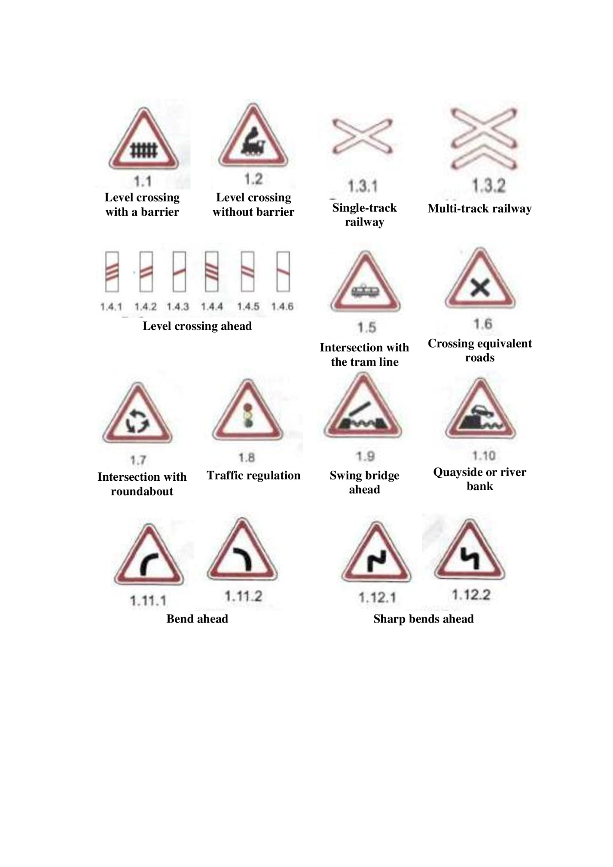
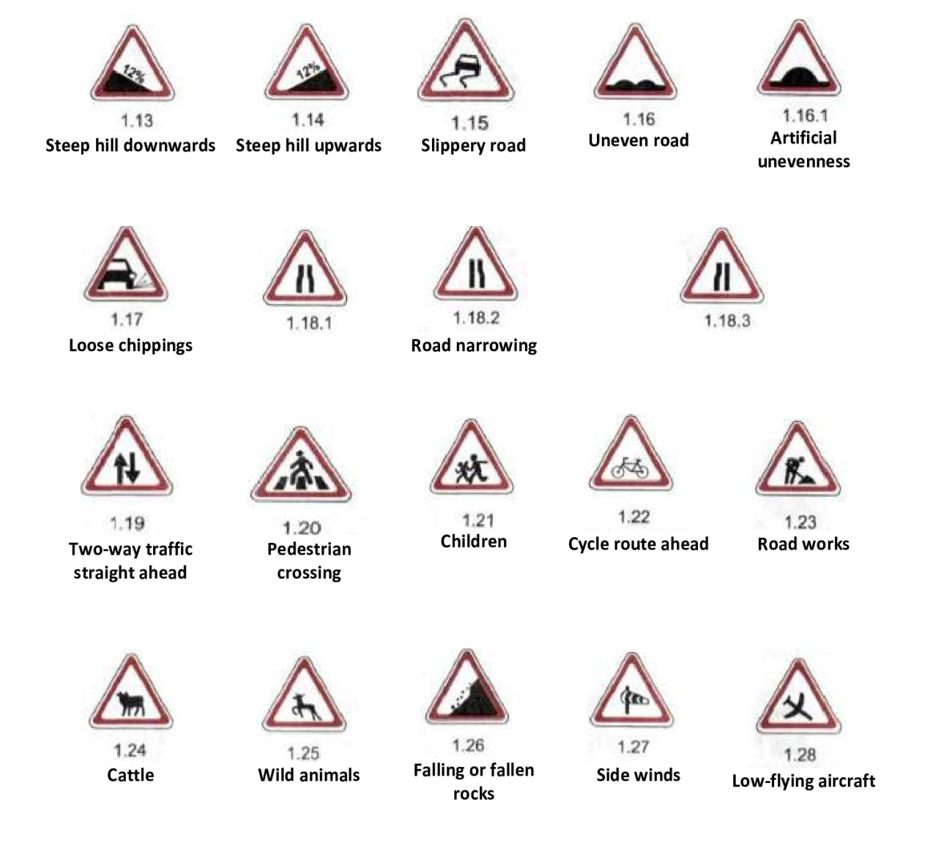
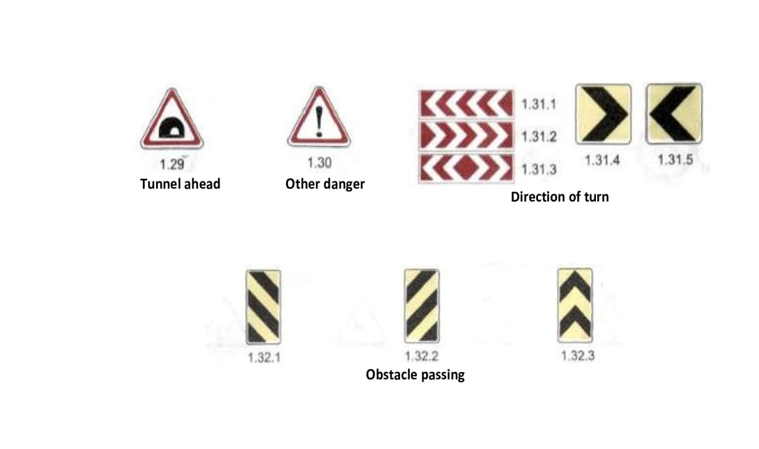

2. SIGNS OF PRIORITY

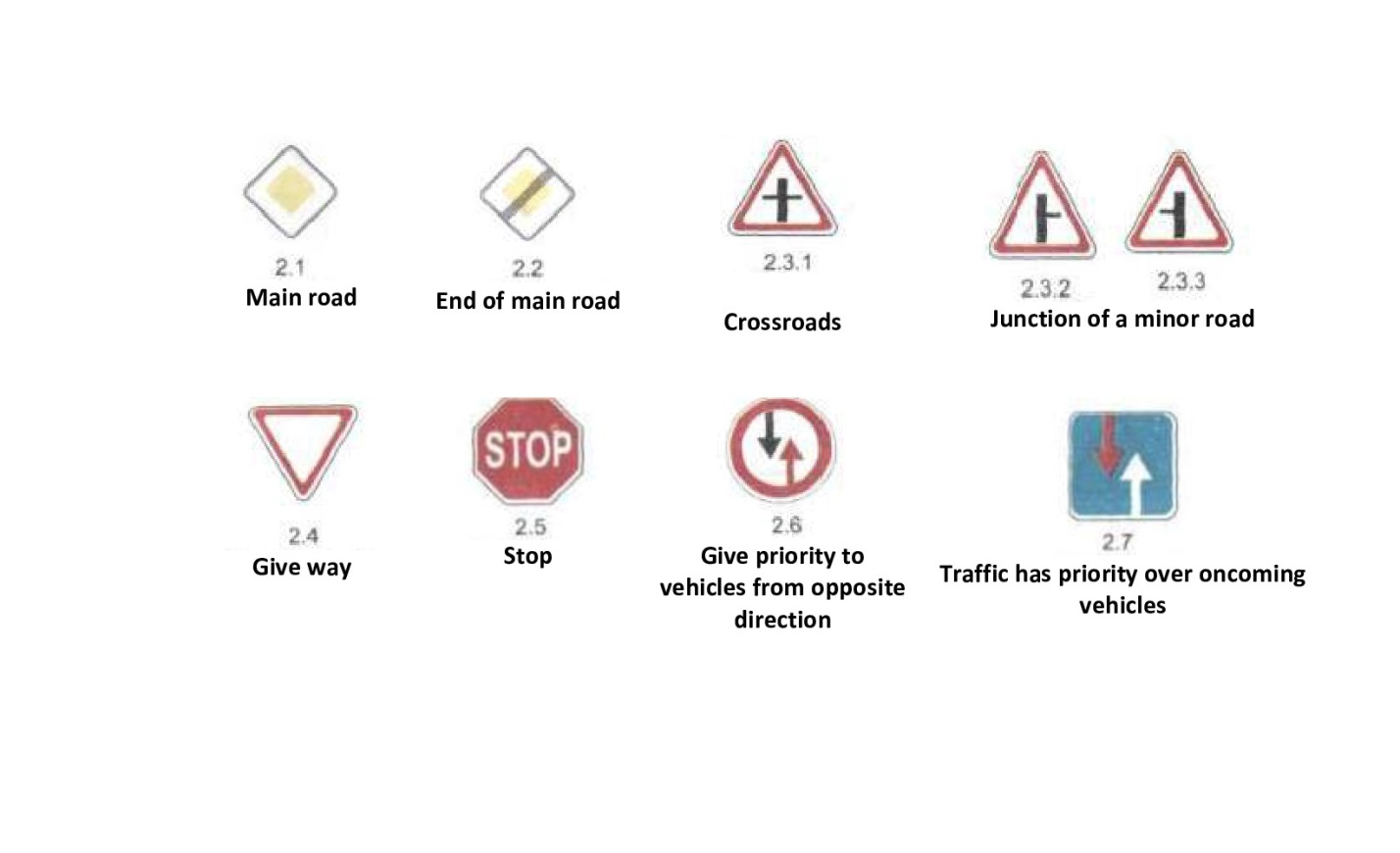

3. PROHIBITION SIGNS

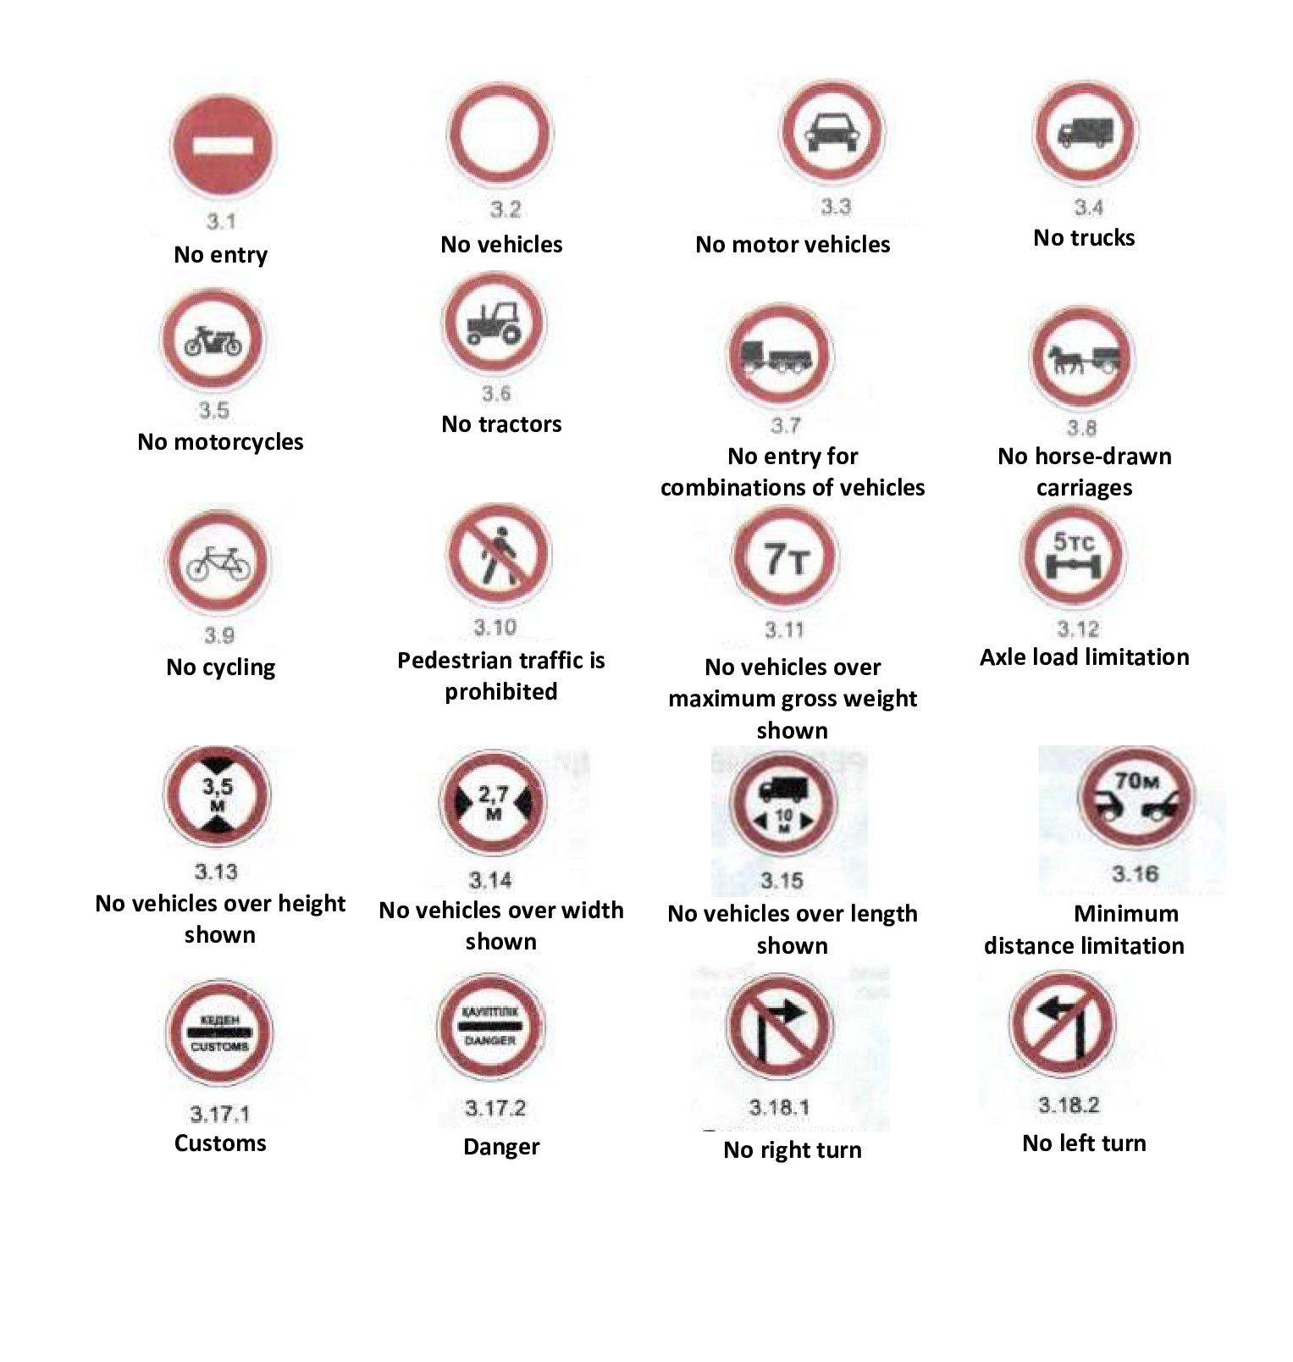

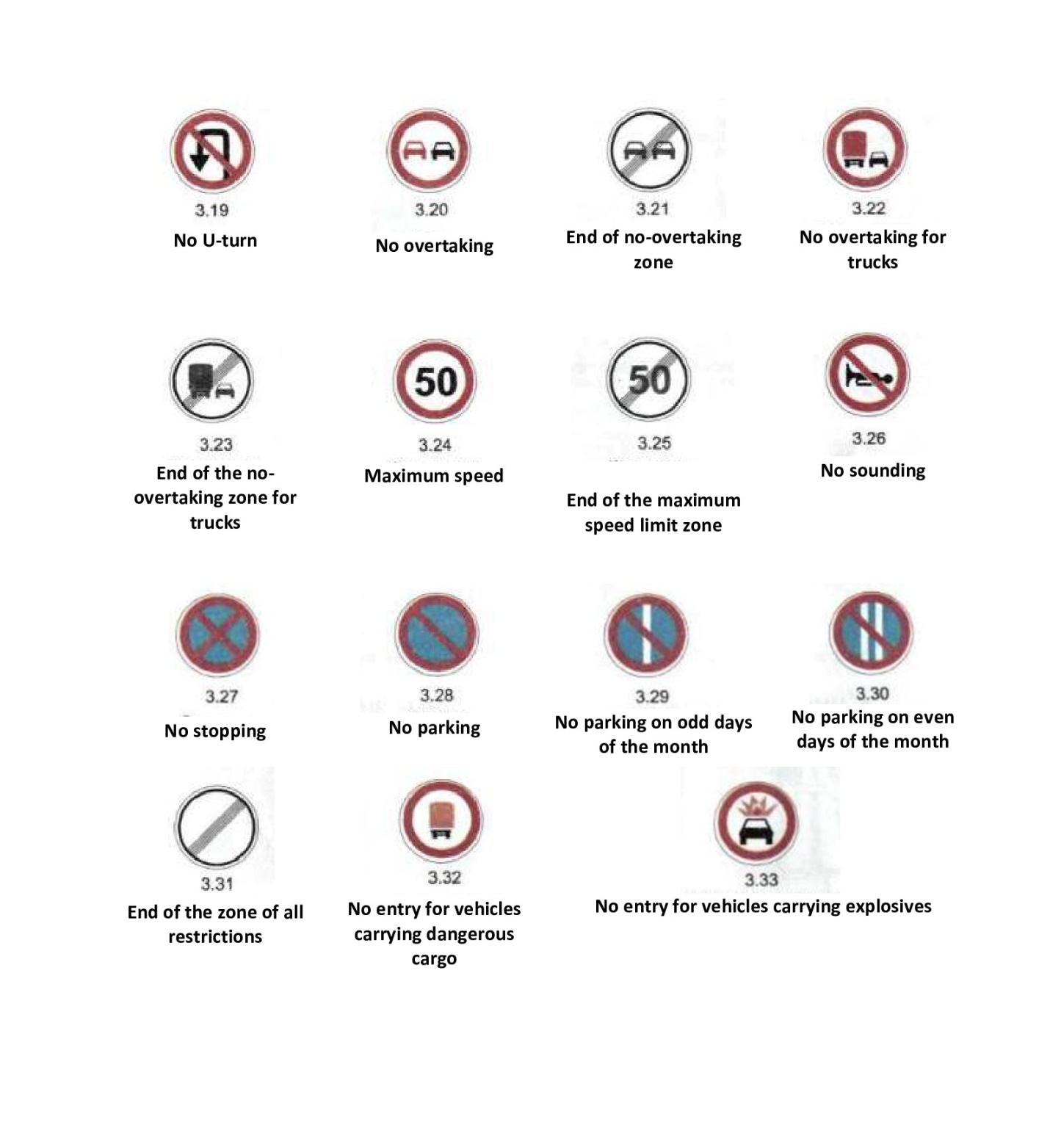

4. MANDATORY SIGNS

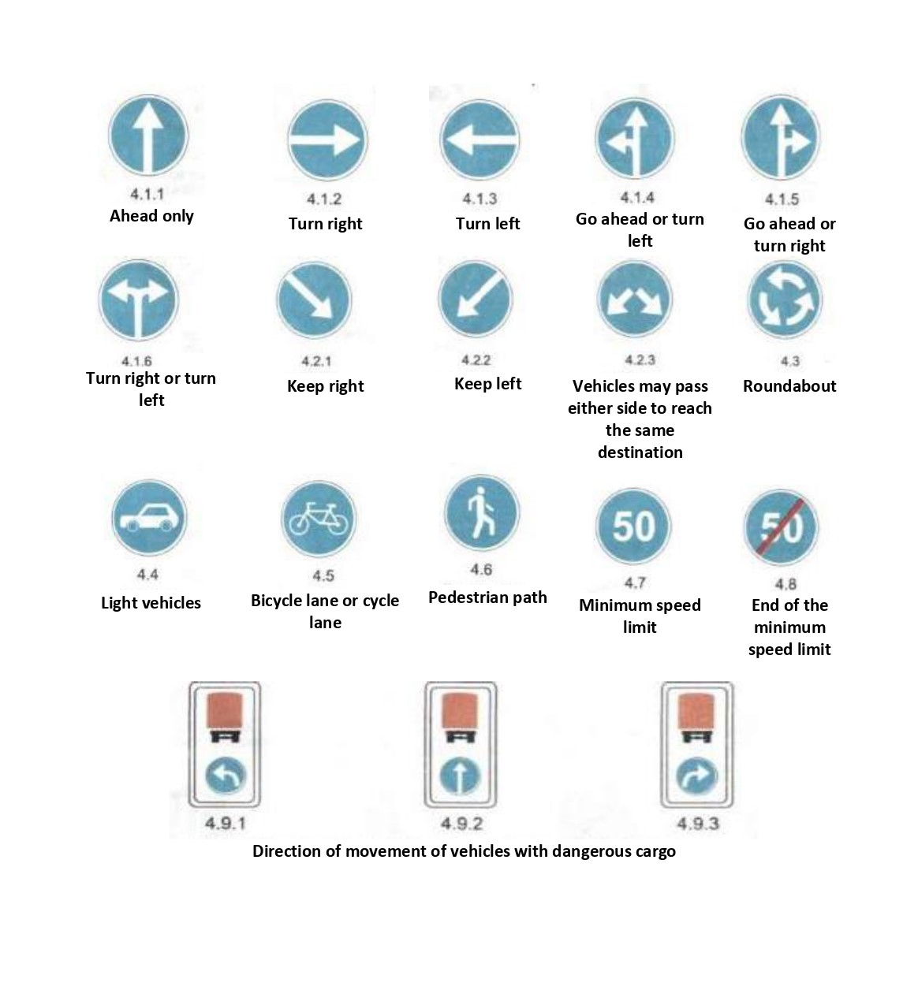

5. INFORMATION AND INSTRUCTION SIGNS

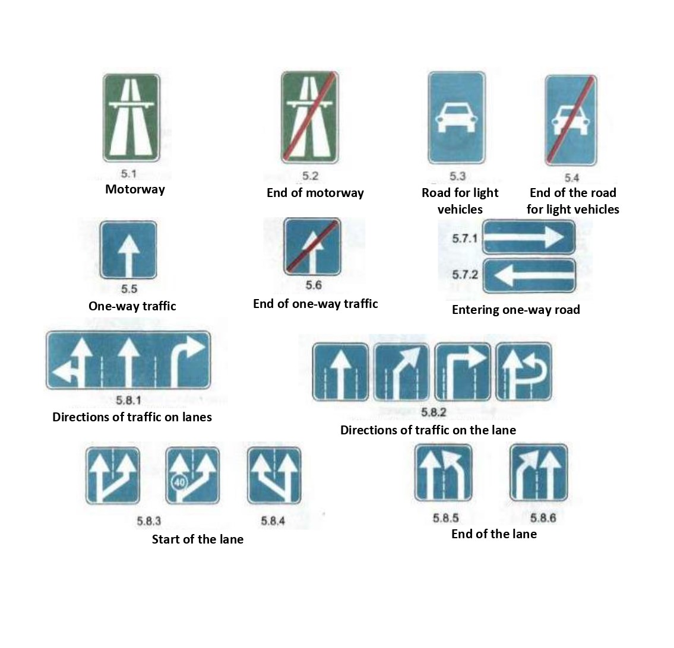

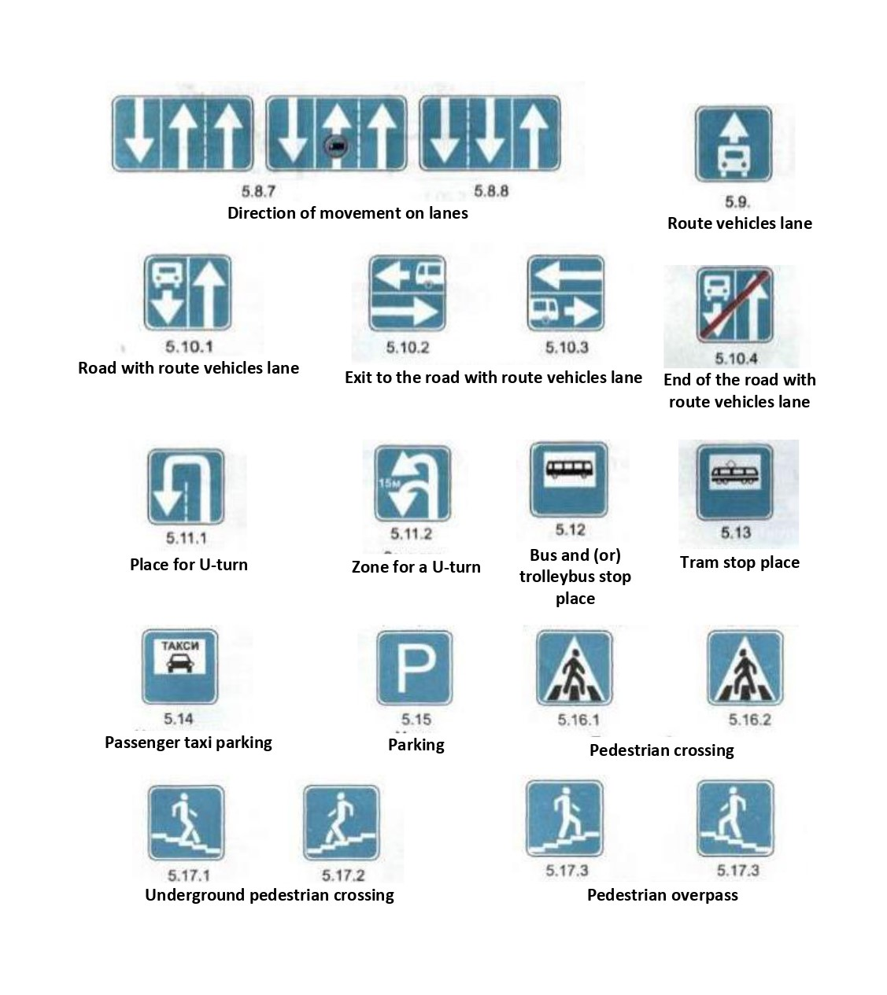

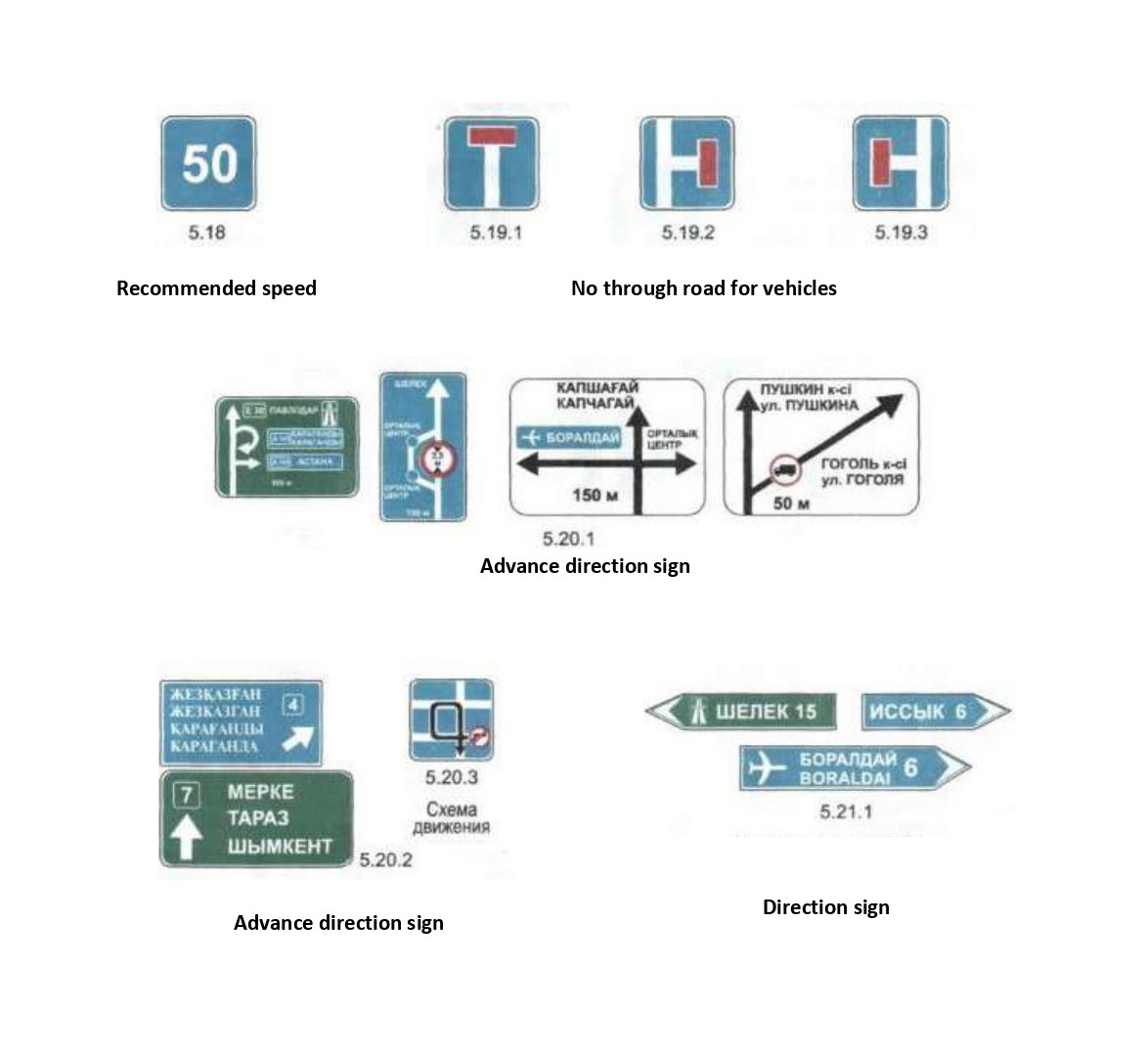

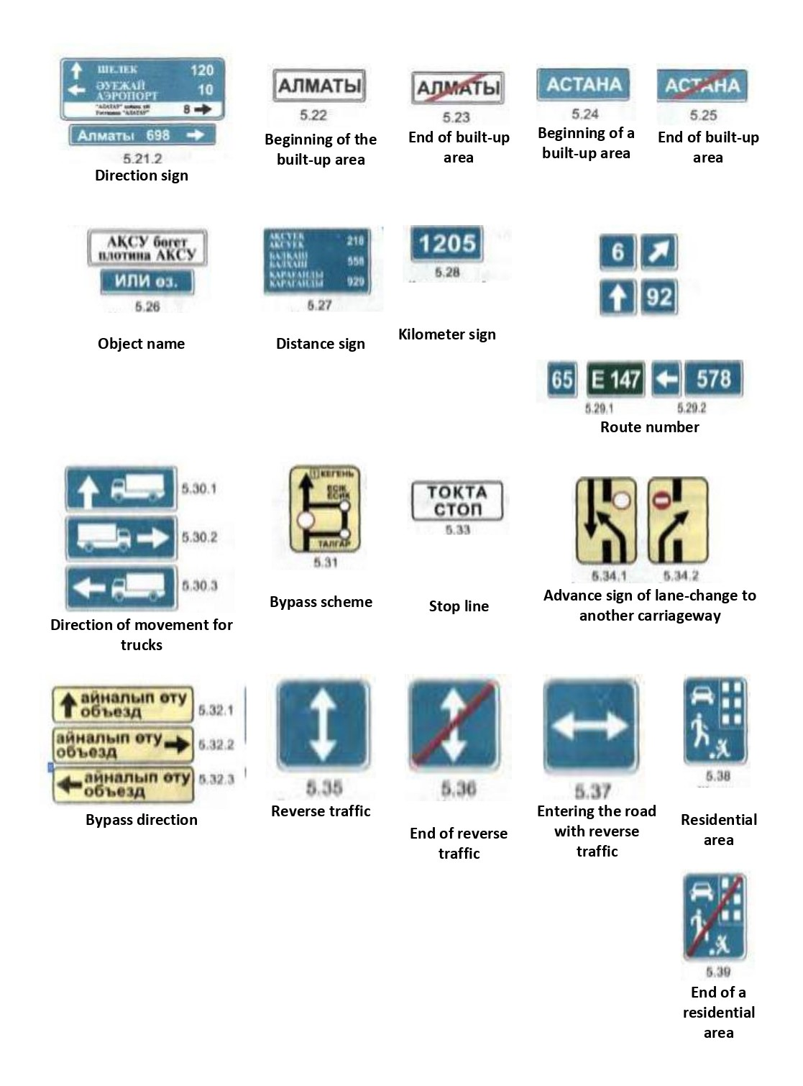

6. SERVICE SIGNS
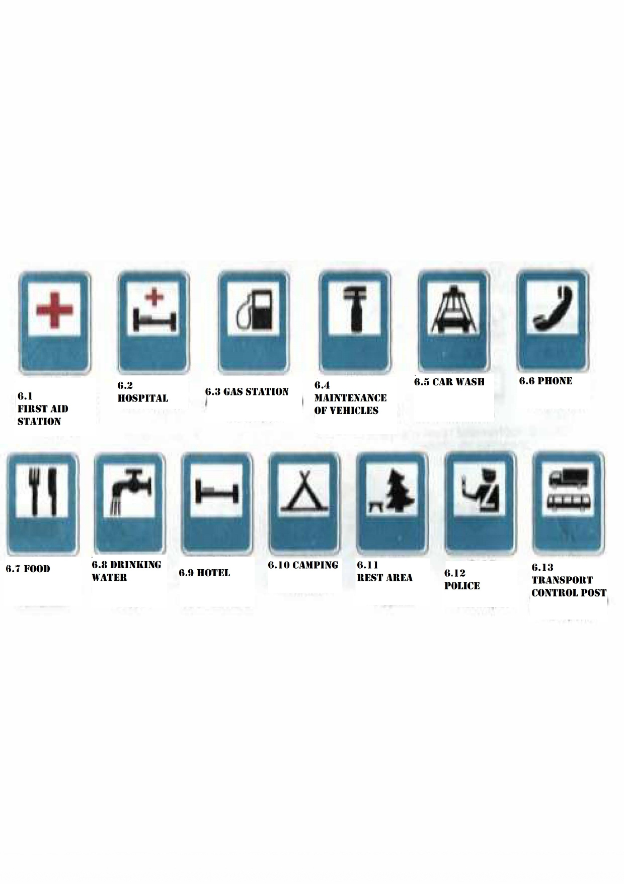

7. SIGNS OF ADDITIONAL INFORMATION

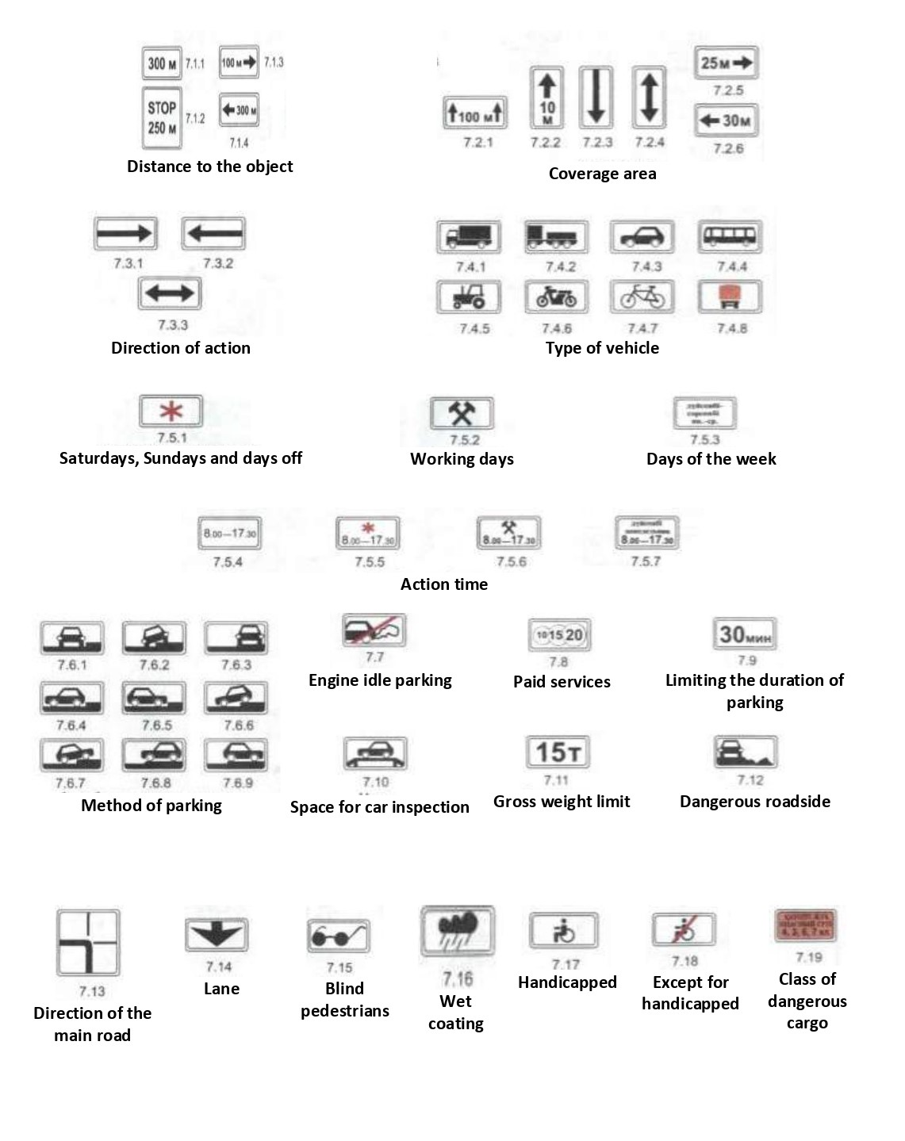

Annex 2
to the Traffic rules
Road marking and its characteristics
(according to ST RK 1124 and ST RK 1412)
Footnote. Annex 2 as amended by Resolution of the Government of the Republic of Kazakhstan dated 02.08.2017 No. 463 (shall come into effect ten calendar days after the day of its first official publication); dated 26.10.2022 No. 850 (shall enter into force upon expiry of ten calendar days after the day of its first official publication).
1. Horizontal markings
Horizontal markings (lines, arrows, inscriptions and other signs on the roadway) shall establish certain modes and order of movement.
The horizontal markings shall be white, except for lines 1.4, 1.10 and 1.17 yellow.
Horizontal markings shall:
1.1 - separate traffic flows of opposite directions and mark the boundaries of traffic lanes in dangerous places on the roads; indicate the boundaries of the carriageway to which entry is prohibited; indicate the boundaries of parking spaces for vehicles and the edge of the carriageway of roads that are not classified as highways (marking numbering corresponds to ST RK 1124. The name and image of road markings are shown in Fig. 3.);
1.2 (wide solid line) - indicate the edge of the carriageway on motorways;
1.3 - separate traffic flows in opposite directions on roads with four lanes or more;
1.4 - indicate places where stopping is prohibited. It shall be used alone or in combination with the sign 3.27 and shall be applied at the edge of the carriageway or along the top of the curb;
1.5 - separate traffic flows of opposite directions on roads with two or three lanes; indicate the boundaries of lanes in the presence of two or more lanes intended for movement in one direction;
1.6 (approach line - a dashed line, in which the length of the strokes is 3 times the gaps between them) - warn of approaching markings 1.1 or 1.11, which separates traffic flows of opposite or passing directions;
1.7 (dashed line with short dashes and equal intervals) - indicate the boundaries of traffic lanes within the intersection;
1.8 (wide dashed line) - indicate the boundary between the acceleration or deceleration lane and the main lane of the carriageway (at intersections, road intersections at different levels, in the area of bus stops, etc.);
1.9 - indicate the boundaries of traffic lanes on which reverse regulation is carried out; separate traffic flows of opposite directions (when reverse traffic lights are off) on roads where reverse regulation is carried out;
Line 1.10 shall not apply to vehicles driven by individuals with disabilities of the first and second groups or transporting individuals with such disability groups, and by taxi with a taxi enabled.
1.11 - separate traffic flows of opposite or passing directions on road sections where lane-change is permitted only from one lane; designate places intended for a U-turn, entry and exit from parking areas and the like, where traffic is permitted only in one direction;
1.12 (stop line) - indicate the place where the driver stops in the presence of a sign 2.5 or with a prohibitory traffic light signal (traffic warden);
1.13 - indicate the place where the driver must, if necessary, stop, giving way to vehicles moving on the crossed road;
1.14.1, 1.14.2 ("zebra") - denote an unregulated pedestrian crossing; marking arrows 1.14.2 indicate the direction of movement of pedestrians; 1.14.3 - indicate a pedestrian crossing where traffic is regulated by a traffic light;
1.15 - indicate the place where the cycle path crosses the carriageway;
1.16.1 - 1.16.3 - designation of guide islands in places: 1.16.1 - separation of traffic flows of opposite directions, 1.16.2 - separation of traffic flows of one direction, 1.16.3 - merging of traffic flows;
1.17- indicate stops of route vehicles and taxi ranks;
1.18 - indicate the directions of traffic permitted at the intersection along the lanes. Used alone or in combination with signs 5.8.1, 5.8.2; dead-end markings are applied to indicate that turning onto the nearest carriageway is prohibited; markings that allow a left turn from the leftmost lane also allow a U-turn;
1.19 - warn of approaching a narrowing of the carriageway (a section where the number of lanes in a given direction decreases) or marking lines 1.1 or 1.11 separating traffic flows in opposite directions. In the first case, marking 1.19 may be used in combination with signs 1.18.1 - 1.18.3;
1.20 - warn about approaching marking 1.13;
1.21 (the inscription "STOP") - warn of approaching the marking 1.12 when it is used in combination with the sign 2.5;
1.22 - indicate the number of the road (route);
1.23 - designate a special lane for route vehicles and other public transport.
Lines 1.1 - 1.3 shall be prohibited to be crossed.
It shall be permitted to cross lines 1.1 and 1.2 to stop the vehicle on the side of the road, and lines 1.1 as an exception when avoiding an obstacle if it is impossible to do it without resorting to this exception.
Line action 1.4. shall not apply to route vehicles.
Lines 1.5-1.8 are permitted to cross from any side.
Line 1.9 in the absence of reversing traffic lights or when they are turned off, it shall be permitted to cross if it is located to the right of the driver; when reversing traffic lights are on - from either side, if it separates the lanes on which traffic shall be permitted in one direction. When reversing traffic lights are turned off, the driver shall immediately change lanes to the right beyond the marking line 1.9.
Line 1.9, which separates traffic flows of opposite directions, shall be prohibited to cross when reverse traffic lights are turned off.
Line 1.10 shall not apply to vehicles driven by handicapped people of groups I and II or carrying such handicapped people, and to taxis with a taximeter turned on.
Line 1.11 shall be permitted to be crossed from the intermittent side, as well as from the solid side, but only when overtaking or bypassing is completed.
In cases where the meanings of temporary road signs placed on a portable stand and marking lines contradict each other, drivers should be guided by the signs.
2. Vertical marking
Vertical marking in the form of a combination of black and white stripes on road structures and elements of road equipment shall show their dimensions and serve as a means of visual orientation.
Vertical marking shall:
2.1 - mean elements of road structures (pillars of bridges, overpasses, end parts of parapets, etc.), when these elements pose a danger to moving vehicles;
2.2 - mean the lower edge of the span of tunnels, bridges and overpasses;
2.3 - mean round bollards installed on traffic lines or safety islands;
2.4 - mean guide posts, gouges, fence supports and the like;
2.5 - mean the side surfaces of road barriers on curves of a small radius, steep slopes, and other dangerous areas;
2.6 - mean the side surfaces of road barriers in other sections;
2.7 - mean curbs in dangerous areas and towering safety islands;
Fig. 3. ROAD MARKING
HORIZONTAL MARKING

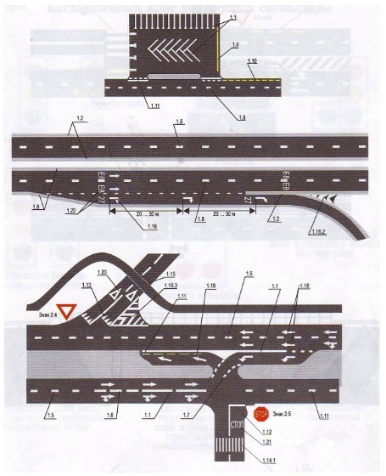

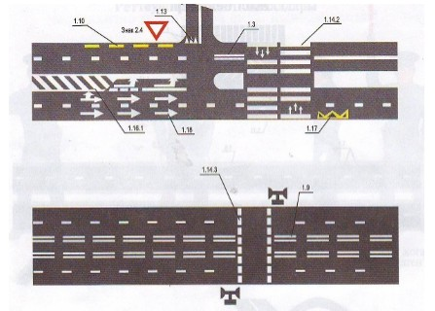

VERTICAL MARKING

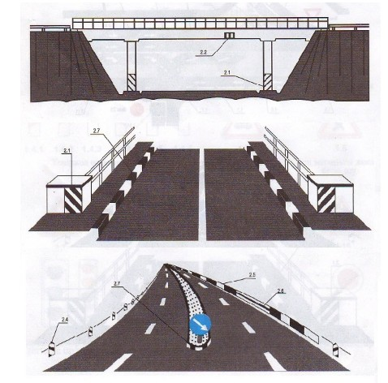

Approved
by Resolution of the Government of the
Republic of Kazakhstan
dated November 13, 2014 No. 1196
Basic regulations for the admission of vehicles to operation
1. The technical condition and equipment of vehicles participating in road traffic in the part related to road traffic safety and environmental protection must meet the requirements of the relevant technical regulations, standards, rules and guidelines for their technical operation.
2. Power-driven vehicles and trailers must be registered with the internal affairs bodies during the period of validity of the registration plate "Transit" or no later than ten days from the date of purchase or customs declaration.
3. On motor vehicles (except for trams and trolleybuses) and trailers, state registration plates must be installed in the places provided in accordance with ST RK 986.
The numbers and letters of registration plates must be repeated on the back wall of the bodies of trucks, trailers (except for trailers for cars and motorcycles) and buses. The height of the digits shall be not less than three hundred millimetres, the width shall be not less than one hundred and twenty millimetres, the thickness of the stroke shall be thirty millimetres, and the size of the letters shall be 2/3 of the size of the digits.
On trams and trolleybuses, registration numbers assigned by the relevant departments shall be applied.
4. In the event of a traffic accident with the occurrence of malfunctions, in which the operation of vehicles is prohibited, a vehicle shall undergo a repeated mandatory technical inspection.
Note. In the event of a traffic accident with the occurrence of malfunctions, in which the operation of vehicles is prohibited, an authorized official of the internal affairs bodies shall send the vehicle for re-passing the mandatory technical inspection.
The fact of passing the mandatory technical inspection of a power-driven vehicle shall be carried out by requesting information to the unified information system of the mandatory technical inspection of power-driven vehicles and their trailers.
5. A truck with an onboard platform used for the transportation of passengers shall be equipped with seats fixed at a height of thirty to fifty centimetres from the floor and at least thirty centimetres from the upper edge of the side, and when transporting children, in addition, the sides must have a height of at least eighty centimetres from floor level.
Seats located along the rear or side walls must have strong backs.
Footnote. Paragraph 5 as amended by Resolution of the Government of the Republic of Kazakhstan dated 23.06.2015 No. 472 (shall come into effect ten calendar days after the day of its first official publication).
6. A power-driven vehicle used for driving training and belonging to an educational organization must be equipped with an additional clutch and brake pedals, an identification mark "Training vehicle", on the side and rear surfaces of such a vehicle the inscription "Training vehicle" shall be applied on the state language.
7. The bicycle must have a working brake, steering wheel and sound signal, equipped with a retroreflector and a lantern or a headlight (for driving at night and conditions of poor visibility) in front of white colour, in the rear - with a retroreflector or a red lantern, and on each side - with a retroreflector orange or red.
8. A horse-drawn carriage must have a serviceable parking brake and wheel chocks provided for by the design, be equipped in front with two retroreflectors or a white lamp (for driving at night and in conditions of insufficient visibility), and in the rear - with two retroreflectors or a red lamp.
9. The following identification signs shall be installed on vehicles:
Note. The names and images of identification marks are shown in Fig. 4.
"Road train" - in the form of three orange lights located horizontally on the roof of the cabin with gaps between them from one hundred and fifty to three hundred millimetres - on trucks and wheeled tractors (class 1.4 and above) with trailers, as well as on articulated buses and trolleybuses. It shall be permitted to use identification signs of a road train in the form of an equilateral triangle of yellow colour (side - two hundred and fifty millimetres) with a device for internal lighting;
Optionally "Studs" - in the form of an equilateral triangle of white colour with the top up with a red border, into which the letter "Ш" is inscribed in black (the side of the triangle shall not be less than two hundred millimetres, the width of the border shall be 1/10 of the side) - behind mechanical vehicles with studded tires;
"Children" - in the form of a yellow square with a red border (side not less than two hundred and fifty millimetres, border width - 1/10 of the side), with a black image of the symbol of road sign 1.21 in front and behind buses or trucks when transporting groups of children;
"Driver with complete hearing loss" - in the form of a yellow circle with a diameter of one hundred and sixty millimeters with applied inside three black circles with a diameter of forty millimeters, located at the corners of an imaginary equilateral triangle, the apex of which faces down - front and rear of motor vehicles driven by drivers with complete loss of speech and hearing, or with complete hearing loss;
"Training vehicle" - in the form of an equilateral triangle of white colour with the top up with a red border, into which the letter "U" is inscribed in black (side - at least two hundred millimetres, border width - 1/10 of the side) - in front and behind mechanical vehicles used for driving training (it shall be permitted to install a two-sided sign on the roof of a car);
"Speed limit" - in the form of a reduced colour image of road sign 3.24 indicating the permitted speed (sign diameter - at least one hundred and sixty millimetres, border width - 1/10 of the diameter) - on the rear side of the body on the left of motor vehicles carrying heavy and large cargo, as well as in cases where the maximum speed of the vehicle according to the technical characteristics is lower than that specified in paragraph 10.3 of the Traffic rules of the Republic of Kazakhstan.
Fig. 4 IDENTIFICATION AND OTHER MARKS

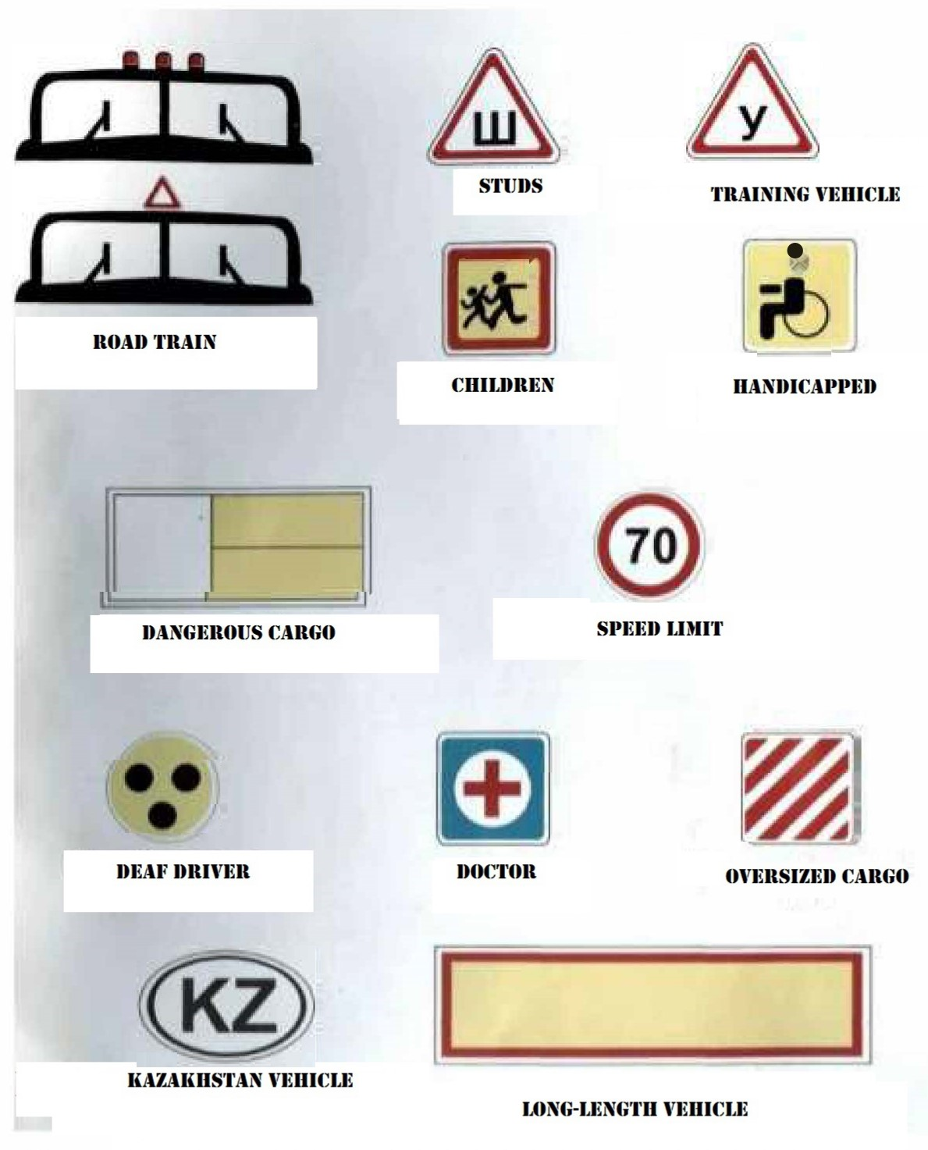

"Dangerous cargo" - in the form of a rectangle with a retroreflective surface that meets the requirements of ST RK GOST R 41.104, 690x300 mm in size, the right side of which is 400x300 mm in size, painted orange, and the left side is white with a black border (width - fifteen millimetres) and symbols characterizing the hazardous properties of the cargo (according to GOST 19433) - in front and behind the vehicles carrying such cargo;
"Oversize cargo" - in the form of a shield measuring 400x400 mm with red and white alternating stripes applied diagonally fifty millimetres wide with a retroreflective surface that meets the requirements of GOST ST RK GOST R 51253 and ST RK GOST R 41.104 - in front, behind and on the side of oversize cargo;
"Long-length vehicle" - in the form of a yellow rectangle with a size of at least 1200x200 mm with a red border (width - forty millimetres), with a retroreflective surface - behind vehicles, the length of which (including one trailer) with or without cargo is more than twenty meters and road trains with two or more trailers. If it is impossible to place a sign of the specified size, it shall be permitted to install two identical signs with a size of at least 600x200 mm symmetrically to the axis of the vehicle;
"An individual with a disability" - in the form of a yellow square with a side of one hundred and fifty millimeters and an image of the symbol of the road mark 7.17 in black - in front and rear of motor vehicles driven by individuals with disabilities of the first and second groups or transporting individuals with such disability groups.
Optionally, an identification sign "Doctor" may be installed - in the form of a blue square (side - one hundred and forty millimetres) with an inscribed white circle (diameter - one hundred and twenty-five millimetres), on which a red cross is applied (height - ninety millimetres, stroke width - twenty-five millimetres) - in front and behind a car driven by a doctor - driver.
Footnote. Paragraph 9 as amended by Resolution of the Government of the Republic of Kazakhstan dated 10.21.2017 No. 667 (shall come into effect ten calendar days after the day of its first official publication); dated 26.10.2022 No. 850 (shall enter into force upon expiry of ten calendar days after the day of its first official publication).
10. The emergency stop sign must comply with the requirements of GOST 24333. The flashing red colour emitted by the lamp used in accordance with the requirements of section 7 of the Traffic rules of the Republic of Kazakhstan must be well distinguished during the day in sunny weather and conditions of poor visibility.
11. In cases where the distinguishing sign of the vehicle of the Republic of Kazakhstan "KZ" is placed separately from the state registration plate, it must meet the following requirements: the letters must be at least eighty millimetres high and marked with strokes at least ten millimetres wide. The letters must be black on a white background, shaped like an ellipse, the main axis of which is horizontal. The white background may be made of reflective material. The sign is glued or installed on the rear window in the upper right corner of cars, minibuses and buses, and for other vehicles - on the rear panel in the right part - in the middle.
12. Warning devices for designating flexible connecting links when towing motor vehicles must be made in the form of flags or shields measuring 200x200 mm with red and white alternating stripes fifty millimetres wide with a retroreflective surface applied diagonally on both sides.
At least two warning devices must be installed on the flexible link.
13. The design of a rigid towing device must comply with the requirements of GOST 25907.
14. The operation of vehicles shall be prohibited in the following cases:
1) the presence of technical malfunctions and conditions that pose a threat to road safety and the environment, their non-compliance with technical regulations, standards, rules and guidelines for their technical operation, as well as their re-equipment without appropriate approval;
2) excluded by Resolution of the Government of the Republic of Kazakhstan dated June 23, 2015 No. 472 (shall come into effect ten calendar days after the day of its first official publication);
3) non-compliance of the numbers of units and assemblies installed on the vehicle with the data entered in the registration documents for the vehicle, and also if the units and units installed on the vehicle have hidden, fake and changed numbers;
4) lack of registration documents;
5) failure to pass the mandatory technical inspection, except for vehicles of category M1, the age of which does not exceed seven years, including the year of manufacture, not used in business activities in the field of road transport;
6) the absence of state registration plates or their non-compliance with the established requirements and registration documents;
7) failure to agree on compulsory insurance of civil liability of vehicle owners and (or) an agreement on compulsory insurance of civil liability of a carrier to passengers.
The fact of concluding a contract of compulsory insurance of civil liability of vehicle owners and (or) a contract of compulsory insurance of civil liability of the carrier to passengers is confirmed by requesting officials to a single insurance database;
8) excluded by Resolution of the Government of the Republic of Kazakhstan dated 21.10.2017 No. 667 (shall come into effect ten calendar days after the day of its first official publication);
9) if their technical condition and equipment do not meet the requirements of the list of malfunctions and conditions under which the operation of vehicles is prohibited (according to Annex);
10) driving a car with a trailer that is not intended for movement in combination with it;
11) the presence of technical malfunctions of rail vehicles that pose a threat to road safety, as well as if their technical condition and equipment do not meet the requirements of the Rules for the technical operation of rail vehicles approved by the authorized body in the field of transport and communications;
12) equipping vehicles with special light and sound signals and painting according to special colour and graphic schemes, not included in the list of operational and special services, the transport of which is subject to equipment with special light and sound signals and painting according to special colour and graphic schemes, approved by the Government of the Republic of Kazakhstan;
13) installation of state registration plates of a vehicle in places not provided for by the requirements of the legislation of the Republic of Kazakhstan in the field of road traffic;
14) the absence of the "Dangerous goods" sign in front and behind the vehicles carrying dangerous goods.
Footnote. Paragraph 14 as amended by Resolutions of the Government of the Republic of Kazakhstan dated 06.23.2015 No. 472 (shall come into effect ten calendar days after the day of its first official publication); dated 21.10.2017 No. 667 (shall come into effect upon the expiration of ten calendar days after the day of its first official publication); dated November 16, 2018 No. 749 (shall come into effect from January 1, 2019).
15. Officials and other persons responsible for the technical condition and operation of vehicles shall be prohibited from:
1) allowing to operation the vehicles that have malfunctions with which their operation is prohibited, or converted without an appropriate permit, or not registered in the prescribed manner, or that have not passed a mandatory technical inspection, as well as owners who, in cases established by law, have not concluded a contract for mandatory liability insurance of vehicle owners and/or an agreement on compulsory insurance of the carrier's liability to passengers;
2) allowing drivers who are in a state of intoxication (alcoholic, narcotic or otherwise) to drive vehicles, under the influence of drugs that impair reaction and attention, in a sick or tired state that jeopardizes traffic safety, or persons who do not have the right to drive the vehicle of this category;
3) directing tractors and caterpillar self-propelled vehicles to drive on asphalt and cement concrete roads.
Note. The text of the Basic regulations for the admission of vehicles to operation uses the terminology established by the Traffic rules of the Republic of Kazakhstan.
Annex
to the Basic regulations for the
admission of vehicles for operation
LIST
of malfunctions and conditions that pose a threat to road
safety and the environment, under which the
operation of vehicles shall be prohibited
This list shall establish malfunctions of cars, buses, road trains, trailers, motorcycles, mopeds, tractors, and self-propelled machines and the conditions under which their operation shall be prohibited. Methods for checking the given parameters shall be regulated by the relevant technical regulations, standards, rules and manuals for their technical operation.
1. Brake systems
During road tests, the standards of braking efficiency of the service brake system, given in the table, are not observed:
 |  |  | Table
Vehicles | Category of vehicle  (tow car as part of a road train) | Braking distance,  m,  no more than | steady state deceleration,  m/s2, no less
Passenger and  cargo-passenger  cars | M 1 * | 14.7 | 5.8
 | M 2, M 3 | 18.3 | 5.0
Light vehicles with a trailer | M 1 | 14.7 | 5.8
Cargo vehicles | N 1 N 2, N 3 | 18.3 | 5.0
Cargo vehicles with a trailer  (semi-trailer) | N 1 N 2, N 3 | 19.5 | 5.0
Notes.
1. Tests shall be carried out on a horizontal section of the road with a smooth, dry, clean cement or asphalt concrete surface at a speed at the beginning of braking of 40 km/h for cars, buses and road trains, and 30 km/h for motorcycles and mopeds. Vehicles shall be tested by a single impact on the control of the service brake system. The mass of the vehicle during the tests shall not exceed the permitted maximum mass.
2. The efficiency of the service brake system of vehicles may also be assessed by other signs in accordance with ST RK GOST R 51709.
3. "*" Hereinafter, the categories of vehicles are specified in Annex A to ST RK GOST R 51709.
2. The tightness of the hydraulic brake drive is broken.
3. Violation of the tightness of the pneumatic and pneumohydraulic brake actuators causes a drop in air pressure with the engine off by more than 0.05 MPa (0.5 kgf/cm 2) in 15 minutes after they are fully activated.
4. The pressure gauge of the pneumatic and pneumohydraulic brake drives does not work.
5. The parking brake system does not provide a stationary state:
1) vehicles with a full load - on a slope up to 16% inclusive;
2) cars and buses in running order - on a slope of up to 23% inclusive;
3) trucks and road trains in running order - on a slope of up to 31% inclusive.
2. Steering
1. The total play in the steering exceeds the following values:
Vehicle type  Passenger cars and trucks based on them and  buses 10  Buses 20  Trucks 25 | Total backlash (degrees), no more
2. There are movements of parts and assemblies not provided for by the design; threaded connections are not tightened or not secured in the prescribed manner.
3. The power steering or steering damper (for motorcycles) is defective or missing.
3. External lights
1. Quantity, type, colour, location and mode of operation of external lighting devices do not meet the requirements of the vehicle design.
Note. On vehicles discontinued from production, it shall be permitted to install external lighting devices from vehicles of other brands and models.
2. The headlight adjustment does not meet the requirements.
3. External lights and retroreflectors do not work in the prescribed mode or are dirty.
4. There are no diffusers on the lighting devices or diffusers and lamps are used that do not correspond to the type of this lighting device.
5. Installation of rotating beacons does not meet the requirements of the standard.
6. Lighting devices with red lights or red reflectors are installed in front of the vehicle, and white in the back, except for reversing lights and registration plate lighting, retroreflective registration, distinctive and identification marks.
4. Windshield wipers and windshield washers
1. Windshield wipers do not work in the set mode.
2. The windshield washers provided for by the design of the vehicle do not work.
5. Wheels and tires
1. Car tires have a residual tread height of less than 1.6 mm, trucks - 1 mm, buses - 2 mm, motorcycles and mopeds - 0.8 mm.
Note. For trailers, standards for the residual height of the tire tread pattern are established, similar to the standards for tires of tractor vehicles.
2. Tires have local damage (punctures, cuts, ruptures), exposing the cord, as well as delamination of the carcass, delamination of the tread and sidewall.
3. The fastening bolt (nut) is missing or there are cracks in the disk and wheel rims.
4. Tires in size or load capacity do not match the vehicle model.
5. Tires of various sizes, designs (radial, diagonal, chamber, tubeless), models, with different tread patterns, studded and non-studded, frost-resistant and non-frost-resistant, new and restored are installed on one axle of vehicles.
6. On the front axle of an intercity bus (class II**) and a long-distance bus (class III), retreaded tires are installed, and on other axles - tires retreaded according to the second repair class.
Note: "**" Hereinafter, the classes of buses are specified in Annex A to ST RK GOST R 51709.
7. On the front axle of a passenger car and a city bus (class I), tires retreaded according to the second repair class are installed.
6. Engine
1. The content of harmful substances in exhaust gases and their opacity exceeds the norms established by technical regulations and standards.
2. The tightness of the power supply system is broken.
3. The system of release of the fulfilled gases is defective.
4. The tightness of the crankcase ventilation system is broken.
7. Other structural elements
1. There are no rear-view mirrors provided for by the design of the vehicle or their equipment does not meet the requirements established by ST RK GOST R 51709.
2. There are no windows and sun visors provided for by the design of the vehicle.
3. The does not work or the klaxon horn with the changing basic frequency is set.
4. Additional objects have been installed that restrict visibility from the driver's seat (except for rear-view mirrors, windshield wiper parts, radio antennas external and applied or built into the glass, heating elements for defrosting and windshield dehydration devices), entailing the risk of injury to road users.
Coatings have been applied or transparent coloured films have been glued on the windshields and (or) front side windows of the cab (passenger cabin) of a power-driven vehicle.
Note. On the upper part of the windshield, it shall be permitted to use a strip of a transparent colour film with a width of not more than 140 mm, and on vehicles of categories M3, N2, N3 - with a width not exceeding the minimum distance between the upper edge of the windshield and the upper boundary of its cleaning zone with a wiper. It shall be permitted to use curtains on the windows of buses, as well as blinds and curtains on the rear windows of cars.
Footnote. Paragraph 4 as amended by Resolution of the Government of the Republic of Kazakhstan dated 10.21.2017 No. 667 (shall come into effect ten calendar days after the day of its first official publication).
5. The presence of cracks on the windshield of a motor vehicle in the zone of cleaning with a wiper half of the glass located on the driver's side.
6. The body or cabin door locks provided for by the design, the locks of the sides of the cargo platform, the locks of the tank necks and the fuel tank plugs, the adjustment mechanism and the locking devices of the driver and passengers seats, the emergency door switch and the stop request signal on the bus, the emergency exits of the bus and devices for driving them, devices for interior lighting of the passenger compartment, a door control drive and an alarm for their operation, a speedometer, a tachograph, anti-theft devices, glass heating and blowing devices do not work in the prescribed manner.
7. No rear guard, mud guards or mud flaps provided for by design.
8. The towing and coupling devices of the tractor and the trailer link are defective, and the safety cables (chains) provided for by their design are missing or defective. There are backlashes in the connections of the motorcycle frame with the frame of the side trailer.
9. Not available:
1) a first-aid kit, a fire extinguisher, an emergency stop sign (a flashing red light on a bus, car and truck, wheeled tractors);
2) wheel chocks (at least two) on trucks with a maximum permitted weight of more than 3.5 tons and buses;
3) a first-aid kit, an emergency stop sign (flashing red light) on a motorcycle with a side trailer;
4) marking with retroreflective material that meets the requirements of ST RK GOST R 51253 and ST RK GOST R 41.104 of vehicles of categories M2, M3, N2, N3, 02, 03, 04 in accordance with GOST 22895.
Note. The minimum content of medicines and medical products in a first-aid kit shall be established by the Ministry of Health and Social Development of the Republic of Kazakhstan.
10. On vehicles that are not included in the list of operational and special services, with the transport subject to be equipped with special light and sound signals and painting according to special colour and graphic schemes, flashing light signals of red and blue colours are used, regardless of their location, or sound signals with alternating tones, or special colour schemes used on vehicles of operational and special services*.
11. There are no seat belts if their installation is provided for by the vehicle design.
12. Seat belts are inoperable or have visible tears on the strap.
13. The registration plate of the vehicle does not meet the requirements of the standard.
14. There are no safety bars on the motorcycle.
15. On motorcycles and mopeds there are no footrests, or transverse handles for passengers on the saddle provided for by the design.
16. There are no additional elements of brake systems, steering and other components and assemblies provided for by the design or installed without agreement with the vehicle manufacturer or other authorized organization, the requirements for which are regulated by this list.
17. Re-equipment of vehicles was carried out in violation of the requirements provided for in the field of technical regulation.
Re-equipment of vehicles of categories M1, M2, M3, associated with the installation (dismantling) of seats, the organization of sleeping places and cargo compartments, was carried out.
Re-equipment of vehicles of categories N1, N2, N3, associated with the transfer to the categories M2 and M3, was carried out.
For category M1, re-equipment associated with a decrease in the number of seats shall be permitted.
For category M1, M2, re-equipment associated with their transfer to categories N1, N2 shall be permitted.
Note: re-equipment (change in design) of vehicles, means - the exclusion of components and items of equipment that are not provided for by the design of the vehicle and that affect road safety.
Footnote. Paragraph 17 as amended by Resolution of the Government of the Republic of Kazakhstan dated 10.21.2017 No. 667 (shall come into effect ten calendar days after the day of its first official publication).
18. Elements (devices) are installed on the state registration plates to hide the alphabetic and numeric designations of the registration plate.
Footnote. Paragraph 18 as amended by Resolution of the Government of the Republic of Kazakhstan dated 10.21.2017 No. 667 (shall come into effect ten calendar days after the day of its first official publication).
Approved
by Resolution of the Government of the
Republic of Kazakhstan
dated November 13, 2014 No. 1196
List
of operational and special services, with the transport subject to be
equipped with special light and sound signals
and painting according to special colour schemes
Footnote. The list as amended by the Resolutions of the Government of the RK dated 23.06.2015 No. 472 (shall come into effect ten calendar days after the day of its first official publication); dated 10.21.2017 No. 667 (shall come into effect ten calendar days after the day of its first official publication); dated 28.04.2021 No. 275 (shall come into effect ten calendar days after its first official publication); dated 17.02.2023 No. 138 (shall enter into force upon expiry of ten calendar days after the day of its first official publication).
1. State Security Service of the Republic of Kazakhstan.
2. Operational services of the national security bodies of the Republic of Kazakhstan.
3. Operational services of the internal affairs bodies of the Republic of Kazakhstan.
4. Operational services of bodies in the field of civil protection of the Republic of Kazakhstan.
5. Bodies of the military police.
6. Emergency services.
7. Ambulance service.
8. Mobile emergency response teams of private security organizations.
9. Mobile checkpoints of transport control bodies.
10. Department of Special Prosecutors of the General Prosecutor's Office of the Republic of Kazakhstan.
11. Operational divisions of the economic investigation service.
12. Operational services of the anti-corruption service.
13. Collection services.
14. Vehicles accompanying organized groups of cyclists.
15. State courier service of the Republic of Kazakhstan.
16. Vehicles of subdivisions of the Committee for Forestry and Wildlife of the Ministry of Ecology, Geology and Natural Resources of the Republic of Kazakhstan.
17. Vehicles of territorial divisions of the Fisheries Committee of the Ministry of Ecology and Natural Resources of the Republic of Kazakhstan.
Notes:
1. Colour scheme, identification marks, inscriptions, and installation of special light and sound signals shall be regulated by the standard of the Republic of Kazakhstan.
2. Vehicles of the State Security Service, operational services of national security bodies, internal affairs bodies, Economic Investigation Service, Anti-Corruption Service, Department of Special Prosecutors of the Prosecutor General's Office of the Republic of Kazakhstan, State Courier Service of the Republic of Kazakhstan, subdivisions of the Forestry and Wildlife Committee of the Ministry of Ecology and Natural Resources of the Republic of Kazakhstan, territorial divisions of the Fisheries Committee of the Ministry of Ecology and Natural Resources of the Republic of Kazakhstan may not have special color markings, identification marks and inscriptions.
3. The assignment of vehicles to mobile emergency response teams of private security organizations with the possibility of equipping them with the special colour scheme, identification marks, inscriptions, and light and sound signals shall be carried out after receiving supporting documents from the authorized body exercising state control over the subjects involved in security activities.
4. Admission to the installation of special light and sound signals and colouring according to special colour schemes of vehicles escorting organized groups of cyclists shall be carried out by the internal affairs bodies by making an appropriate entry in the "Special Marks" column of the vehicle registration certificate.
Annex
to Resolution of the Government of the
Republic of Kazakhstan
dated November 13, 2014 No. 1196
List of some terminated decisions of the Government of the Republic of Kazakhstan
1. Resolution of the Government of the Republic of Kazakhstan dated November 25, 1997 No. 1650 "On approval of the Traffic rules of the Republic of Kazakhstan, the Basic regulations for the admission of vehicles to operation and the duties of officials and road users to ensure road safety and the List of operational and special services, with the transport subject to be equipped with special light and sound signals and painting according to special colour schemes.
2. Resolution of the Government of the Republic of Kazakhstan dated May 26, 1999 No. 643 "Certain issues of regulation of motor vehicles on the territory of the Republic of Kazakhstan" (CAPG of the Republic of Kazakhstan, 1999, No. 22, Art. 219).
3. Resolution of the Government of the Republic of Kazakhstan dated December 19, 2002 No. 1329 "Some issues of ensuring road safety" (CAPG of the Republic of Kazakhstan, 2002, No. 45, Art. 453).
4. Resolution of the Government of the Republic of Kazakhstan dated January 30, 2004 No. 115 "On introducing amendments and additions to the Resolution of the Government of the Republic of Kazakhstan dated November 25, 1997 No. 1650" (CAPG of the Republic of Kazakhstan, 2004, No. 4, Art. 64).
5. Resolution of the Government of the Republic of Kazakhstan dated October 12, 2005 No. 1021 "On introducing amendments and additions to the Resolution of the Government of the Republic of Kazakhstan dated November 25, 1997 No. 1650" (CAPG of the Republic of Kazakhstan, 2005, No. 37, Art. 525).
6. Resolution of the Government of the Republic of Kazakhstan dated January 9, 2007 No. 6 "On introducing additions to the Resolution of the Government of the Republic of Kazakhstan dated November 25, 1997 No. 1650" (CAPG of the Republic of Kazakhstan, 2007, No. 1, Art. 9).
7. Resolution of the Government of the Republic of Kazakhstan dated May 25, 2007 No. 420 "On introducing additions and amendments to the Resolution of the Government of the Republic of Kazakhstan dated November 25, 1997 No. 1650" (CAPG of the Republic of Kazakhstan, 2007, No. 17, Art. 187).
8. Resolution of the Government of the Republic of Kazakhstan dated January 26, 2009 No. 47 "On introducing amendments and additions to the Resolution of the Government of the Republic of Kazakhstan dated November 25, 1997 No. 1650" (CAPG of the Republic of Kazakhstan, 2009, No. 5, Art. 18).
9. Resolution of the Government of the Republic of Kazakhstan dated October 26, 2009 No. 1682 "On introducing amendments to the Resolutions of the Government of the Republic of Kazakhstan dated November 25, 1997 No. 1650 and January 9, 2007 No. 6" (CAPG of the Republic of Kazakhstan, 2009, No. 46, Art. 433).
10. Resolution of the Government of the Republic of Kazakhstan dated December 7, 2011 No. 1479 "On introducing amendments and additions to the Resolution of the Government of the Republic of Kazakhstan dated November 25, 1997 No. 1650 "On approval of the Traffic rules of the Republic of Kazakhstan, the Basic regulations for the admission of vehicles to operation and obligations officials and road users to ensure road safety and the List of operational and special services, with the transport subject to be equipped with special light and sound signals and painting according to special colour and graphic schemes" (CAPG of the Republic of Kazakhstan, 2012, No. 6, Art. 130).
11. Resolution of the Government of the Republic of Kazakhstan dated July 10, 2013 No. 709 "On introducing additions and amendments to the Resolution of the Government of the Republic of Kazakhstan dated November 25, 1997 No. 1650 "On approval of the Traffic rules of the Republic of Kazakhstan, the Basic regulations for the admission of vehicles to operation and obligations officials and road users to ensure road safety and the List of operational and special services, with the transport subject to be equipped with special light and sound signals and painting according to special colour and graphic schemes" (CAPG of the Republic of Kazakhstan, 2013, No. 40, Art. 604).

© 2012. «Institute of legislation and legal information of the Republic of Kazakhstan» of the Ministry of Justice of the Republic of Kazakhstan

