On some issues of special economic zones
Unofficial translation
Resolution No. 624 of the Government of the Republic of Kazakhstan dated October 6, 2017.
Unofficial translation
In accordance with subparagraph 2) of Article 10 of the Law of the Republic of Kazakhstan dated April 3, 2019 "On Special Economic and Industrial Zones", the Government of the Republic of Kazakhstan HEREBY RESOLVES:
Footnote. Preamble as amended by Resolution of the Government of the Republic of Kazakhstan dated May 22, 2019 No. 307.
1. The Khorgos International Centre of Boundary Cooperation special economic zone (hereinafter referred to as SEZ) shall be established for the period up to 2041.
2. To approve the attached:
1) Regulations on SEZ "Seaport Aktau" and its target indicators;
2) Regulations on SEZ "Ontustik" and its target indicators;
3) Regulation on SEZ "Pavlodar" and its target indicators;
4) Regulations on the SEZ "International Center for Border Cooperation" Khorgos" and its target indicators.
Footnote. Paragraph 2 - as amended by the Resolution of the Government of the Republic of Kazakhstan dated 14.08.2021 No. 558.
3. Ceased to be valid by the Resolution of the Government of the Republic of Kazakhstan dated 04.12.2018 No. 802.
4. This decree is put into effect from the date of its signing.
Prime Minister
of the Republic of Kazakhstan | B. Sagintayev
Approved by No. 624
Decree of the Government of the
Republic of Kazakhstan
dated October 6, 2017
PROVISION
on Aktau Seaport special economic zone 1. General regulations
1. The special economic zone "Seaport Aktau" (hereinafter referred to as the SEZ) is located on the territory of the Mangystau region within the administrative-territorial boundaries of the city of Aktau, Munailinsky, Karakiyansky and Tupkaragansky districts of the Mangystau region according to the attached plan.
SEZ is a port special economic zone.
The territory of the SEZ is 2322,1719 hectares and is an integral part of the territory of the Republic of Kazakhstan.
Footnote. Paragraph 1 - as amended by the Resolution of the Government of the Republic of Kazakhstan dated February 10, 2023 No. 107.
2. SEZ shall be created to accelerate the development of the region to enhance the entry of the republic's economy into the system of world economic relations, the creation of highly efficient, including high-tech and competitive industries, the development of new types of products, attracting investments, improving the legal norms of market relations, introducing modern management methods and management, increasing the tourism potential of the region and developing a highly efficient, competitive tourism infrastructure that can provide and satisfy the needs of arriving Kazakhstani and foreign tourists, as well as solving social problems.
Footnote. Paragraph 2 as amended by the Resolution of the Government of the Republic of Kazakhstan dated January 22, 2020 No. 9.
3. The activity of the SEZ shall be regulated by the Constitution of the Republic of Kazakhstan, the Law of the Republic of Kazakhstan dated April 3, 2019 "On Special Economic and Industrial Zones", this Regulation and other regulatory legal acts of the Republic of Kazakhstan.
Footnote. Paragraph 3 as amended by the Resolution of the Government of the Republic of Kazakhstan dated May 22, 2019 No. 307.
3-1. The list of priority activities of the SEZ, corresponding to the goals of its creation, as well as the procedure for including priority activities in this list, shall be determined by the authorized state body that carries out state regulation in the field of creation, operation and abolition of special economic and industrial zones, in agreement with the authorized body for state planning and the authorized body exercising leadership in the field of ensuring the receipt of taxes and other obligatory payments to the budget.
Footnote. The Regulation is supplemented by paragraph 3-1, in accordance with the Resolution of the Government of the Republic of Kazakhstan dated 14.08.2021 No. 558.
4. Excluded by Resolution of the Government of the Republic of Kazakhstan dated February 19, 2021 No. 78.
2. Management of SEZ
5. The management of the SEZ shall be carried out in accordance with the Law of the Republic of Kazakhstan dated April 3, 2019 "On Special Economic and Industrial Zones".
Footnote. Paragraph 5 as amended by the Resolution of the Government of the Republic of Kazakhstan dated May 22, 2019 No. 307.
3. Taxation in the territory of SEZ
6. Taxation on the territory of SEZ is regulated by the tax legislation of the Republic of Kazakhstan.
4. Customs regulation
7. Customs regulation in the territory of SEZ is carried out in accordance with the provisions of the customs legislation of the Eurasian economic union and the Republic of Kazakhstan.
8. The customs procedure of a free customs zone can be applied in the territory of SEZ or in part of its territory.
9. Products intended for placement and (or) use in the territory of SEZ by persons carrying out priority types of activity in the territory of SEZ in accordance with the agreement on the implementation of activity as a participant of SEZ are placed under the customs procedure of a free customs zone.
10. The territory of SEZ, where the customs procedure of the free customs zone is applied, is a zone of customs control. In order to conduct customs control, the boundaries of SEZ along its perimeter are equipped in accordance with the customs legislation of the Republic of Kazakhstan.
11. In the territory of SEZ, places of temporary storage of products may be established in the order determined by the customs legislation of the Eurasian economic union and the Republic of Kazakhstan.
12. In the territory of SEZ products placed under the customs procedure of the free customs zone, as well as products of the Eurasian economic union, not placed under the customs procedure of the free customs zone, and foreign products placed under other customs procedures can be placed and used.
13. Products imported into the territory of SEZ and placed under the customs procedure of the free customs zone are considered as being outside the customs territory of the Eurasian economic union for the purposes of application of customs duties, taxes, as well as measures of non-tariff regulation.
14. Customs operations related to temporary storage, customs declaration, customs clearance and release of products, as well as the conduct of customs control in the territory of SEZ, are carried out in the order determined by the customs legislation of the Eurasian economic union and the Republic of Kazakhstan.
5. Protection of the environment
15. The activity of SEZ in terms of environmental regulation is carried out in accordance with the environmental legislation of the Republic of Kazakhstan and is based on the rational and efficient use of natural resources by creating conditions for the transition to sustainable development and environmental protection based on the balance of economic, social and environmental aspects of improving the quality of life.
6. Final provisions
16. The terms and conditions set forth in this Provision may be amended by a resolution of the Government of the Republic of Kazakhstan.
17. Early abolition of the SEZ shall be carried out in accordance with the Law of the Republic of Kazakhstan dated April 3, 2019 "On Special Economic and Industrial Zones".
Footnote. Paragraph 17 as amended by the Resolution of the Government of the Republic of Kazakhstan dated May 22, 2019 No. 307.
18. The activity of SEZ, not regulated by this Provision, is carried out in accordance with the current legislation of the Republic of Kazakhstan and the Eurasian economic union.
Annex
to the Provision on
Aktau Seaport special
economic zone
PLAN
of the Seaport Aktau special economic zone
Footnote. Annex - as amended by the Resolution of the Government of the Republic of Kazakhstan dated February 10, 2023 No. 107.

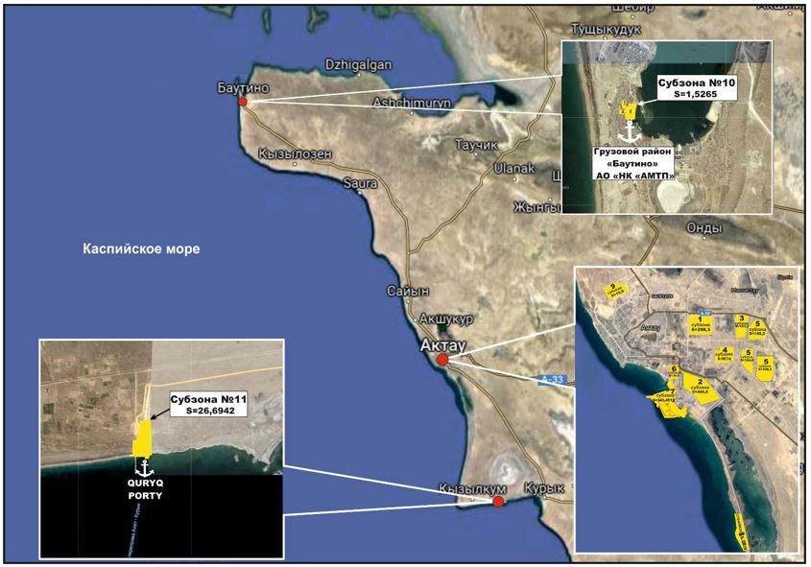

No. | Name of zones: | Area, hectare
1. | Port area | 371.6719
2. | Industrial zone | 1950.5
 | Total: | 2322.1719

Approved
by Resolution No. 624 of the Government
of the Republic of Kazakhstan,
dated October 6, 2017
Target indicators of the special economic zone "Seaport Aktau"
Footnote. The title - as amended by the Resolution of the Government of the Republic of Kazakhstan dated August 14, 2021 No. 558.
Footnote. Target indicators as amended by the Resolution of the Government of the Republic of Kazakhstan dated February 19, 2021 No. 78.
No. | Goals, objectives and indicators (names) | Unit | Base period 2019 | Achievement by 2021 | Achievement by 2023 | Achievement  by 2025 | Achievement by 2027
 |  |  |  | target indicator | target indicator | target indicator | target indicator
1 | 2 | 3 | 4 | 5 | 6 | 7 | 8
1. | Total investment, including: | billion tenge | 119.3 | 137.0 | 155.0 | 173.0 | 191.0
1.1 | The volume of foreign investments | billion tenge | 97.1 | 114.3 | 131.0 | 147.7 | 164.4
1.2 | The volume of domestic investments | billion tenge | 22.2 | 22.7 | 24.0 | 25.3 | 26.6
2. | The volume of production of goods and services | billion tenge | 344.1 | 365.0 | 390.0 | 420.0 | 450.0
 | (works) on the territory of the special economic zone
3. | Number of participants | companies | 30 | 35 | 40 | 45 | 50
4. | The number of jobs created in the territory of the special economic zone | Persons | 1650 | 1700 | 2300 | 3000 | 3500
5. | The average value of the share of local content in the total volume of production in the territory of the special economic zone | % | 50 | 50 | 50 | 50 | 50

Approved
by Resolution No. 624
of the Government
of the Republic of Kazakhstan,
dated October 6, 2017
REGULATION
on the Ontustik special economic zone
1. General provisions
1. The special economic zone "Ontustik" (hereinafter referred to as the SEZ) is located on the territory of the city of Shymkent according to the attached plan.
The territory of the SEZ is 225.0001 hectares and is an integral part of the territory of the Republic of Kazakhstan.
Footnote. Paragraph 1 as amended by the Resolution of the Government of the Republic of Kazakhstan dated February 19, 2021 No. 78.
2. The SEZ creation is aimed at:
1) accelerated development of the region for activation of entry of the republic’s economy to the system of world economic networks, creation of high-level production, including high-technological and competitive productions, development of production of new types of products, attraction of investments, improvement of legal norms of market relations, introduction of modern methods of administration and management, as well as solution of social problems;
2) development of cotton-processing enterprises, textile and clothing industry of the Republic of Kazakhstan;
3) development of textile industry;
4) attraction of manufacturers of world trade marks for production of textile products;
5) creation of high-technological production, improvement of quality and expansion of range of produced textile products;
6) development of chemical and petrochemical spheres.
3. The activity of the SEZ shall be regulated by the Constitution of the Republic of Kazakhstan, the Law of the Republic of Kazakhstan dated April 3, 2019 "On Special Economic and Industrial Zones", this Regulation and other regulatory legal acts of the Republic of Kazakhstan.
Footnote. Paragraph 3 as amended by the Resolution of the Government of the Republic of Kazakhstan dated May 22, 2019 No. 307.
4. Excluded by Resolution of the Government of the Republic of Kazakhstan dated February 19, 2021 No. 78.
2. Management of the SEZ
5. The management of the SEZ shall be carried out in accordance with the Law of the Republic of Kazakhstan dated April 3, 2019 "On Special Economic and Industrial Zones".
Footnote. Paragraph 5 as amended by the Resolution of the Government of the Republic of Kazakhstan dated May 22, 2019 No. 307.
3. Taxation in the territory of the SEZ
6. Taxation in the SEZ territory shall be regulated by the tax legislation of the Republic of Kazakhstan.
4. Customs regulation
7. Customs regulation in the SEZ territory is carried out in accordance with the provision of the customs legislation of the Eurasian Economic Union and the Republic of Kazakhstan.
8. Customs procedure of the free customs zone can be applied on the SEZ territory or a part of it.
9. The products covered by customs procedure of the free customs zone are those intended for placement and (or) use in the territory of the SEZ by persons, carrying out priority kinds of activities in accordance with the agreement on implementation of activities as the SEZ participant.
10. The territory of the SEZ, where customs procedure of the free customs zone is applied, is a zone of customs control. In fulfillment of customs control the SEZ boundaries are equipped along its perimeter in accordance with the customs legislation of the Republic of Kazakhstan.
11. In the SEZ territory facilities for temporary storage of products can be created in the order specified by the customs legislation of the Eurasian Economic Union and the Republic of Kazakhstan.
12. The products covered by the customs procedure of the free customs zone, as well as the products of the Eurasian Economic Zone, not covered by the customs procedure of the free customs zone, and foreign products, covered by other customs procedures can be place and used in the SEZ territory.
13. The products imported into the SEZ territory and covered by the customs procedure of the free customs zone shall be considered as products outside the customs territory of the Eurasian Economic Zone for the purposes of application of customs duties, taxes, as well as non-tariff regulation measures.
14. Customs operations, related to temporary storage, customs declaration, customs clearance and release of products, as well as implementation of customs control in the SEZ territory, are carried out in the order specified by the customs legislation of the Eurasian Economic Union and the Republic of Kazakhstan.
5. Protection of environment
15. The activities of the SEZ in terms of ecological regulation are carried in accordance with the ecological legislation of the Republic of Kazakhstan and based on the rational and effective use of nature resources through creation of the conditions for transfer to sustainable development and protection of environment based on the balance of economic, social and ecological aspects of life standards improvement.
6. Final provisions
16. Terms and conditions, specified in this Regulation can be amended by the resolution of the Government of the Republic of Kazakhstan.
17. Early abolition of the SEZ shall be carried out in accordance with the Law of the Republic of Kazakhstan dated April 3, 2019 "On Special Economic and Industrial Zones".
Footnote. Paragraph 17 as amended by the Resolution of the Government of the Republic of Kazakhstan dated May 22, 2019 No. 307.
18. The activities of the SEZ, not regulated by this Regulation, are carried out in accordance with the current legislation of the Republic of Kazakhstan and the Eurasian Economic Union.
Annex
to the Regulation on the Ontustik
special economic zone
Footnote. Annex as amended by Resolution of the Government of the Republic of Kazakhstan dated February 19, 2021 No. 78.
Plan of the territory of "Ontustik" special economic zone

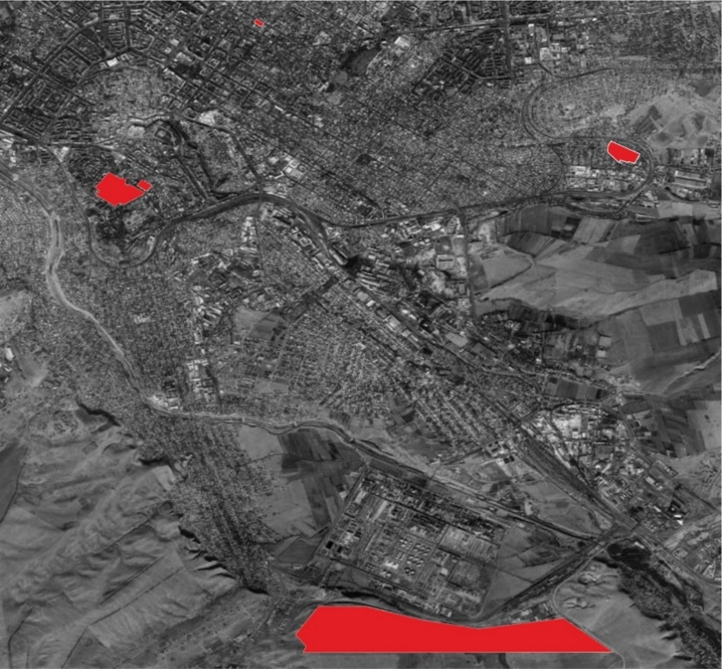

The total territory of the special economic zone "Ontustik" S = 225.0001 ha
Approved
by Resolution No. 624
of the Government
of the Republicof Kazakhstan,
dated October 6, 2017
Target indicators of the "Ontustik" special economic zone
Footnote. The title - as amended by the Resolution of the Government of the Republic of Kazakhstan dated August 14, 2021 No. 558.
Footnote. Target indicators as amended by the Resolution of the Government of the Republic of Kazakhstan dated February 19, 2021 No. 78.
No. | Goals, objectives and indicators (names) | Unit | Base period (2019) | Achievement  by 2020 | Achievement  by 2025 | Achievement  by 2030
 |  |  |  | target indicator | target indicator | target indicator
1 | 2 | 3 | 4 | 5 | 6 | 7
1. | Total investment, including: | billion tenge | 29.6 | 38.6 | 45.5 | 54.2
1.1 | The volume of foreign investments | billion tenge | 2.5 | 4.5 | 5.1 | 7.3
1.2 | The volume of domestic investment | billion tenge | 27.1 | 28.5 | 40.4 | 46.9
2. | The volume of production of goods and services (works) in the territory of the special economic zone | billion tenge | 53.9 | 72 | 147 | 253
3. | The annual increase in investment in non-primary sectors of the region's economy (manufacturing industry) | % | 0.1 | 0.3 | 0.3 | 0.3
4. | Number of participants | companies | 33 | 40 | 45 | 50
5. | The number of jobs created in the territory of the special economic zone | persons | 1500 | 3500 | 4200 | 5000
6. | The share of local content in the total volume of production in the territory of the special economic zone | % | 70 | 70 | 70 | 70
7. | The share of exports of products in the total volume of production in the territory of the special economic zone | % | 50 | 50 | 50 | 50
Approved
by Resolution No. 624
of the Government
of the Republic of Kazakhstan,
dated October 6, 2017
REGULATION on Pavlodar special economic zone 1. General provisions
1. "Pavlodar" special economic zone (hereinafter referred to as SEZ) is located on the territory of the Northern industrial region of Pavlodar City according to the attached plan.
The territory of the SEZ is 3310 hectares and is an integral part of the territory of the Republic of Kazakhstan.
Footnote. Paragraph 1 as amended by the Resolution of the Government of the Republic of Kazakhstan dated August 14, 2021 No. 558.
2. The SEZ creation is aimed at:
development of chemical, petrochemical industries, in particular, the production of export-oriented products with high added value, using high-technology environmentally friendly modern technologies;
development and implementation of breakthrough investment projects, scientific research and scientific technical innovation projects for the creation and development of chemical, petrochemical industries for advanced processing of raw materials and the production of a wide range of competitive products with high added value;
implementation of integration of Kazakhstan products into the global production and marketing system, creation of innovative, competitive domestic products in accordance with international standards;
creation of highly effective and innovative productions of chemical and petrochemical industries, including high-technology and competitive productions, development of new types of products;
creation of a favorable investment climate and attraction of domestic and foreign investments for realization of investment projects and complex development of chemical, petrochemical industries on the basis of mechanisms of public-private partnership;
accelerated development of the region to activate the entry of the republic's economy into the system of world economic networks;
introduction of modern administration and management methods;
solution of social problems, increase of employment;
development of the metallurgical and metalworking industries, in particular, the production of finished products by attracting manufacturers of world trade marks;
development and implementation of breakthrough investment projects for the creation and development of manufacturing industries, including metallurgical, metal processing, non-metallic mineral products, world-class rubber and plastic products for advanced processing of raw materials and the production of a wide range of competitive products with high added value.
3. The activity of the SEZ is regulated by the Constitution of the Republic of Kazakhstan, the Law of the Republic of Kazakhstan dated April 3, 2019 "On Special Economic and Industrial Zones", this Regulation and other regulatory legal acts of the Republic of Kazakhstan.
Footnote. Paragraph 3 as amended by the Resolution of the Government of the Republic of Kazakhstan dated May 22, 2019 No. 307.
3-1. The list of priority activities of the SEZ, corresponding to the goals of its creation, as well as the procedure for including priority activities in this list, shall be determined by the authorized state body that carries out state regulation in the field of creation, operation and abolition of special economic and industrial zones, in agreement with the authorized body for state planning and the authorized body exercising leadership in the field of ensuring the receipt of taxes and other obligatory payments to the budget.
Footnote. The Regulation is supplemented by paragraph 3-1, in accordance with the Resolution of the Government of the Republic of Kazakhstan dated 14.08.2021 No. 558.
4. Excluded by Resolution of the Government of the Republic of Kazakhstan dated February 19, 2021 No. 78.
2. Management of the SEZ
5. The management of the SEZ shall be carried out in accordance with the Law of the Republic of Kazakhstan dated April 3, 2019 "On Special Economic and Industrial Zones".
Footnote. Paragraph 5 as amended by the Resolution of the Government of the Republic of Kazakhstan dated May 22, 2019 No. 307.
3. Taxation in the SEZ territory
6. Taxation in the SEZ territory shall be regulated by the tax legislation of the Republic of Kazakhstan.
4. Customs regulation
7. Customs regulation in the SEZ territory is carried out in accordance with the provision of the customs legislation of the Eurasian Economic Union and the Republic of Kazakhstan.
8. Customs procedure of the free customs zone is applied on the whole SEZ territory.
9. The products covered by customs procedure of the free customs zone are those intended for placement and (or) use in the territory of the SEZ by persons, carrying out priority kinds of activities in accordance with the agreement on implementation of activities as the SEZ participant.
10. The SEZ territory is a zone of customs control. In fulfillment of customs control the SEZ boundaries are equipped with special fences along its perimeter.
11. In the SEZ territory facilities for temporary storage of products can be created in the order specified by the customs legislation of the Eurasian Economic Union and the Republic of Kazakhstan.
12. The products covered by the customs procedure of the free customs zone, as well as the products of the Eurasian Economic Zone, not covered by the customs procedure of the free customs zone, and foreign products, covered by other customs procedures can be place and used in the SEZ territory.
13. The products imported into the SEZ territory and covered by the customs procedure of the free customs zone shall be considered as products outside the customs territory of the Eurasian Economic Zone for the purposes of application of customs duties, taxes, as well as non-tariff regulation measures.
14. Customs operations, related to temporary storage, customs declaration, customs clearance and release of products, as well as implementation of customs control in the SEZ territory, are carried out in the order specified by the customs legislation of the Eurasian Economic Union and the Republic of Kazakhstan.
5. Protection of environment
15. The activities of the SEZ in terms of ecological regulation are carried in accordance with the ecological legislation of the Republic of Kazakhstan and based on the rational and effective use of nature resources through creation of the conditions for transfer to sustainable development and protection of environment based on the balance of economic, social and ecological aspects of life standards improvement.
6. Final provisions
16. Terms and conditions, specified in this Regulation can be amended by the resolution of the Government of the Republic of Kazakhstan.
17. Early abolition of the SEZ shall be carried out in accordance with the Law of the Republic of Kazakhstan dated April 3, 2019 "On Special Economic and Industrial Zones".
Footnote. Paragraph 17 as amended by the Resolution of the Government of the Republic of Kazakhstan dated May 22, 2019 No. 307.
18. The activities of the SEZ, not regulated by this Regulation, are carried out in accordance with the current legislation of the Republic of Kazakhstan and the Eurasian Economic Union.
Annex
to the Regulation
on Pavlodar special
economic zone
PLAN of "Pavlodar" special economic zone
Footnote. The plan is as amended by the Resolution of the Government of the Republic of Kazakhstan dated August 14, 2021 No. 558.

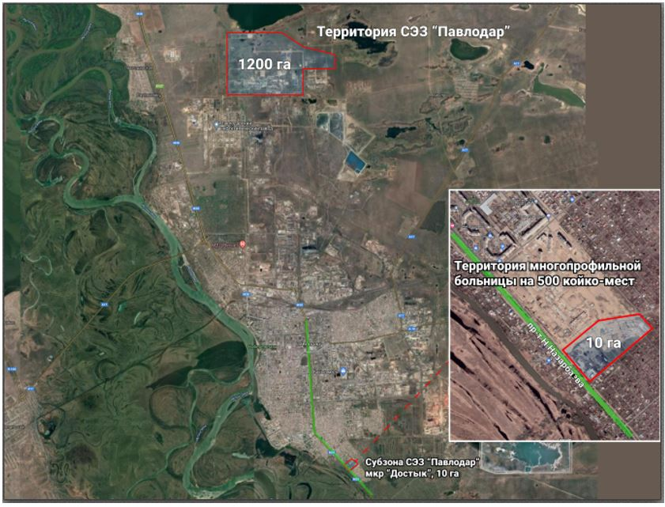

Territory of SEZ "Pavlodar" S = 3310 ha
No. | Name of zones: | Area, ha
1. | SEZ "Pavlodar" | 3300 (of which 2100 ha is the Bylkyldak storage lake)
2. | Subzone of SEZ "Pavlodar" | 10
 | Total: | 3310
Approved
by Resolution No. 624
of the Government
of the Republic of Kazakhstan,
dated October 6, 2017
Target indicators of the special economic zone "Pavlodar"
Footnote. The title - as amended by the Resolution of the Government of the Republic of Kazakhstan dated August 14, 2021 No. 558.
Footnote. Target indicators as amended by the Resolution of the Government of the Republic of Kazakhstan dated February 19, 2021 No. 78.
No. | Goals, objectives and indicators (names) | Unit | Base period (2019) | Achievement  by 2021 | Achievement  by 2026 | Achievement  by 2031 | Achievement  by 2036
 |  |  |  | target indicator | target indicator | target indicator | target indicator
1 | 2 | 3 | 4 | 6 | 7 | 8
1. | Total investment, including: | billion tenge | 74.5 | 80 | 156 | 257.3 | 394.1
1.1 | The volume of foreign investments | billion tenge | 17.3 | 19 | 37 | 61 | 93.4
1.2 | The volume of domestic investments | billion tenge | 57.2 | 61 | 119 | 196.3 | 300.7
2. | The volume of production of goods and services (works) in the territory of the special economic zone | billion tenge | 120.2 | 166.5 | 347 | 867.5 | 2071
3. | The annual increase in investment in non-primary sectors of the region's economy (manufacturing industry) | % | 7 | 7 | 7 | 10 | 10
4. | Number of participants | companies | 20 | 25 | 25 | 28 | 30
5. | The number of jobs created in the territory of the special economic zone | persons | 1500 | 1530 | 1670 | 1885 | 2000
6. | The share of local content in the total volume of production in the territory of the special economic zone | % | 65 | 65 | 70 | 70 | 70
7. | The share of exports of products in the total volume of production in the territory of the special economic zone | % | 20 | 30 | 40 | 50 | 50
8. | Increasing labor productivity | times | 1.6 | 1.7 | 1.9 | 2 | 2.5
Approved
by Resolution No. 624
of the Government of the
Republic of Kazakhstan,
dated October 6, 2017
Regulations
on the Khorgos International Centre of Boundary Cooperation special economic zone
1. General provisions
1. The special economic zone "International Center for Cross-Border Cooperation "Khorgos" (hereinafter referred to as the SEZ) is located on the territory of the Panfilov district of the Almaty region within the boundaries according to the attached plan.
The SEZ is a special economic zone, the limits of which completely or partially coincide with sections of the customs border of the Eurasian Economic Union in accordance with the Customs Code of the Eurasian Economic Union.
The territory of the SEZ is 608.56 hectares and is an integral part of the territory of the Republic of Kazakhstan.
Footnote. Paragraph 1 as amended by the Resolution of the Government of the Republic of Kazakhstan dated May 22, 2019 No. 307.
2. The SEZ creation is aimed at:
development of cross-border trade and economic cooperation;
development of export-oriented industries;
activation of the business and investment environment;
development of transport infrastructure, tourism and cultural interaction;
solution of socio-economic issues of the Almaty oblast, in which the SEZ is located.
3. The activities of the FEZ shall be regulated by the Constitution of the Republic of Kazakhstan, the Agreement between the Government of the Republic of Kazakhstan and the Government of the People's Republic of China on the establishment and regulation of the activities of the International Center for Border Cooperation "Khorgos", concluded in Astana on July 4, 2005, the Law of the Republic of Kazakhstan "On special economic and industrial zones", these Regulations and other regulatory legal acts of the Republic of Kazakhstan.
Footnote. Paragraph 3 as amended by the Resolution of the Government of the Republic of Kazakhstan dated May 22, 2019 No. 307.
4. Excluded by Resolution of the Government of the Republic of Kazakhstan dated February 19, 2021 No. 78.
2. Management of the SEZ
5. The SEZ shall be managed in accordance with the Law of the Republic of Kazakhstan "On Special Economic and Industrial Zones".
Footnote. Paragraph 5 as amended by the Resolution of the Government of the Republic of Kazakhstan dated May 22, 2019 No. 307.
3. Taxation in the territory of SEZ
6. Taxation in the SEZ territory shall be regulated by the tax legislation of the Republic of Kazakhstan.
4. Customs regulation
7. Customs regulation in the SEZ territory is carried out in accordance with the provision of the customs legislation of the Eurasian Economic Union and the Republic of Kazakhstan.
8. Customs procedure of the free customs zone is applied within the SEZ territory of a part of it, where the priority kinds of activities will be carried out.
The products covered by customs procedure of the free customs zone are those intended for placement and (or) use in the territory of the SEZ by persons, carrying out priority kinds of activities in accordance with the agreement on implementation of activities as the SEZ participant
9. The SEZ territory is a zone of customs control. In fulfillment of customs control the SEZ boundaries are equipped with special fences along its perimeter.
10. In the SEZ territory facilities for temporary storage of products can be created in the order specified by the customs legislation of the Eurasian Economic Union and the Republic of Kazakhstan.
In the SEZ territory facilities for global post exchange can be created in accordance with the legislation of the Republic of Kazakhstan.
11. The products covered by the customs procedure of the free customs zone, as well as the products of the Eurasian Economic Zone, not covered by the customs procedure of the free customs zone, and foreign products, covered by other customs procedures can be place and used in the SEZ territory.
12. The products imported into the SEZ territory and covered by the customs procedure of the free customs zone shall be considered as products outside the customs territory of the Eurasian Economic Zone for the purposes of application of customs duties, taxes, as well as non-tariff regulation measures.
13. Customs operations, related to temporary storage, customs declaration, customs clearance and release of products, as well as implementation of customs control in the SEZ territory, are carried out in the order specified by the customs legislation of the Eurasian Economic Union and the Republic of Kazakhstan.
5. Protection of environment
14. Implementation of the activities of the SEZ is based on the rational and effective use of nature resources through creation of the conditions for transfer to sustainable development and protection of environment based on the balance of economic, social and ecological aspects of life standards improvement
6. Procedure and terms of the SEZ elimination
15. The SEZ is eliminated upon the expiry of the term for which it was created.
The SEZ is eliminated with the resolution of the Government of the Republic of Kazakhstan on the proposal of the authorized body.
7. Final provisions
16. Early abolition of the SEZ shall be carried out in accordance with the Law of the Republic of Kazakhstan "On Special Economic and Industrial Zones".
Footnote. Paragraph 16 as amended by the Resolution of the Government of the Republic of Kazakhstan dated May 22, 2019 No. 307.
17. The activities of the SEZ, not regulated by this Regulation, are carried out in accordance with the current legislation of the Republic of Kazakhstan and the Eurasian Economic Union.
Annex
to the Regulation on the
Khorgos International Centre of
Boundary Cooperation special
economic zone
Plan of the Khorgos International Centre of Boundary Cooperation special economic zone
Footnote. Annex as amended by the Resolution of the Government of the Republic of Kazakhstan dated May 22, 2019 No. 307.

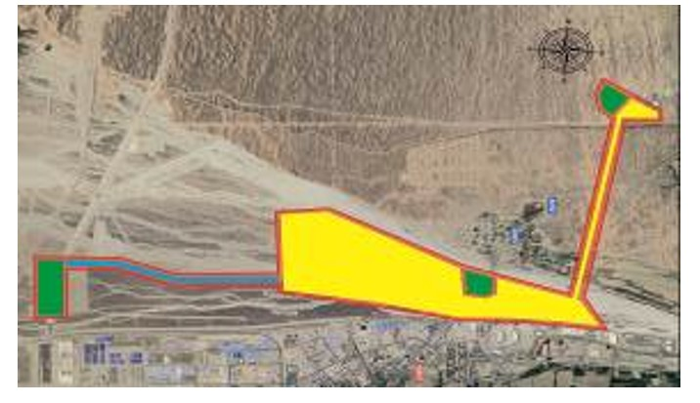

"International Center for Cross-border Cooperation "Khorgos"
Total area S = 608.56 ha
Approved
by Resolution No. 624
of the Government
of the Republic of Kazakhstan,
dated October 6, 2017
Target indicators of the special economic zone
"International Center for Border Cooperation "Khorgos"
Footnote. The title - as amended by the Resolution of the Government of the Republic of Kazakhstan dated August 14, 2021 No. 558.
Footnote. Target indicators as amended by Resolution of the Government of the Republic of Kazakhstan dated February 19, 2021 No. 78.
No. | Goals, objectives and indicators (names) | Unit | Base period (2019) | Achievement by 2021, including | Achievement by 2026, including | Achievement by 2031, including | Achievement by 2036, including | Achievement by 2041, including
 |  |  |  | target indicator | target indicator | target indicator | target indicator | target indicator
1 | 2 | 3 | 4 | 5 | 6 | 7 | 8 | 9
1 | Total investment, including: | billion tenge | 55.5 | 196.1 | 316.1 | 436.1 | 490.1 | 520.1
1.1 | The volume of foreign investments | billion tenge | 15.4 | 124.8 | 220.8 | 316.8 | 360 | 384
1.2 | The volume of domestic investments | billion tenge | 40.1 | 71.3 | 95.3 | 119.3 | 130.1 | 136.1
2 | The volume of production of goods and services (works) in the territory of the FEZ | billion tenge | - | - | 46 | 66 | 75 | 80
3 | Number of persons carrying out ancillary activities | units | 0 | 4 | 7 | 10 | 15 | 17
4 | Number of participants (companies) | persons | 33 | 40 | 70 | 90 | 100 | 110
5 | The number of jobs created in the SEZ | persons | 170 | 2086 | 3 363 | 4639 | 5 214 | 5 533
6 | The share of local content in the total volume of production in the territory of the SEZ | % | - | - | 14.5 | 14.5 | 14.5 | 14.5
7 | The volume of transportation of goods (export, import, transit) | thousand tons | 39.4 | 45.5 | 67.8 | 78.3 | 90.2 | 100

© 2012. «Institute of legislation and legal information of the Republic of Kazakhstan» of the Ministry of Justice of the Republic of Kazakhstan

